CUSTOMER CHURN PREDICTION
System Documentation
  - Data Validation, Preprocessing, Feature Engineering, Churn Labeling, Machine Learning, Risk Classification, Customer Segmentation, Retention Priority, Campaign Analytics, Campaign Affinity, Model Feature Importance, Visualization, Streamlit Application, Customer Exploration, Testing and Evidence
Project: Customer Churn Prediction and Campaign Analytics System Using Machine Learning
Environment: Python 3.10.5 • VS Code • Pandas • Scikit-learn • Plotly • Streamlit

Ayush Sarkar
• ayush1234sarkar@hotmail.com
• linkedin.com/in/ayush-sarkar-00016b278
• github.com/Ayush-Sarkar-04/Customer-Churn-Prediction

Current System Scope and Objective
Analytical Limitations
The following analytical limitations are explicit:
- Retention priority is a prioritization proxy.
- Expected revenue at risk is not a true revenue forecast.
- Feature importance is not a causal explanation.
- Campaign affinity describes observed click response rather than proving customer preference.
System Scope
The system includes:
- Fixed-schema CSV validation and resource protection
- Data preprocessing
- Customer-level feature engineering
- 90-day future-purchase churn labeling
- Supervised model training and evaluation
- Persisted prediction models
- Churn probability and risk classification
- RFM segmentation
- Retention priority and expected revenue at risk
- Campaign funnel and campaign-type performance analysis
- Customer campaign affinity based on delivered-to-clicked behavior
- Random Forest feature importance
- Reusable visualizations
- Customer search and exploration
- Streamlit dashboards
Business Questions Addressed
The system is designed to answer distinct business questions at different stages:
- Is the input data trustworthy?
- Which customers are most likely to churn?
- Which customers deserve the highest retention attention?
- Which customer segments require intervention?
- Which campaign types perform best overall?
- Which campaign types generate the strongest observed click response for an individual customer?
- Which model features contribute most to the Random Forest prediction?
The application presents these outputs as decision support rather than autonomous campaign execution.

Current System Scope and Objective

1. Purpose of the Validator
The validator is the quality-control layer between CSV upload and the rest of the customer churn prediction pipeline. Its purpose is to prevent incorrectly structured or invalid data from entering feature engineering, analytics and machine-learning stages.
The implemented validation flow is:
Uploaded CSV
↓
Schema / Column Validation
↓
Data-Type Validation
↓
Date Validation
↓
Missing-Value Validation
↓
Duplicate-ID Validation
↓
ID Validation
↓
Cross-File Customer Reference Validation
↓
Accept / Reject

2. Design Principle
The application uses fixed schemas. Users are expected to provide data using the predefined column names. The validator does not attempt to automatically map arbitrary column names to the required schema.
- Missing required columns cause rejection.
- Unexpected columns cause rejection.
- Invalid values cause rejection.
- The validator reports specific errors so the user can identify the problem.
- customer_features.csv is a derived/training dataset and is not part of the three raw upload schemas.

3. Fixed Raw Dataset Schemas
The raw datasets accepted by the project are Customers, Transactions and Campaigns.

Customers
Column | Role / Expected Data
customer_id | Customer identifier
gender | Text/category
age | Numeric
city | Text/category
registration_date | Date

Transactions
Column | Role / Expected Data
transaction_id | Transaction identifier
customer_id | Customer identifier
transaction_date | Date
bill_amount | Numeric amount
outlet | Text/category

Campaigns
Column | Role / Expected Data
campaign_id | Campaign identifier
customer_id | Customer identifier
campaign_date | Date
campaign_type | Text/category
reward_type | Text/category
reward_value | Numeric
campaign_cost | Numeric
sent | Numeric/count
delivered | Numeric/count
clicked | Numeric/count
redeemed | Numeric/count
redemption_date | Date

Note: customer_features.csv contains the derived machine-learning feature set, including observation_date, RFM metrics, campaign metrics, future_90d_purchases and churn. It is used for training/reference rather than being one of the raw three upload schemas.

4. Implemented Validator Code
The current validator.py contains the following functions.
import pandas as pd

def validate_columns(df, expected_columns):
actual_columns = set(df.columns)
expected_columns = set(expected_columns)

missing = expected_columns - actual_columns
extra = actual_columns - expected_columns

if missing or extra:
return {
"valid": False,
"missing": sorted(missing),
"extra": sorted(extra)
}

return {
"valid": True,
"missing": [],
"extra": []
}

def validate_data_types(df, dataset_type):
errors = []

if dataset_type == "customer":
if not pd.api.types.is_numeric_dtype(df["age"]):
errors.append("age must be numeric")

elif dataset_type == "transaction":
if not pd.api.types.is_numeric_dtype(df["bill_amount"]):
errors.append("bill_amount must be numeric")

elif dataset_type == "campaign":
numeric_columns = [
"reward_value",
"campaign_cost",
"sent",
"delivered",
"clicked",
"redeemed"
]

for column in numeric_columns:
if not pd.api.types.is_numeric_dtype(df[column]):
errors.append(f"{column} must be numeric")

return {
"valid": len(errors) == 0,
"errors": errors
}

def validate_dates(df, dataset_type):
errors = []

if dataset_type == "customer":
date_columns = [
"registration_date"
]

elif dataset_type == "transaction":
date_columns = [
"transaction_date"
]

elif dataset_type == "campaign":
date_columns = [
"campaign_date",
"redemption_date"
]

else:
return {
"valid": False,
"errors": ["Unknown dataset type"]
}

for column in date_columns:
invalid_dates = pd.to_datetime(
df[column],
errors="coerce"
).isna()

if invalid_dates.any():
errors.append(
f"{column} contains invalid dates"
)

return {
"valid": len(errors) == 0,
"errors": errors
}

def validate_missing_values(df, required_columns):
errors = []

for column in required_columns:
if df[column].isna().any():
errors.append(
f"{column} contains missing values"
)

return {
"valid": len(errors) == 0,
"errors": errors
}

def validate_duplicates(df, id_column):
errors = []

duplicate_count = df[id_column].duplicated().sum()

if duplicate_count > 0:
errors.append(
f"{id_column} contains {duplicate_count} duplicate values"
)

return {
"valid": len(errors) == 0,
"errors": errors
}

def validate_ids(df, id_column):
errors = []

if df[id_column].isna().any():
errors.append(
f"{id_column} contains missing IDs"
)

if (df[id_column].astype(str).str.strip() == "").any():
errors.append(
f"{id_column} contains empty IDs"
)

return {
"valid": len(errors) == 0,
"errors": errors
}

def validate_customer_references(customers_df, transactions_df, campaigns_df):
errors = []

customer_ids = set(customers_df["customer_id"])

transaction_customer_ids = set(
transactions_df["customer_id"]
)

campaign_customer_ids = set(
campaigns_df["customer_id"]
)

invalid_transaction_ids = (
transaction_customer_ids - customer_ids
)

invalid_campaign_ids = (
campaign_customer_ids - customer_ids
)

if invalid_transaction_ids:
errors.append(
f"Transactions contain {len(invalid_transaction_ids)} "
"customer IDs not found in customers"
)

if invalid_campaign_ids:
errors.append(
f"Campaigns contain {len(invalid_campaign_ids)} "
"customer IDs not found in customers"
)

return {
"valid": len(errors) == 0,
"errors": errors
}

5. Function-by-Function Explanation
Function | Purpose
validate_columns() | Compares the actual CSV column set with the expected fixed schema. It identifies both missing and unexpected columns.
validate_data_types() | Checks the numeric fields required by each dataset type. Customer age and transaction bill_amount are checked; campaign reward/cost/funnel fields are checked.
validate_dates() | Attempts to parse required date columns with pandas.to_datetime(errors='coerce'). Values that cannot be interpreted as dates are reported.
validate_missing_values() | Checks required columns for NaN/missing values.
validate_duplicates() | Checks whether the specified ID column contains duplicate occurrences.
validate_ids() | Checks the specified ID column for missing IDs and empty-string IDs.
validate_customer_references() | Checks referential integrity: every customer_id used by transactions and campaigns must exist in customers.csv.

6. Test Files Created
Test File | Purpose | Observed/Expected Evidence
test_validator_valid.py | Valid schema test | {'valid': True, 'missing': [], 'extra': []}
test_validator_invalid.py | Invalid schema test | {'valid': False, 'missing': ['outlet'], 'extra': ['wrong_column']}
test_data_types.py | Numeric data-type tests | Valid numeric input passes; invalid bill_amount is rejected.
test_dates.py | Date validation tests | Valid dates pass; 'not-a-date' is rejected.
test_missing_values.py | Required-field tests | Complete customer data passes; None in city is rejected.
test_duplicates.py | Duplicate-ID tests | Unique IDs pass; duplicate C002 is rejected.
test_ids.py | Missing/empty ID tests | Normal IDs pass; empty and None IDs are rejected.
test_customer_references.py | Cross-file reference tests | Valid references pass; C999 not present in customers is rejected.

7. Representative Test Code

7.1 Schema validation — invalid case
import pandas as pd

from src.schema import TRANSACTION_COLUMNS
from src.data.validator import validate_columns

df = pd.DataFrame(columns=[
"transaction_id",
"customer_id",
"transaction_date",
"bill_amount",
"wrong_column"
])

result = validate_columns(
df,
TRANSACTION_COLUMNS
)

print(result)

7.2 Data-type validation
import pandas as pd
from src.data.validator import validate_data_types

df = pd.DataFrame({
"bill_amount": [500.00, "invalid", 750.25]
})

result = validate_data_types(
df,
"transaction"
)

print(result)

7.3 Date validation
import pandas as pd
from src.data.validator import validate_dates

df = pd.DataFrame({
"transaction_date": [
"2026-06-10",
"2026-07-15",
"not-a-date"
]
})

result = validate_dates(
df,
"transaction"
)

print(result)

7.4 Missing-value validation
import pandas as pd
from src.data.validator import validate_missing_values

df = pd.DataFrame({
"customer_id": ["C001", "C002", "C003"],
"gender": ["Male", "Female", "Male"],
"age": [25, 30, 28],
"city": ["Delhi", "Mumbai", None],
"registration_date": [
"2026-01-10",
"2026-02-15",
"2026-03-20"
]
})

required_columns = [
"customer_id",
"gender",
"age",
"city",
"registration_date"
]

result = validate_missing_values(
df,
required_columns
)

print(result)

7.5 Duplicate validation
import pandas as pd
from src.data.validator import validate_duplicates

df = pd.DataFrame({
"customer_id": [
"C001",
"C002",
"C002"
]
})

result = validate_duplicates(
df,
"customer_id"
)

print(result)

7.6 ID validation
import pandas as pd
from src.data.validator import validate_ids

df = pd.DataFrame({
"customer_id": [
"C001",
"C002",
None
]
})

result = validate_ids(
df,
"customer_id"
)

print(result)

7.7 Cross-file reference validation
import pandas as pd
from src.data.validator import validate_customer_references

customers_df = pd.DataFrame({
"customer_id": [
"C001",
"C002",
"C003"
]
})

transactions_df = pd.DataFrame({
"customer_id": [
"C001",
"C002",
"C999"
]
})

campaigns_df = pd.DataFrame({
"customer_id": [
"C001",
"C002",
"C003"
]
})

result = validate_customer_references(
customers_df,
transactions_df,
campaigns_df
)

print(result)

8. Test Evidence from VS Code
The following screenshots were captured during development and show the validator being tested with both valid and intentionally invalid inputs.
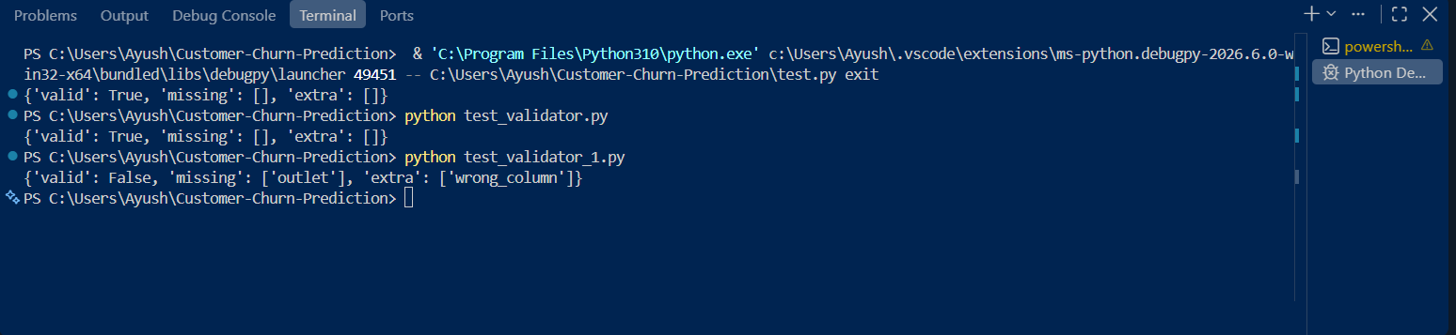
Figure 1. Schema validation: valid schema passes and invalid schema reports missing outlet and extra wrong_column.
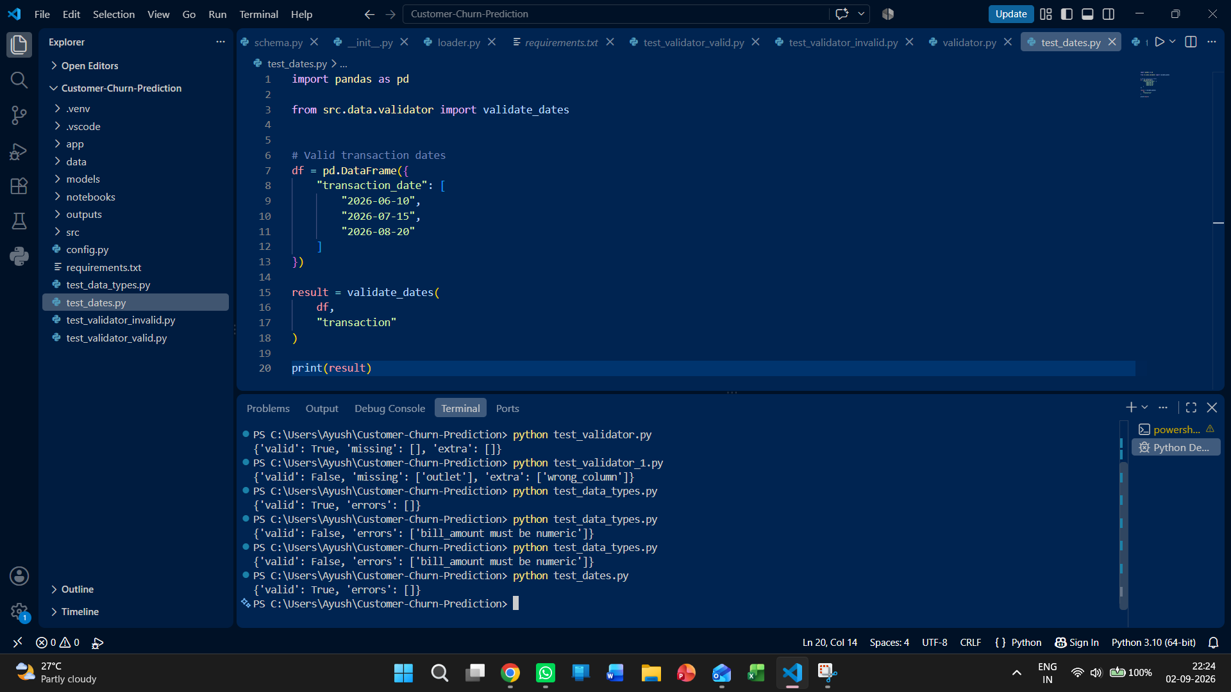
Figure 2. Data-type validation: valid numeric input passes and invalid bill_amount is rejected.
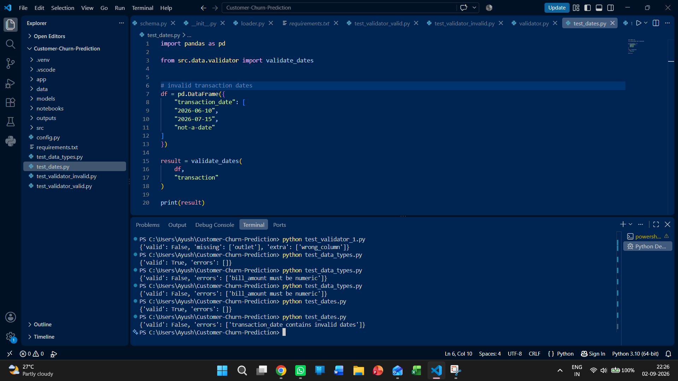
Figure 3. Date validation: valid dates pass and an invalid transaction date is rejected.
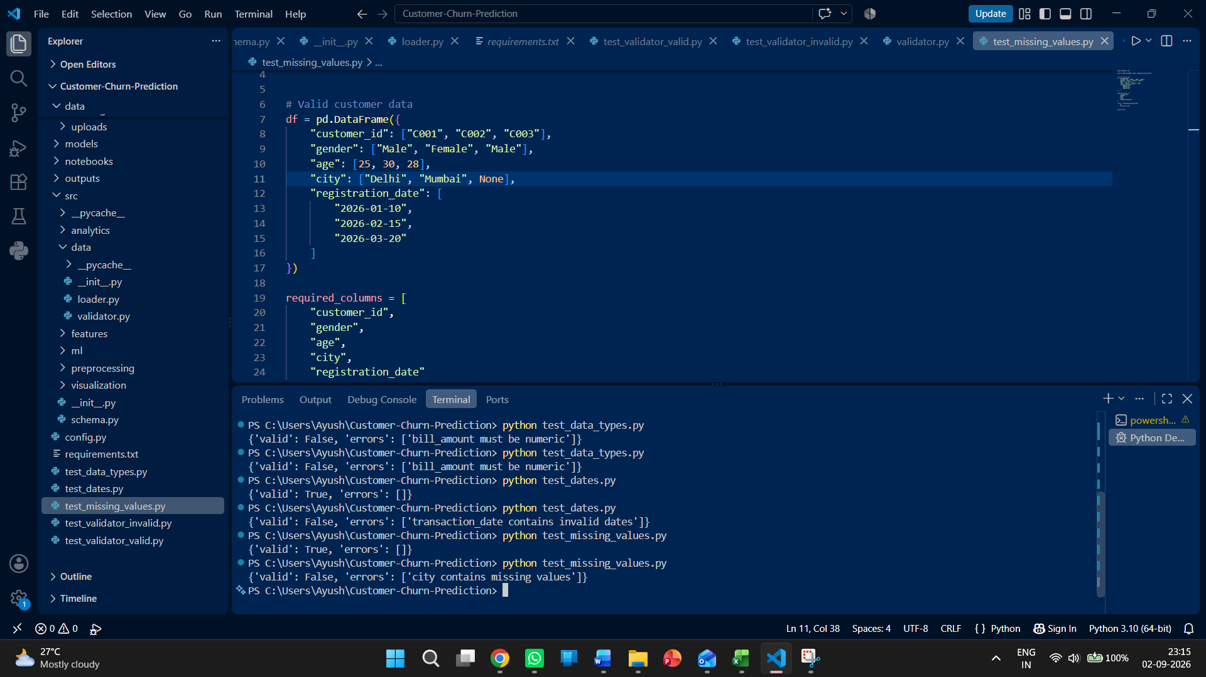
Figure 4. Missing-value validation: a missing city value is detected.
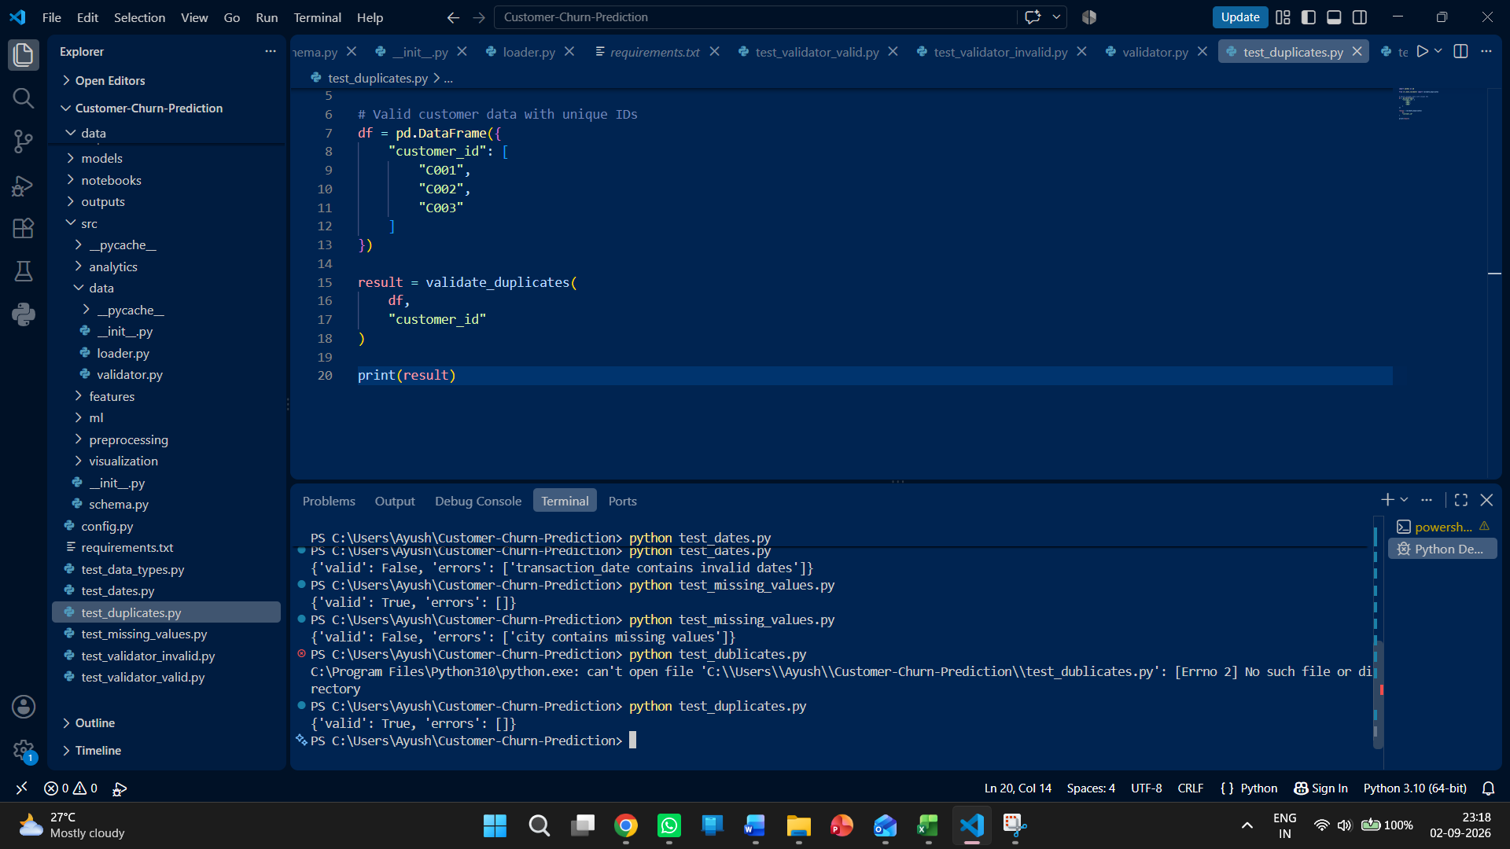
Figure 5. Duplicate validation: the valid unique-ID test passes.
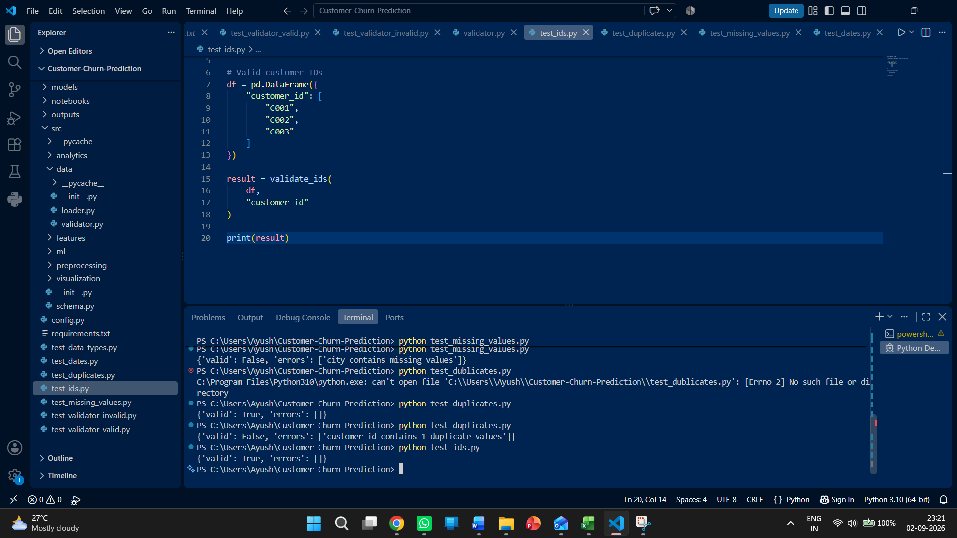
Figure 7. ID validation: the valid unique/non-empty ID case passes.
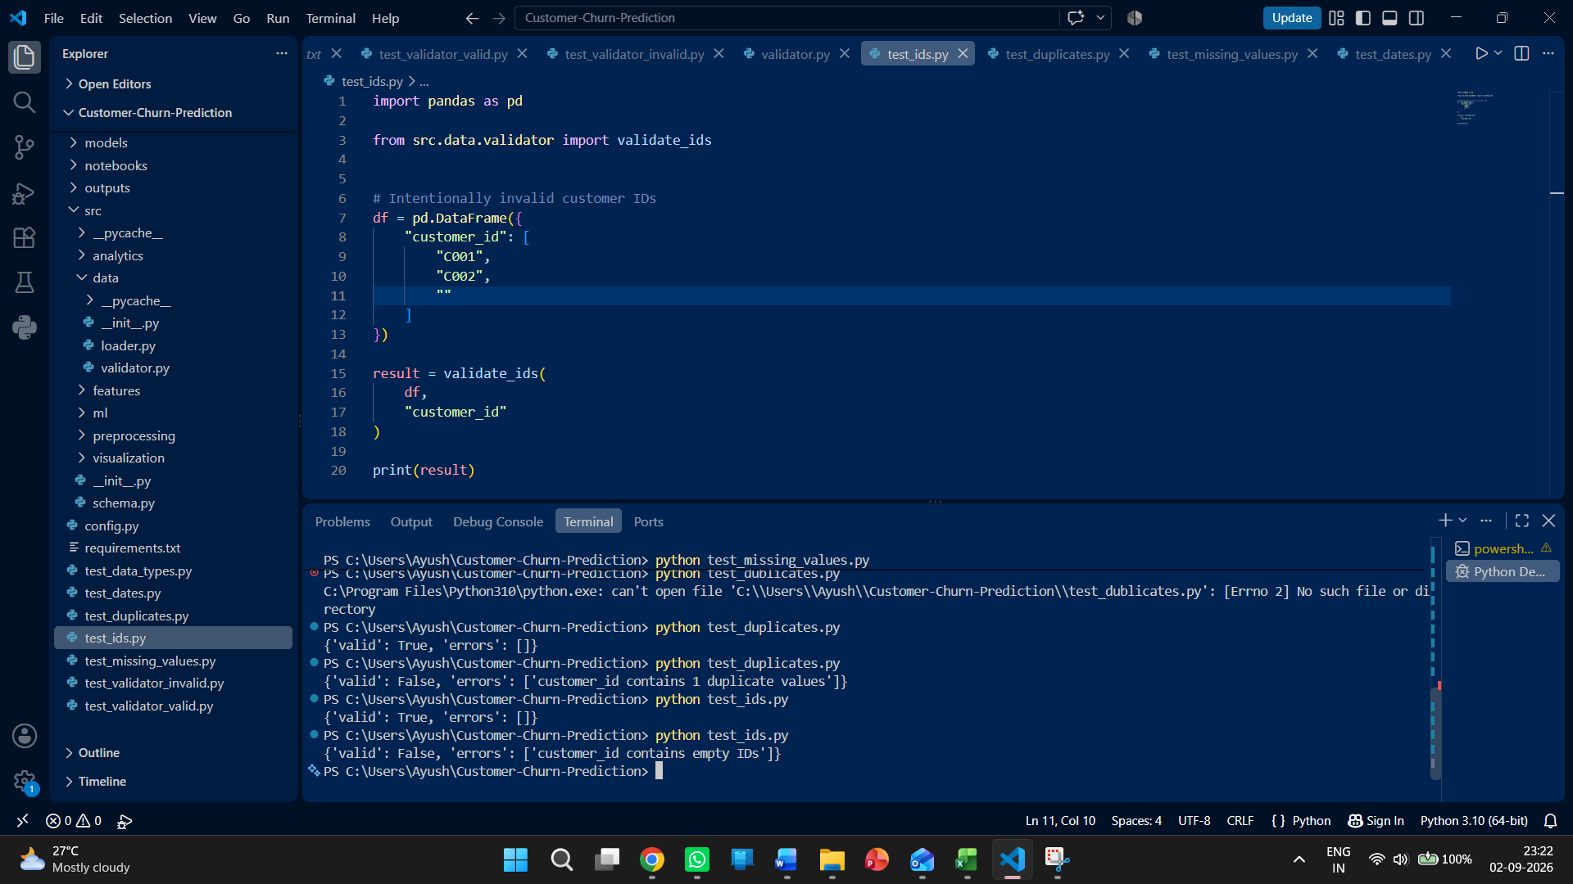
Figure 8. ID validation: empty and missing customer IDs are detected.
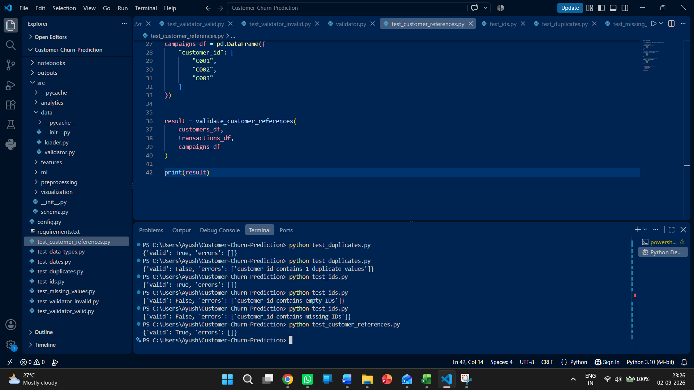
Figure 9. Cross-file reference validation: valid customer references pass.
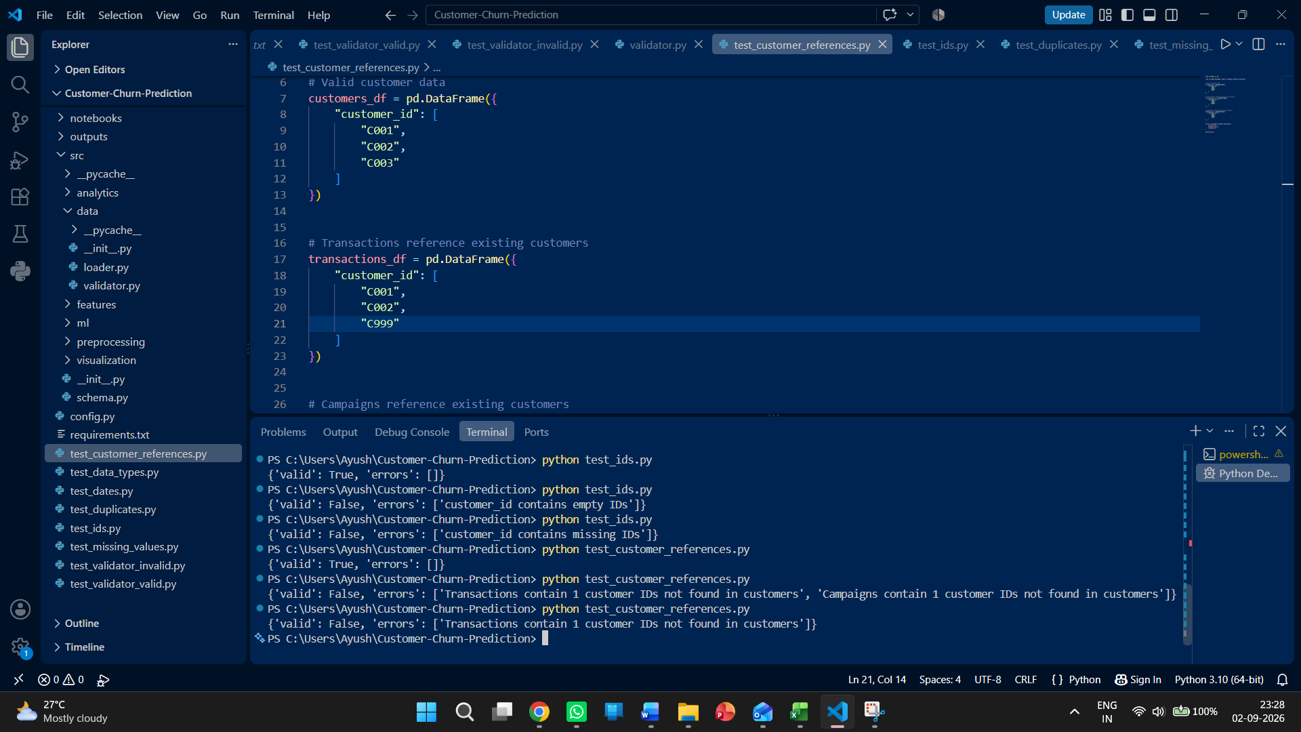
Figure 10. Cross-file reference validation: a transaction customer_id not present in customers is detected.

9. Validation Test Results
Validation Layer | Valid Case | Invalid Case | Status
Schema / columns | Accepted | Missing/extra columns reported | PASS
Data types | Accepted | bill_amount non-numeric reported | PASS
Dates | Accepted | Invalid transaction date reported | PASS
Missing values | Accepted | city missing value reported | PASS
Duplicates | Accepted | 1 duplicate customer_id reported | PASS
IDs | Accepted | Empty/None IDs reported | PASS
Cross-file references | Accepted | Unknown transaction customer_id reported | PASS

10. Current Implementation Notes / Limitations
- The current validator.py focuses on the content-level checks shown above. File-size and upload-rate/resource limits belong in the upload layer rather than inside these DataFrame validation functions.
- validate_dates() follows the project's campaign-date rules: redemption_date may be blank for non-redeemed campaigns, but redeemed campaigns require a valid redemption date, and a redemption date cannot occur before the campaign date.
- The numeric checks use pandas dtype detection. If a CSV contains numeric values stored as text, the file may be rejected rather than automatically converted. This is intentional at the current validation stage.
- validate_duplicates() checks the specified ID column for duplicates. Whether duplicate transaction or campaign IDs are acceptable should remain aligned with the project's data rules.
- The cross-file reference function assumes customers_df, transactions_df and campaigns_df have already passed their individual schema/ID checks.

11. Validation Pipeline Integration
The validator functions were combined into the upload-validation pipeline. The integrated flow performs resource checks, fixed-schema validation, data-quality checks, and cross-file customer-reference validation before validated data proceeds to preprocessing, feature engineering, analytics and machine-learning operations.
Upload
↓
File size / resource limit
↓
CSV read
↓
Schema validation
↓
Data validation
↓
Cross-file validation
↓
QC result
├── Fail → show errors / reject
└── Pass → preprocessing → feature engineering → analytics / ML

12. Extended Upload Validation and Resource Protection
The validator has now been extended beyond DataFrame-level quality checks to include the controls required for user-provided CSV uploads. The application still uses fixed, predefined schemas: uploaded files must match the required column structure exactly. The new upload layer adds file-size, row-count and file-count protection before the data is allowed to proceed through the validation pipeline.

12.1 Upload and Resource Limits
The following limits have been implemented in config.py to prevent excessively large uploads from consuming excessive memory or processing resources:
Control | Configured Limit | Purpose
Maximum file size | 50 MB per file | Reject oversized CSV files before processing.
Maximum rows | 500,000 rows per file | Prevent very large datasets from overloading processing.
Maximum files | 4 files per upload | Limit the number of simultaneous uploaded datasets.

12.2 Resource-Limit Configuration
from pathlib import Path
BASE_DIR = Path(__file__).resolve().parent
TRAINING_DATA_DIR = BASE_DIR / "data" / "training"
UPLOAD_DATA_DIR = BASE_DIR / "data" / "uploads"
MODEL_DIR = BASE_DIR / "models"
OUTPUT_DIR = BASE_DIR / "outputs"
MAX_FILE_SIZE_MB = 50
MAX_FILE_SIZE_BYTES = MAX_FILE_SIZE_MB * 1024 * 1024
MAX_ROWS = 500_000
MAX_FILES = 4

12.3 Upload Validation Pipeline
A combined validate_uploaded_datasets() function has been added to validate the three raw datasets together. It performs individual dataset validation and then checks cross-file customer references. A valid upload returns {'valid': True, 'errors': []}; an invalid upload returns structured dataset-specific errors and prevents the data from continuing to downstream processing.
Upload files
↓
File size limit
↓
Row-count limit
↓
File-count limit
↓
Fixed schema / column validation
↓
Data-type validation
↓
Date validation
↓
Missing-value validation
↓
Duplicate-ID validation
↓
ID validation
↓
Cross-file customer-reference validation
↓
Accept / Reject
↓
Validated data → preprocessing → feature engineering → analytics / ML

12.4 New Upload-Level Tests
Test File | Purpose | Observed Result
test_upload_limits.py | Tests maximum file size and maximum row count. | Valid size/row count passes; oversized file and 500,001-row file are rejected.
test_file_count.py | Tests maximum number of uploaded files. | 4 files pass; 5 files are rejected.
test_upload_validation.py | Tests the complete multi-file upload validation. | Valid Customers, Transactions and Campaigns upload passes.
test_upload_validation_invalid.py | Tests invalid cross-file references during upload. | Transaction customer_id C999 is detected as not present in customers.

12.5 Test Evidence – Upload and Resource Protection
The following VS Code screenshots were captured during implementation and provide evidence that the newly added upload controls execute correctly.
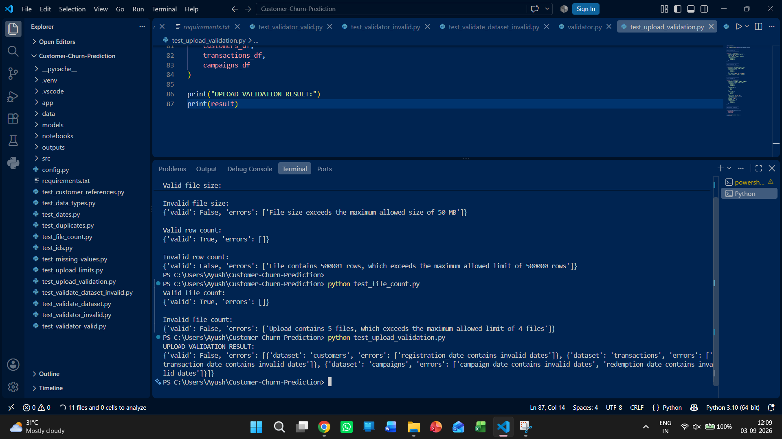
Figure 11. Upload resource-limit and file-count tests: the 50 MB file-size limit, 500,000-row limit, and four-file limit are enforced. The same terminal also shows the invalid upload validation result.
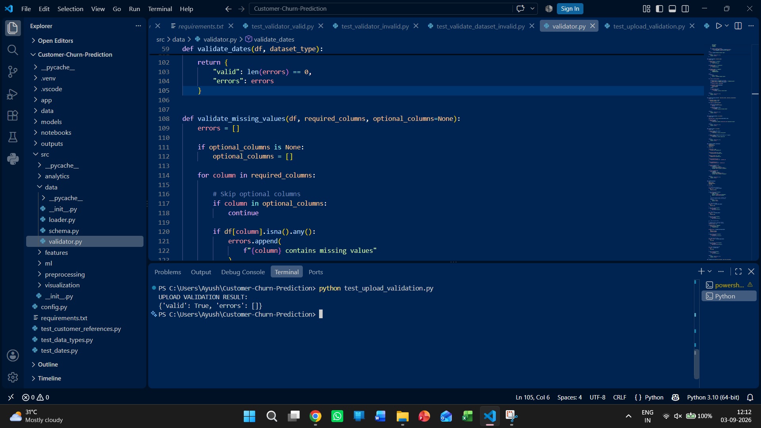
Figure 12. Complete upload validation: the combined upload-validation test returns valid=True with no errors for the valid Customers, Transactions and Campaigns data.
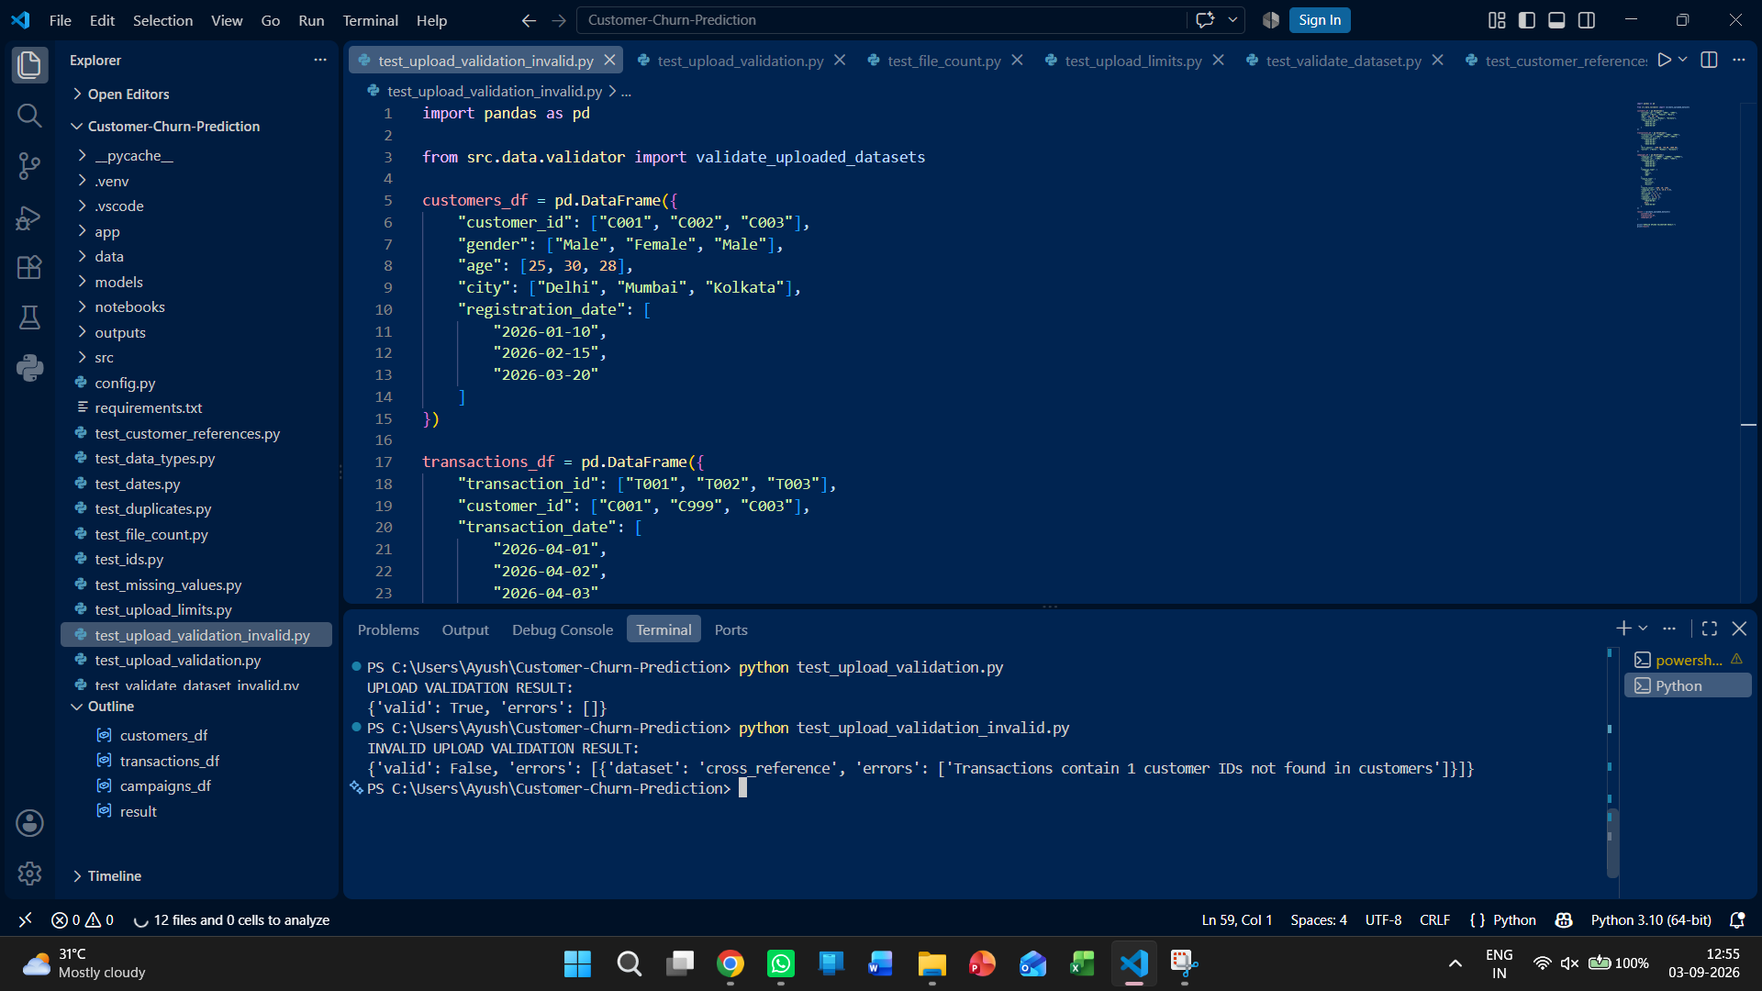
Figure 13. Invalid complete upload validation: the test deliberately includes customer_id C999 in Transactions, and the validator correctly reports that one transaction customer ID is not present in the Customers dataset.

12.6 Updated Validation Test Results
Validation Layer | Valid Case | Invalid Case | Status
Schema / columns | Accepted | Missing/extra columns reported | PASS
Data types | Accepted | Non-numeric bill_amount reported | PASS
Dates | Accepted | Invalid transaction date reported | PASS
Missing values | Accepted | Missing city reported | PASS
Duplicates | Accepted | Duplicate customer_id reported | PASS
IDs | Accepted | Empty/None IDs reported | PASS
Cross-file references | Accepted | Unknown transaction customer_id reported | PASS
File size | Within 50 MB | File above 50 MB rejected | PASS
Row count | Within 500,000 rows | 500,001 rows rejected | PASS
File count | 4 files accepted | 5 files rejected | PASS
Combined upload validation | All datasets accepted | Dataset-specific/cross-file error reported | PASS

12.7 Current Implementation Status
The validator and upload-validation layer are established and tested. The implementation covers fixed-schema enforcement, content validation, cross-file integrity, upload resource protection, and the integrated upload-validation workflow.
Important distinction: the current protection is a file/resource limit mechanism (maximum file size, maximum rows and maximum files). It is not a request-frequency rate limiter. If request-frequency throttling is required later, it should be implemented at the application/web layer separately.

13. Preprocessing Module
After validation, the project now includes a preprocessing layer that prepares validated CSV data for feature engineering, analytics and machine-learning operations. The preprocessing module is implemented under src/preprocessing/preprocessing.py.

13.1 Implemented Preprocessing Functions
clean_column_names() — Removes unnecessary whitespace and standardizes column names to lowercase, producing consistent internal names such as customer_id, bill_amount and transaction_date.
convert_dates() — Converts specified date columns from object/string values to pandas datetime64[ns]. Unparseable values become NaT for subsequent quality handling.
convert_numeric_columns() — Converts specified numeric fields to numeric dtype. Values that cannot be converted become NaN and can be identified by missing-value checks.
check_missing_values() — Reports the number of missing values in each column for data-quality inspection.
remove_empty_rows() — Removes rows that are completely empty while preserving rows containing meaningful data.

13.2 Preprocessing Flow
Validated data
↓
Clean column names
↓
Convert date columns
↓
Convert numeric columns
↓
Check missing values
↓
Remove completely empty rows
↓
Preprocessed data
↓
Feature engineering / analytics / ML

13.3 Separation of Validation and Preprocessing
Validation determines whether an uploaded dataset is acceptable for the project. Preprocessing then standardizes accepted data into consistent formats for downstream processing. Keeping these responsibilities separate makes the pipeline easier to test and reduces the risk of invalid data entering feature engineering or machine learning.

14. Preprocessing Test Evidence
The preprocessing functions were tested independently and then tested together using controlled sample data. The evidence below records the successful outputs observed during development.
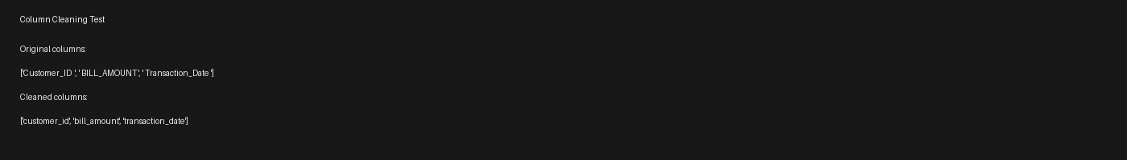
Figure 14. Column cleaning test: whitespace and mixed-case column names are standardized to lowercase internal names.
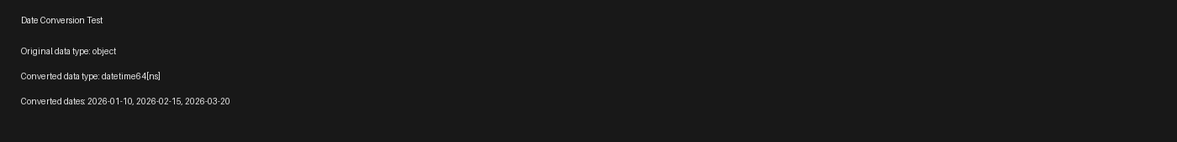
Figure 15. Date conversion test: registration_date is converted from object to datetime64[ns].
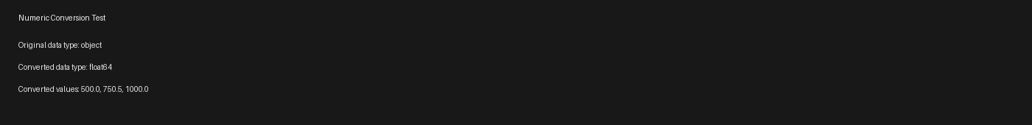
Figure 16. Numeric conversion test: bill_amount is converted from object/string values to float64.
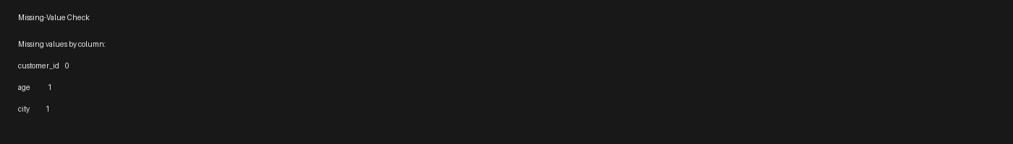
Figure 17. Missing-value check: one missing age value and one missing city value are detected.
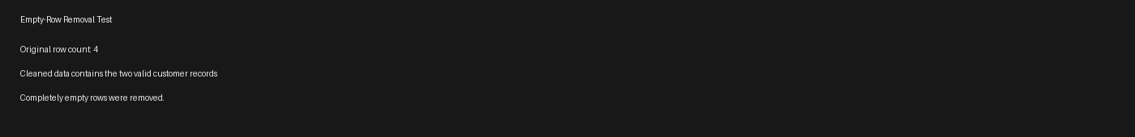
Figure 18. Empty-row removal test: completely empty rows are removed while valid records remain.

15. Full Preprocessing Test
A combined preprocessing test was executed to verify that the individual operations work together in the expected sequence. The sample included an empty row, an invalid numeric value and an invalid date so that the intermediate states could be inspected.
Raw data
↓
Column cleaning
↓
Date conversion
↓
Numeric conversion
↓
Missing-value check
↓
Empty-row removal
↓
Preprocessed output
The combined test confirmed that transaction_date becomes datetime64[ns], bill_amount becomes float64, invalid values become NaN/NaT for subsequent quality handling, and completely empty rows are removed.

16. Updated Project Status
Module | Status | Coverage
Project structure | PASS | Folders, virtual environment and configuration established.
Fixed dataset schemas | PASS | Customers, Transactions and Campaigns use predefined columns.
Schema validation | PASS | Missing and unexpected columns are detected.
Data-type validation | PASS | Required numeric fields are checked.
Date validation | PASS | Required date fields are checked for parseability.
Missing-value validation | PASS | Required fields are checked for missing values.
Duplicate-ID validation | PASS | Duplicate identifiers are detected.
ID validation | PASS | Missing and empty IDs are detected.
Cross-file validation | PASS | Transaction/campaign customer IDs are checked against Customers.
Upload resource protection | PASS | 50 MB, 500,000 rows and 4-file limits are enforced.
Combined upload validation | PASS | Valid multi-file uploads pass; invalid references are rejected.
Preprocessing | PASS | Column, date, numeric, missing-value and empty-row handling tested.
Feature engineering | PASS | Customer-level tenure, RFM, campaign engagement and previous-redemption features implemented and tested.
Churn labeling | PASS | 90-day future-purchase churn target implemented and tested.
Model training/evaluation | PASS | Logistic Regression, Decision Tree and Random Forest trained and evaluated; Random Forest selected by ROC-AUC.
Campaign analytics | PASS | Campaign funnel, campaign-type performance and segment-response analytics implemented and tested.

17. Updated End-to-End Development Pipeline
Fixed demo data / user CSV upload
↓
File size / row count / file count protection
↓
Fixed-schema validation
↓
Data-type / date / missing / duplicate / ID checks
↓
Cross-file customer-reference validation
↓
Preprocessing
↓
Feature engineering
↓
90-day churn label / ML dataset
↓
Model training and evaluation
↓
Churn prediction + RFM + campaign analytics
↓
Application / dashboard

18. Important Implementation Note
The upload controls currently implemented are resource-limit controls rather than request-frequency throttling. The implemented limits are maximum file size, maximum rows per file and maximum number of files per upload. True request-frequency rate limiting, if required later, should be implemented separately at the application/web layer.

19. Feature Engineering Module
The feature engineering stage has now been implemented and tested. It converts the validated customer, transaction and campaign datasets into a customer-level feature table suitable for churn analysis and machine-learning operations.

19.1 Implemented Feature Engineering Functions
- calculate_customer_tenure() — Calculates customer tenure in days from registration_date to observation_date.
- calculate_rfm_features() — Calculates recency, frequency, monetary value, average bill and average purchase gap using transactions available on or before the observation date.
- calculate_campaign_features() — Calculates campaigns sent, delivered, clicked, redeemed and the corresponding delivery, click and redemption rates using campaigns available at the observation date.
- calculate_previous_redemptions() — Counts campaigns redeemed before the observation date for each customer.
- build_customer_features() — Merges customer profile, tenure, RFM, campaign engagement and previous-redemption features into one customer-level feature table.

19.2 Leakage Prevention
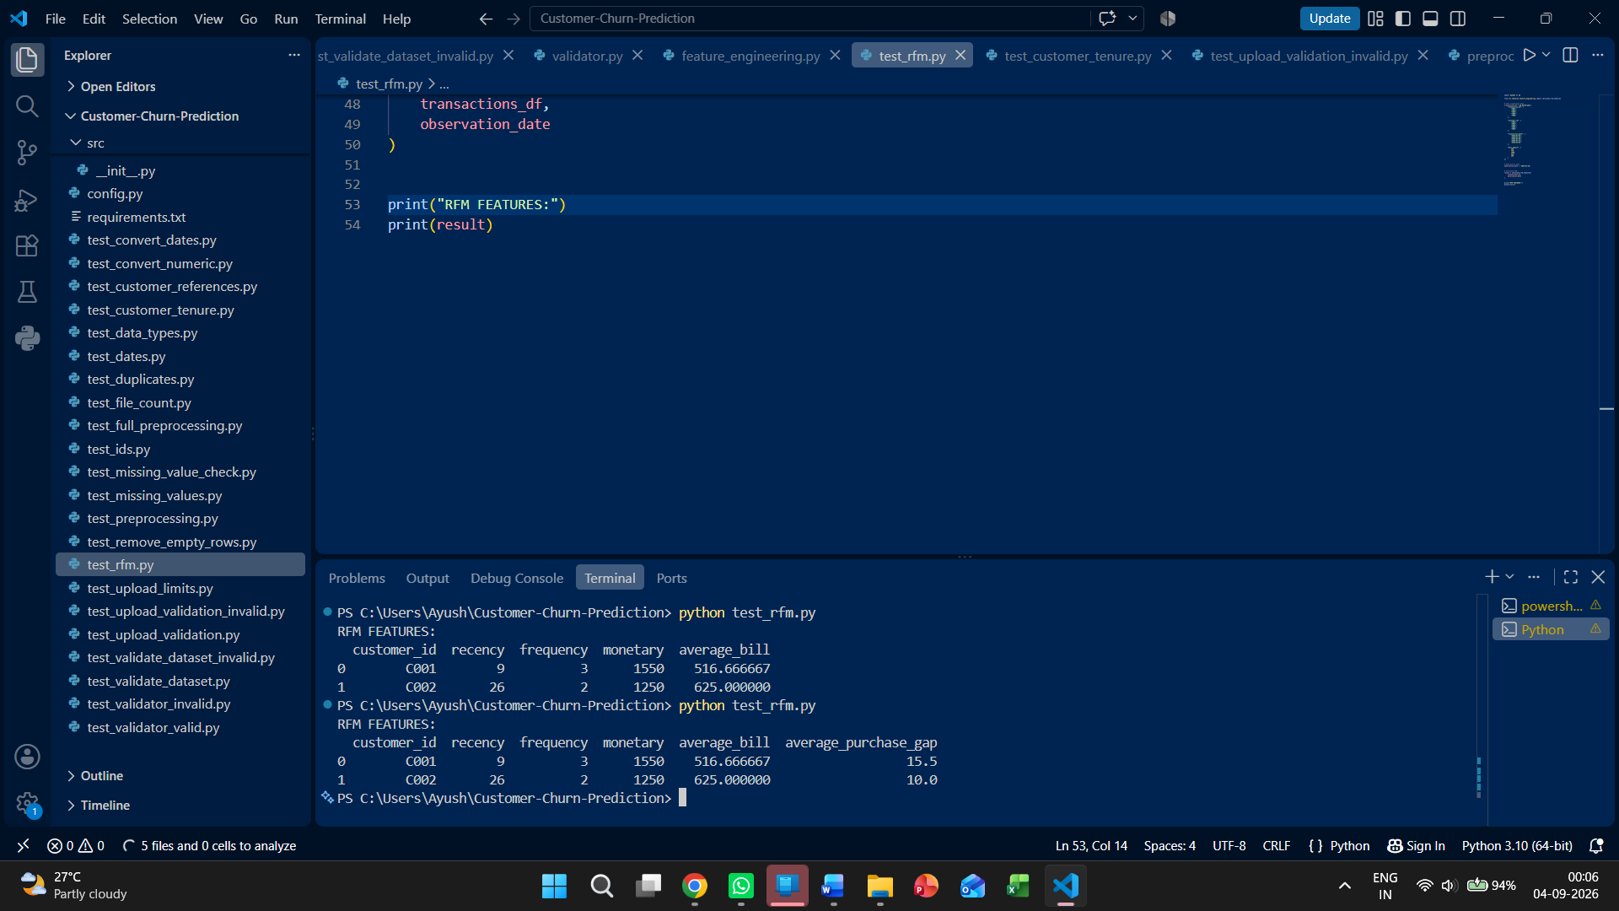
Figure 19.2 — RFM Feature Test: recency, frequency, monetary value, average bill and average purchase gap.
The feature engineering implementation prevents future-data leakage by restricting transaction and campaign records to the observation date. RFM and campaign features therefore use only information that would have been available at the time the customer was observed.

19.3 Feature Engineering Test Evidence
The following figures reproduce the development-test evidence captured in VS Code during implementation.
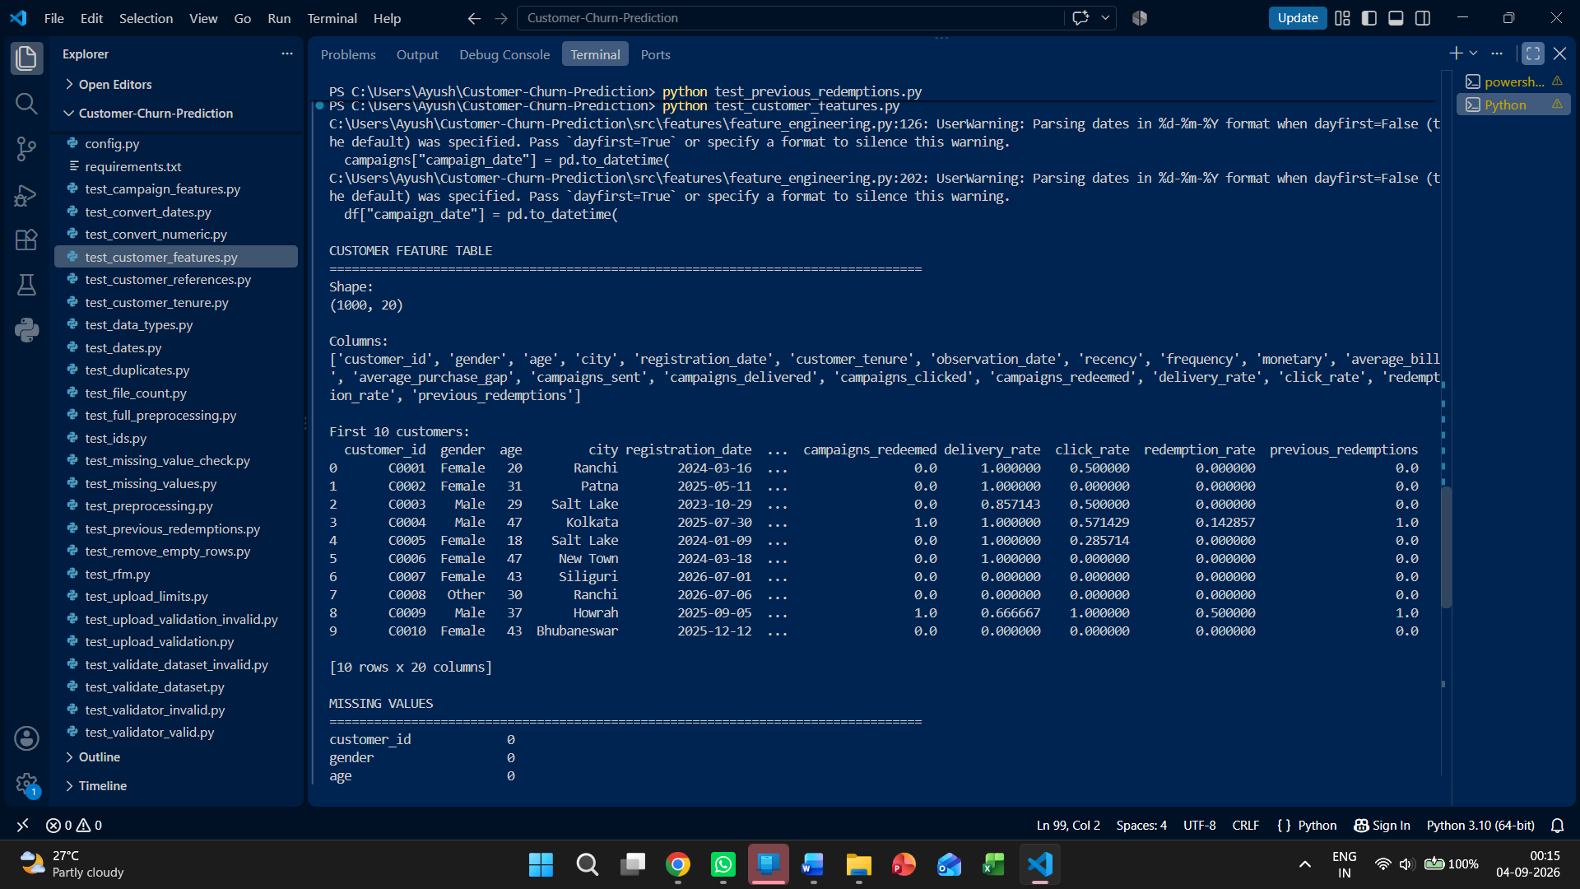
Figure 19.3 — Customer Feature Table Test: generated 1,000 × 20 feature table and feature columns.
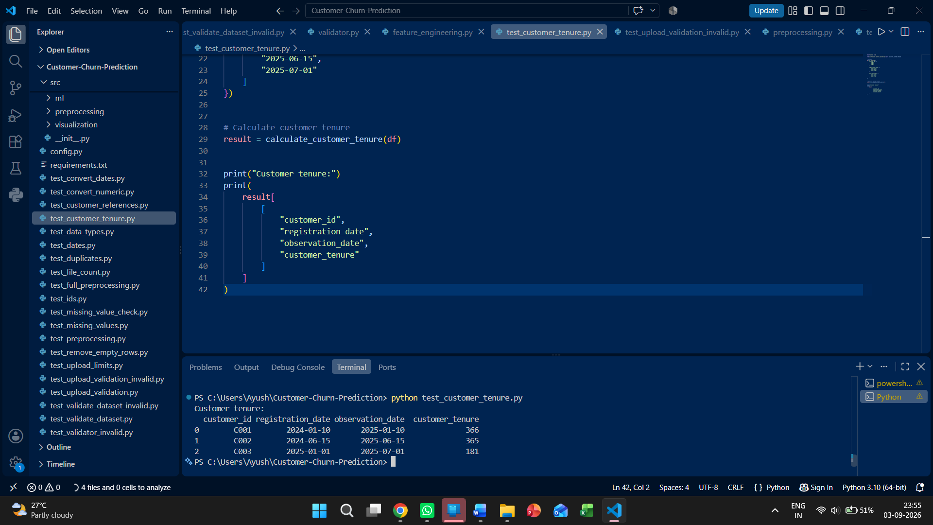
Figure 19.1 — Customer Tenure Test: customer tenure calculated from registration date to observation date.
The customer feature test completed successfully. The generated customer feature table contains 1,000 customer records and 20 columns. The test output reported zero missing values across the generated feature columns, 1,000 customers in both the original customer data and feature table, and zero duplicate customer IDs.
The generated feature set includes customer profile fields, customer_tenure, observation_date, recency, frequency, monetary, average_bill, average_purchase_gap, campaign engagement metrics, campaign rates and previous_redemptions.

20. Churn Labeling Module
The churn-labeling stage has now been implemented and tested. The target variable is based on customer purchasing behavior during the 90-day period following the observation date.

20.1 Churn Definition
A customer is labeled as churned when the customer has no purchases during the future 90-day period. Customers with one or more purchases during that period receive a non-churn label.

20.2 Churn Label Test Evidence
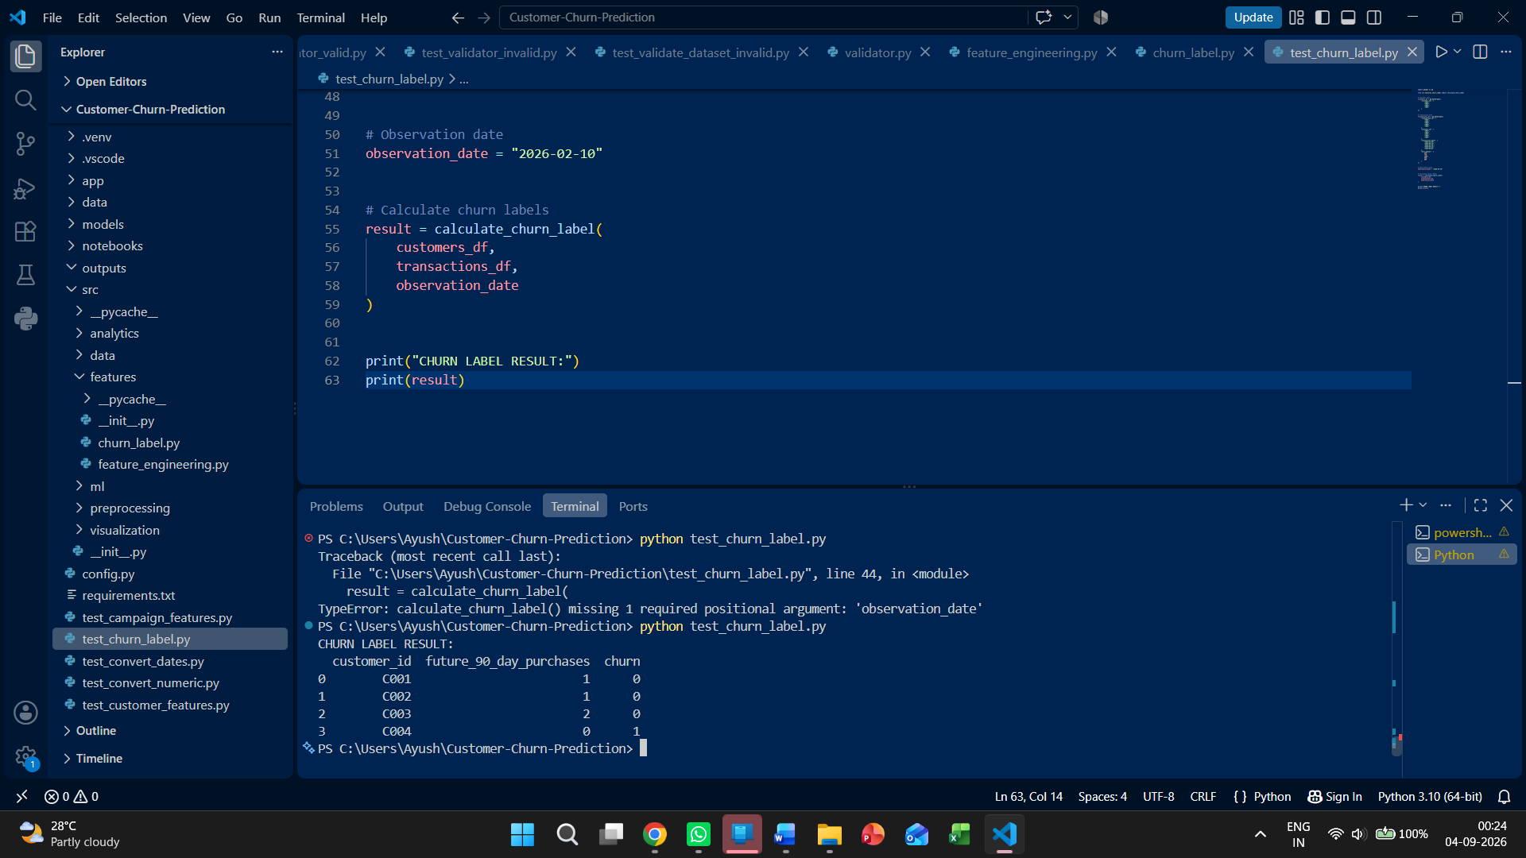
Figure 20.1 — 90-Day Churn Label Test: future purchases and resulting churn labels.
The churn-label test was executed successfully. The test output demonstrated that customers with future purchases receive churn = 0, while a customer with zero future purchases receives churn = 1. The observed test output included C001, C002 and C003 with future purchases and churn = 0, and C004 with zero future purchases and churn = 1.

20.3 ML Dataset Preparation
The churn label was combined with the engineered customer feature observations to create the supervised machine-learning dataset used for model training and evaluation. The prepared dataset contains 5,015 observations.

21. Updated End-to-End Development Status
The project has progressed beyond validation and preprocessing. The current implemented pipeline now covers validation, upload resource protection, preprocessing, customer-level feature engineering, 90-day churn labeling, model training and model evaluation.
Module | Status | Current Evidence
Upload/resource protection | PASS | 50 MB, 500,000 rows and 4-file limits documented and tested.
Fixed-schema validation | PASS | Missing/unexpected columns are detected.
Data validation | PASS | Types, dates, missing values, duplicates, IDs and references tested.
Preprocessing | PASS | Column, date, numeric, missing-value and empty-row handling tested.
Feature engineering | PASS | 1,000 × 20 customer feature table generated; no missing values or duplicate customer IDs.
Churn labeling | PASS | 90-day future-purchase churn target tested successfully.
Model training/evaluation | PASS | Logistic Regression, Decision Tree and Random Forest trained and evaluated; Random Forest selected as best model by ROC-AUC.
Campaign analytics | PASS | Campaign funnel, campaign-type performance and segment-response analytics implemented and tested.

22. Current End-to-End Pipeline
Fixed demo data / user CSV upload
↓
File size / row count / file count protection
↓
Fixed-schema validation
↓
Data-type / date / missing / duplicate / ID checks
↓
Cross-file customer-reference validation
↓
Preprocessing
↓
Feature engineering
↓
90-day churn labeling / ML dataset
↓
Model training and evaluation
↓
Churn prediction + RFM + campaign analytics
↓
Application / dashboard

23. Updated Implementation Note
The project documentation previously focused primarily on the validator. The implementation has now expanded to include preprocessing, feature engineering, churn labeling, model training and model evaluation. Accordingly, this document is maintained as the broader System Documentation.
The upload controls remain resource-limit controls rather than request-frequency throttling. The implemented controls are maximum file size, maximum rows per file and maximum number of files per upload. True request-frequency rate limiting, if required, should be implemented separately at the application/web layer.

24. Model Training and Evaluation
The supervised machine-learning stage has now been implemented and tested. The prepared dataset contains 5,015 customer-level observations. The data was split using an 80/20 train-test split with stratification to preserve the churn-class distribution.

24.1 Models Trained
- Logistic Regression
- Decision Tree
- Random Forest
The models were trained with class balancing enabled. The Random Forest used 200 trees and parallel processing.

24.2 Training Test Evidence
The model-training test completed successfully. The output reported 4,012 training records and 1,003 testing records, and confirmed that all three models were trained.

24.3 Model Evaluation Results
Model | Accuracy | Precision | Recall | F1 Score | ROC-AUC
Logistic Regression | 0.7787 | 0.4251 | 0.6816 | 0.5236 | 0.8172
Decision Tree | 0.8355 | 0.5372 | 0.5642 | 0.5504 | 0.7293
Random Forest | 0.8933 | 0.8600 | 0.4804 | 0.6165 | 0.8639
Random Forest achieved the highest ROC-AUC (0.8639) and was therefore selected as the best model using ROC-AUC as the model-selection criterion. It also achieved the highest accuracy and precision among the three tested models. Logistic Regression produced the highest recall, while Decision Tree produced the lowest ROC-AUC.

24.4 Confusion Matrices
Model | True Negatives / False Positives | False Negatives / True Positives
Logistic Regression | 659 / 165 | 57 / 122
Decision Tree | 737 / 87 | 78 / 101
Random Forest | 810 / 14 | 93 / 86

24.5 Evaluation Test Evidence
The evaluation test was executed with pytest and completed successfully with 1 passed test. The VS Code terminal evidence below shows the metrics for all three models, their confusion matrices, and the final selection of Random Forest as the best model by ROC-AUC.
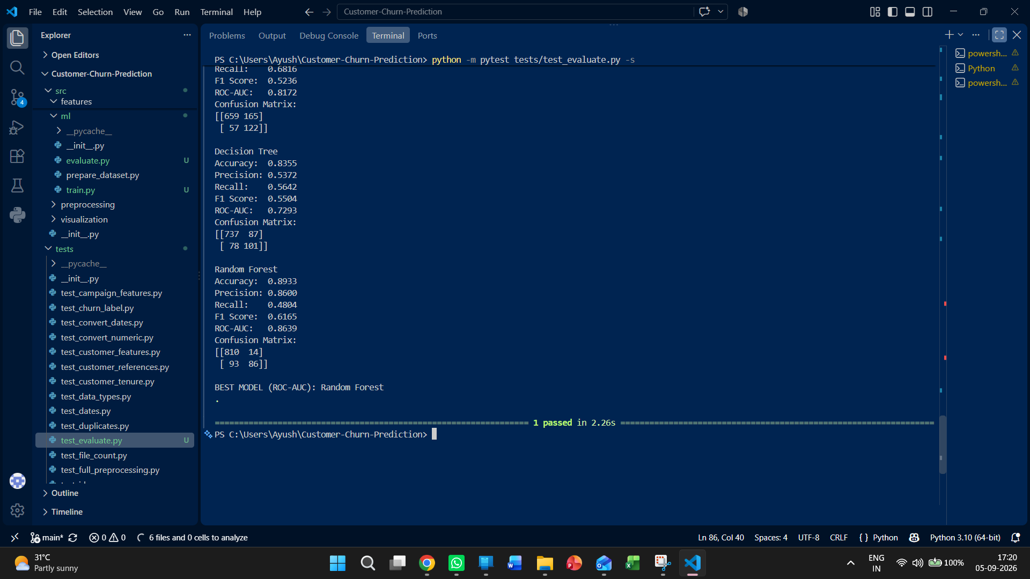
Figure 24.1. Model evaluation test evidence from VS Code: Logistic Regression, Decision Tree and Random Forest metrics, confusion matrices, and Random Forest selected as the best model by ROC-AUC.

24.6 Current ML Status
Model training, evaluation, persistence, prediction generation and risk classification have been implemented and tested. The trained models are saved for reuse, customer-level predictions include churn probability and risk level, and the Random Forest model is selected as the current selected prediction model based on ROC-AUC.

25. Model Persistence, Prediction and Risk Classification
The machine-learning stage was extended from training and evaluation to reusable model persistence, customer-level prediction and churn-risk classification. The trained Logistic Regression, Decision Tree and Random Forest models are saved with Joblib, with Random Forest used as the current prediction model.

25.1 Model Persistence
- Logistic Regression model saved to models/logistic_regression.joblib.
- Decision Tree model saved to models/decision_tree.joblib.
- Random Forest model saved to models/random_forest.joblib.
- Model loading and prediction were verified through automated tests.

25.2 Customer Prediction Output
The customer prediction module prepares the ML features, loads the saved model, generates binary churn predictions and churn probabilities, and attaches a risk level derived from predicted churn probability.
Output Field | Purpose
customer_id | Customer identifier preserved from the input observations.
churn_prediction | Binary churn prediction generated by the selected model.
churn_probability | Predicted probability of churn.
risk_level | Business-facing risk category derived from predicted churn probability.

25.3 Risk Classification
- Low risk: churn probability below 0.25.
- Medium risk: churn probability from 0.25 to below 0.50.
- High risk: churn probability from 0.50 to below 0.75.
- Very High risk: churn probability at or above 0.75.
- Churn prediction remains a separate binary output (0/1). Risk level is assigned independently from predicted churn probability using Low, Medium, High and Very High categories; there is no separate 'Churned' risk category in the current implementation.

25.4 Test Evidence
The model-persistence test successfully saved, loaded and used a Random Forest model for predictions. The prediction module test produced 5,015 customer-level predictions and probabilities, while the risk classification tests passed for the defined risk categories.

26. Campaign Analytics
Campaign analytics has been implemented to evaluate the campaign funnel and compare campaign performance. The analysis covers sent, delivered, clicked and redeemed counts together with delivery, click and redemption rates.

26.1 Overall Campaign Funnel
Metric | Value
Sent | 8,000
Delivered | 7,311
Clicked | 2,236
Redeemed | 701
Delivery Rate | 91.39%
Click Rate | 30.58%
Redemption Rate | 9.59%

26.2 Campaign Performance by Type
Campaign Type | Sent | Delivered | Clicked | Delivery Rate | Click Rate | Redemption Rate
Birthday | 1,376 | 1,252 | 396 | 90.99% | 31.63% | 11.2%
Discount | 1,277 | 1,169 | 384 | 91.54% | 32.85% | 12.8%
Festival | 1,334 | 1,205 | 364 | 90.33% | 30.21% | 9.1%
Loyalty | 1,313 | 1,217 | 333 | 92.69% | 27.36% | 8.4%
New Product | 1,366 | 1,259 | 331 | 92.17% | 26.29% | 6.2%
Win-back | 1,334 | 1,209 | 428 | 90.63% | 35.40% | 9.7%
The campaign analytics module is covered by automated tests and uses the funnel definitions implemented in the project.

27. Customer Segmentation
RFM-based customer segmentation has been implemented using recency, frequency and monetary value. Each observation receives RFM scores and one of seven defined customer segments.

27.1 Segment Definitions
Segment | Description
Champions | High-value customers with strong recent activity.
Loyal Customers | Consistent customers with strong purchase frequency.
Potential Loyalists | Recently active customers with developing loyalty.
Regular Customers | Middle-range customers with typical purchase behavior.
At Risk | Customers with increased purchase recency indicating possible disengagement.
Inactive | Customers with substantially delayed recent activity.
Lost | Customers with very high recency and minimal recent activity.

27.2 RFM Score Calculation
- Recency is scored inversely so more recent purchases receive higher scores.
- Frequency is scored so more frequent purchases receive higher scores.
- Monetary value is scored so higher spending receives higher scores.
- The total RFM score is the sum of the three component scores.

27.3 Actual Segment Distribution
Segment | Customer Observations | Percentage
Champions | 914 | 18.23%
Loyal Customers | 613 | 12.22%
Potential Loyalists | 785 | 15.65%
Regular Customers | 1,792 | 35.73%
At Risk | 376 | 7.50%
Inactive | 353 | 7.04%
Lost | 182 | 3.63%
Total | 5,015 | 100.00%
The actual-data segmentation run covered all 5,015 observations. Regular Customers formed the largest segment, while Lost was the smallest segment.
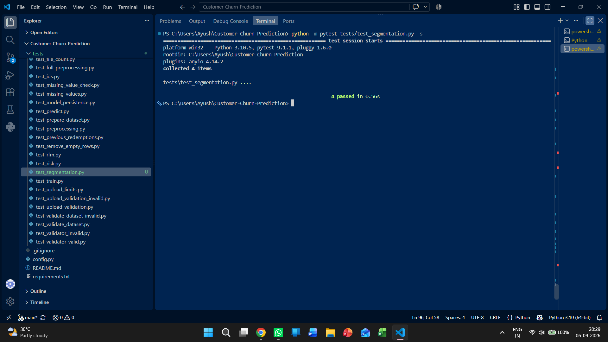
Figure 27.1. Customer segmentation test evidence: all four segmentation tests passed.

28. Customer Analytics Integration
A combined customer analytics module was added to connect RFM segmentation with churn prediction and risk classification. Because the prepared ML dataset contains multiple observations for the same customer, the integration uses a unique observation identifier to align segmentation and prediction results without relying on customer_id uniqueness.

28.1 Combined Customer-Level Output
Field Group | Included Fields
Customer / RFM | customer_id, recency, frequency, monetary, recency_score, frequency_score, monetary_score, rfm_score
Segmentation | customer_segment
Prediction | churn_prediction, churn_probability
Risk | risk_level
Observation | observation_date
Campaign engagement | campaigns_received, campaigns_sent, campaigns_delivered, campaign_clicks, previous_redemptions, delivery_rate, click_rate, redemption_rate

28.2 Integration Test Evidence
The integrated pipeline was tested against the real 5,015-record customer feature dataset. The test confirmed that the result preserves the full observation count, required analytical fields, valid segment labels, valid risk levels and the original customer ID order.
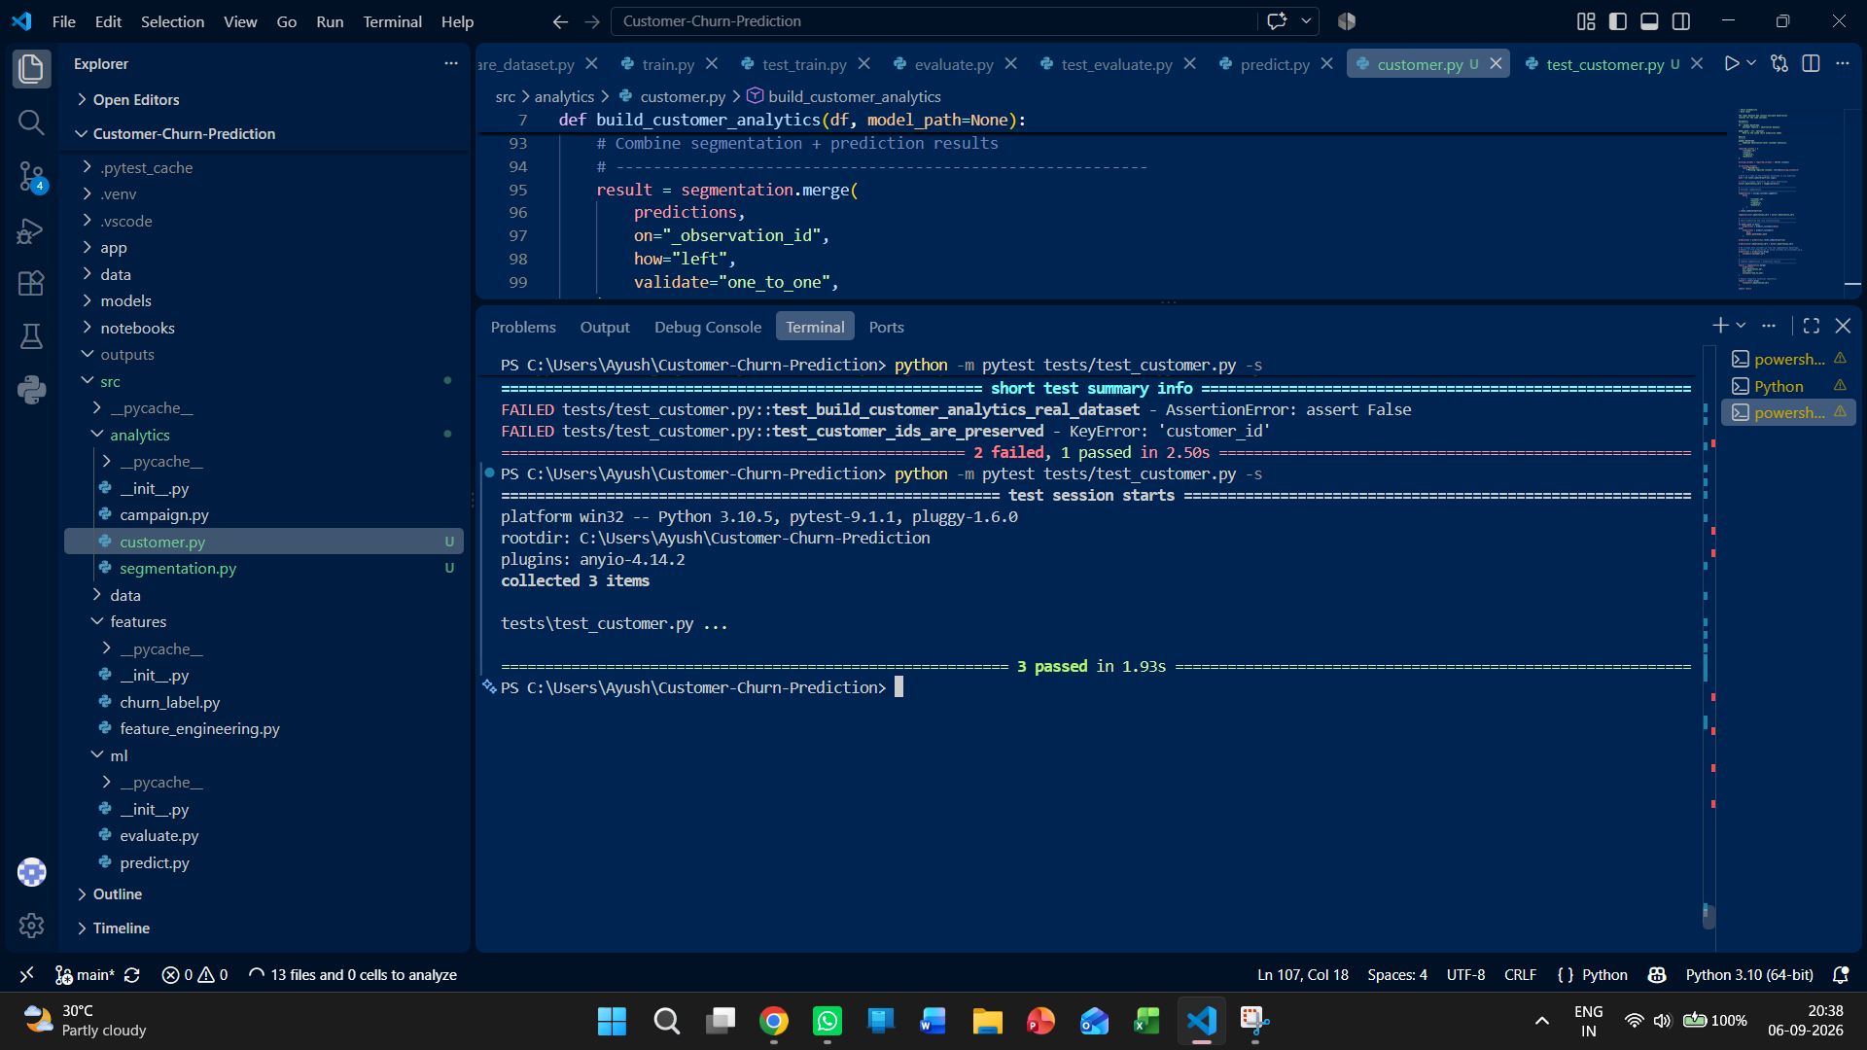
Figure 28.1. Customer analytics integration test evidence: 3 tests passed.

28.3 Segment × Risk Analysis
Customer Segment | Churned Observations | Total Observations | Churned Share
Champions | 46 | 914 | 5.03%
Loyal Customers | 49 | 613 | 7.99%
Potential Loyalists | 61 | 785 | 7.77%
Regular Customers | 177 | 1,792 | 9.88%
At Risk | 107 | 376 | 28.46%
Inactive | 196 | 353 | 55.52%
Lost | 178 | 182 | 97.80%
The segment-risk analysis produced a total of 814 churned observations and demonstrates the relationship between RFM-based customer state and predicted churn outcome.
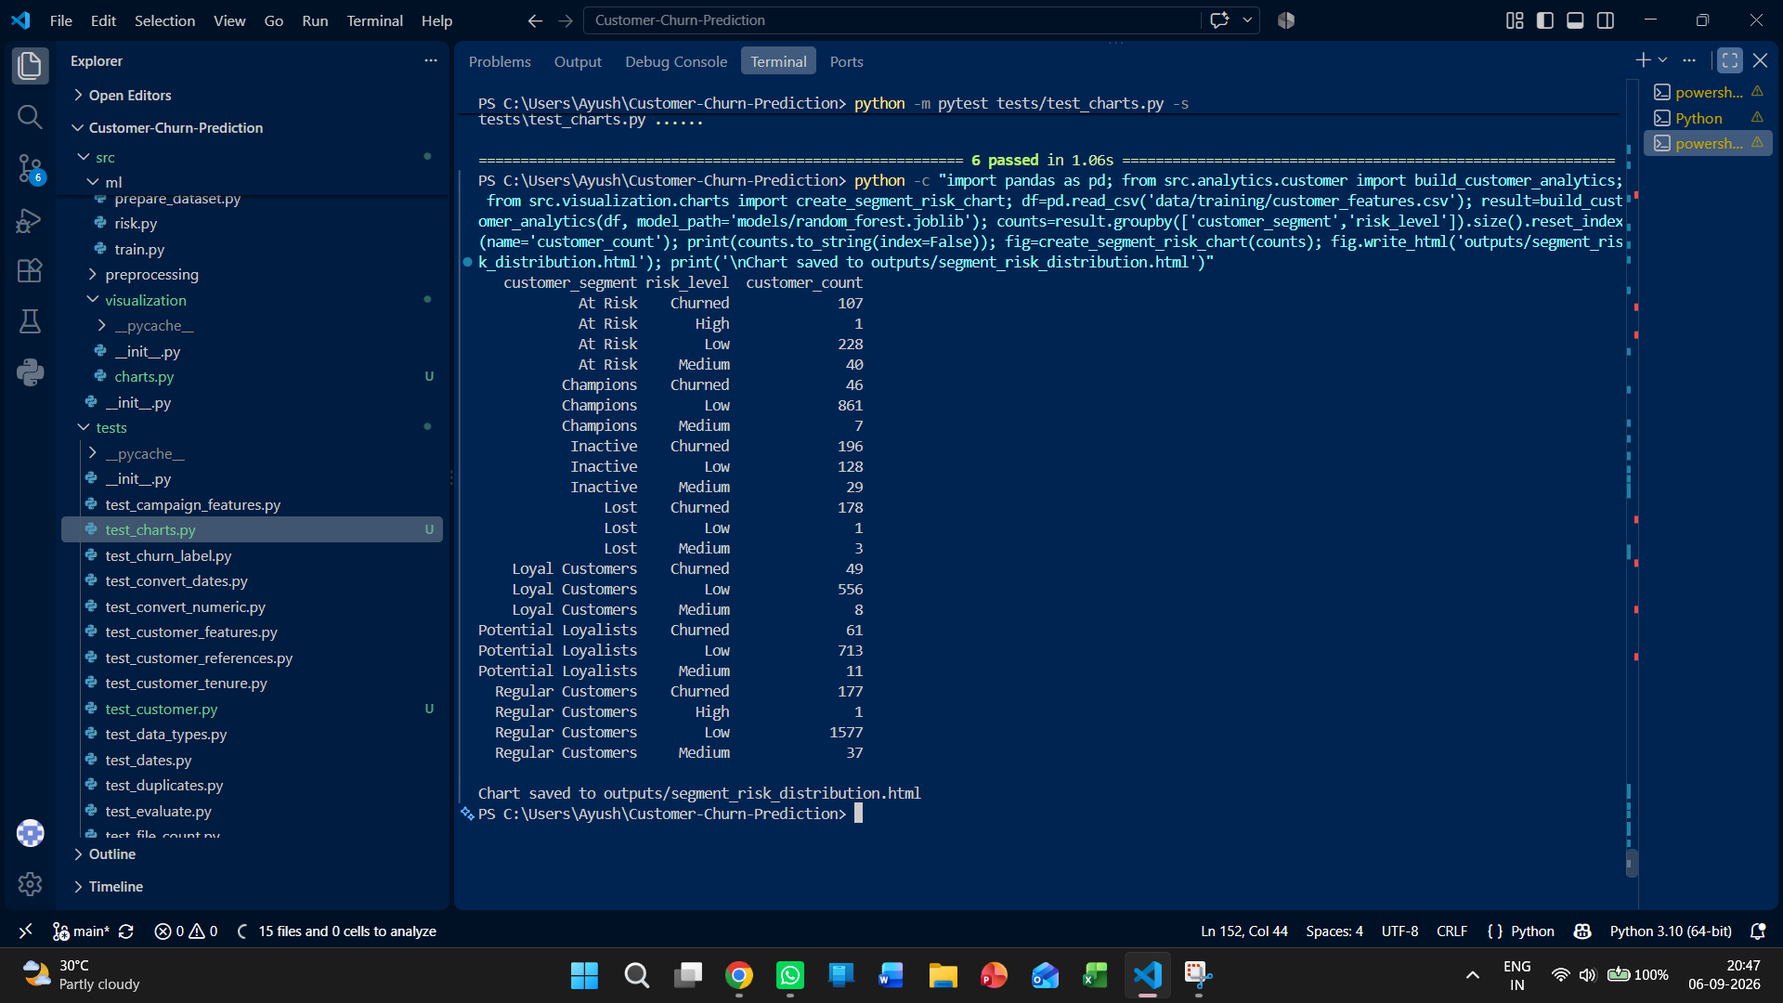
Figure 28.2. Segment × Risk output from the real 5,015-observation dataset.

29. Visualization Layer
A reusable Plotly-based visualization layer has been added under src/visualization/charts.py. The chart functions accept prepared analytics DataFrames so that the same visualization logic can be reused by the application interface.

29.1 Implemented Charts
Chart Function | Purpose
create_segment_distribution_chart() | Customer counts by RFM-based segment.
create_risk_distribution_chart() | Customer counts by churn risk level.
create_segment_risk_chart() | Grouped segment and churn-risk distribution.

29.2 Visualization Testing
The visualization test suite covers valid chart construction and missing-column validation for all three chart functions. The full chart test file completed with 6 passing tests.
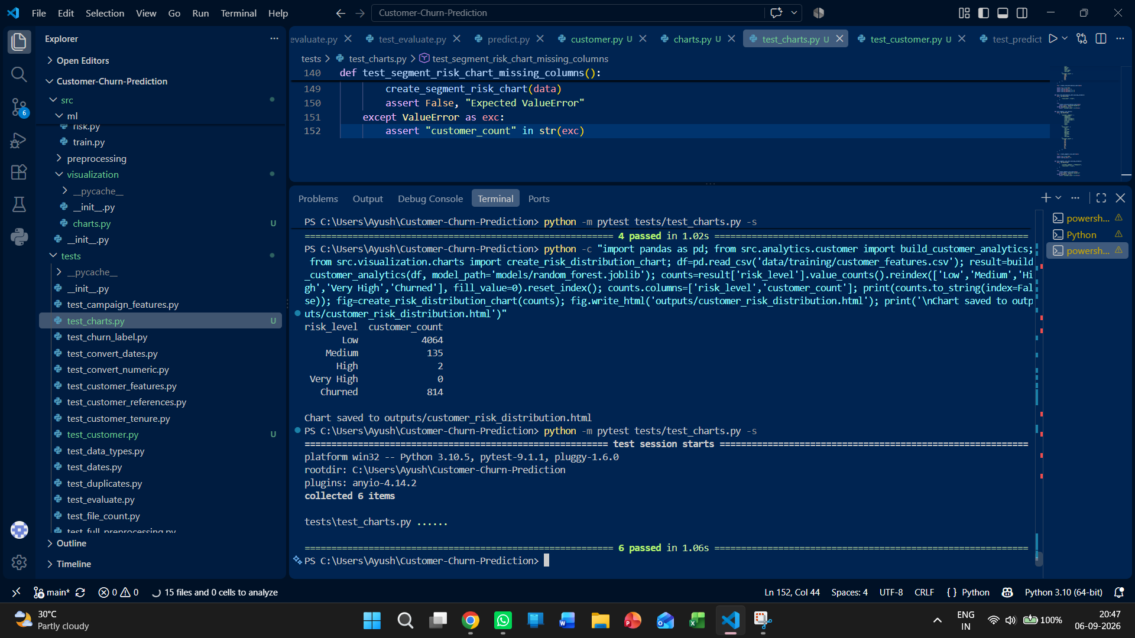
Figure 29.1. Visualization test evidence: all 6 chart tests passed.

29.3 Real-Data Visualization Outputs
- Customer segment distribution chart generated successfully from the 5,015-observation dataset.
- Customer churn-risk distribution chart generated successfully from the Random Forest predictions.
- Segment × Risk chart generated successfully from the combined customer analytics output.
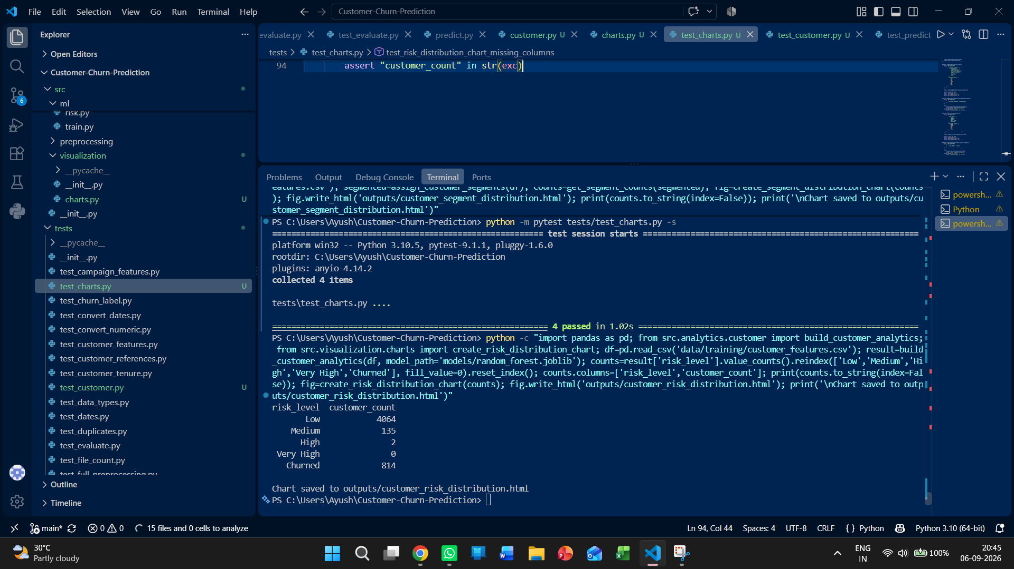
Figure 29.2. Real-data churn-risk distribution generated from the saved Random Forest model.

30. Application Layer: Data Quality, Customer Intelligence and Decision Support
The analytical modules are exposed through a Streamlit application that connects validated data, customer analytics, machine-learning outputs, campaign analytics and reusable visualizations. The application is organized around distinct business questions rather than repeating the same metrics across pages.

30.1 Integrated Streamlit Structure
The main application entry point is app/app.py. The current application structure is organized around the following decision-support views:
- Executive Overview — presents the business footprint and customer-health KPIs, including customers, transactions, campaigns, revenue, churned customers, Very High/High risk counts and average churn probability.
- Customer Intelligence — presents RFM customer segments, churn-risk distribution and Segment × Risk composition.
- Retention & Model Insights — presents retention priority and Random Forest feature importance.
The application acts as the presentation layer over the analytical pipeline. Campaign Performance presents the overall funnel and campaign-type performance; Customer Search provides current customer profiles; Campaign Affinity provides customer-level campaign-response analysis; Data Quality provides operational validation visibility; and Data & Upload provides controlled custom-dataset loading. Reusable visualization functions remain separate from page rendering.

30.2 Data Quality Dashboard
The Data Quality dashboard turns the validator into a user-facing quality-control view. It loads the three raw datasets, executes the existing schema, type, date, missing-value, duplicate, ID and cross-file checks, and presents the results together with dataset size information. For the fixed demo data, the dashboard reports 3 files checked, 39,000 total rows, 19 checks passed and 0 checks failed.
- Overall validity state is shown as DATASET VALID or DATASET REJECTED.
- Dataset Overview reports rows and columns for Customers, Transactions and Campaigns.
- Validation Checks exposes the status of each configured quality check.
- Validation Issues are surfaced directly when a check fails.
30.2.1 Custom Data Upload
The Data & Upload view provides two dataset modes: the fixed demo dataset and a validated custom dataset. Users can download the predefined Customers, Transactions and Campaigns CSV templates, upload the three raw CSV files, validate them against the fixed schemas and resource limits, and activate the custom dataset only when validation succeeds. The page reports the validation result and active dataset size and provides a reset action to return to the demo dataset. Custom uploads are limited to 50 MB per file, 500,000 rows per file and four files at the resource-protection layer.
The validator update is part of the same integration: project dates are parsed using the supported DD-MM-YYYY and YYYY-MM-DD formats; redemption_date is optional for non-redeemed campaigns but required for redeemed campaigns; and redemption_date cannot occur before campaign_date.
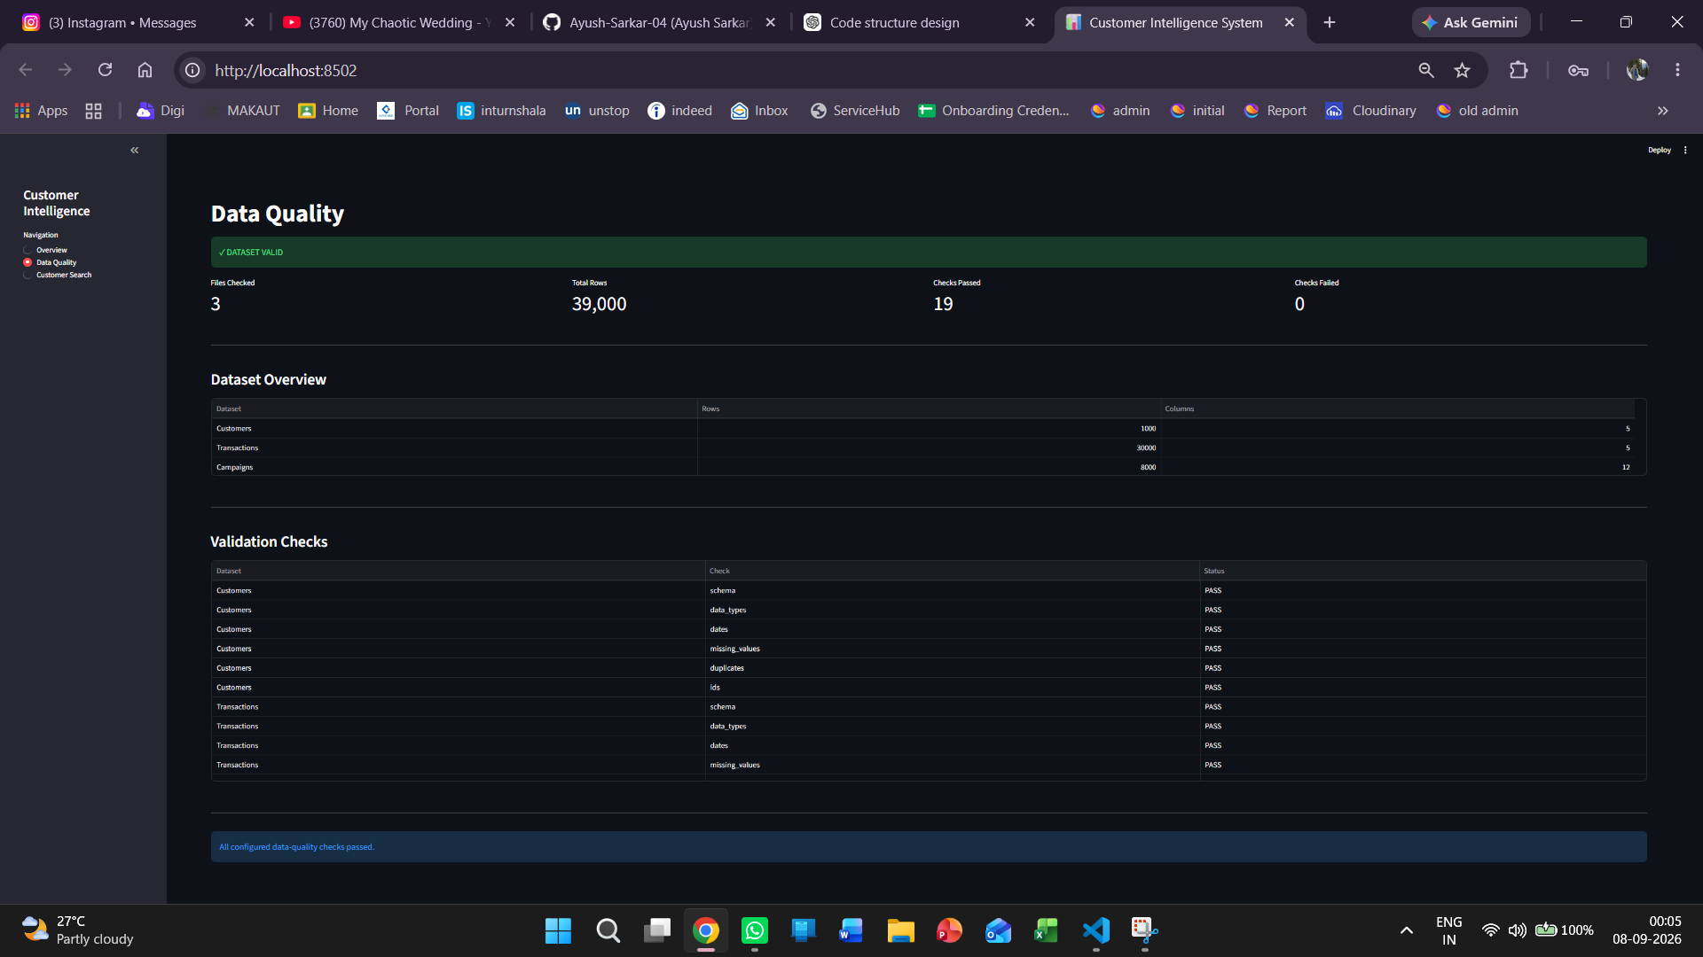
Figure 30.1. Streamlit Data Quality Dashboard showing 3 datasets, 39,000 rows, and 19/19 validation checks passed.

30.3 Customer Search and Customer Explorer
Customer Search extends the combined customer analytics layer into a directly queryable customer-exploration interface. The search functions support both exact and partial customer-ID matching, while the application renders the analytical attributes already produced by the project: recency, frequency, monetary value, RFM score, customer segment, churn probability, risk level, purchase behaviour and campaign engagement.
The prepared customer feature dataset contains 5,015 historical observations across 945 unique customers, with observation dates ranging from 30-06-2024 to 30-06-2026. The Customer Explorer filters the combined analytics to the latest available observation date, 30-06-2026, before search results are displayed. This prevents historical observation rows from appearing as duplicate current customers and produces 945 current customer profiles for exploration.
- Exact customer-ID search opens the complete customer profile immediately.
- Partial customer-ID search returns matching current customer records, one row per current customer.
- Search is case-insensitive and safely handles empty and no-match input.
- The profile combines segmentation, churn prediction, probability-based risk classification, retention-related customer value signals and campaign engagement outputs.
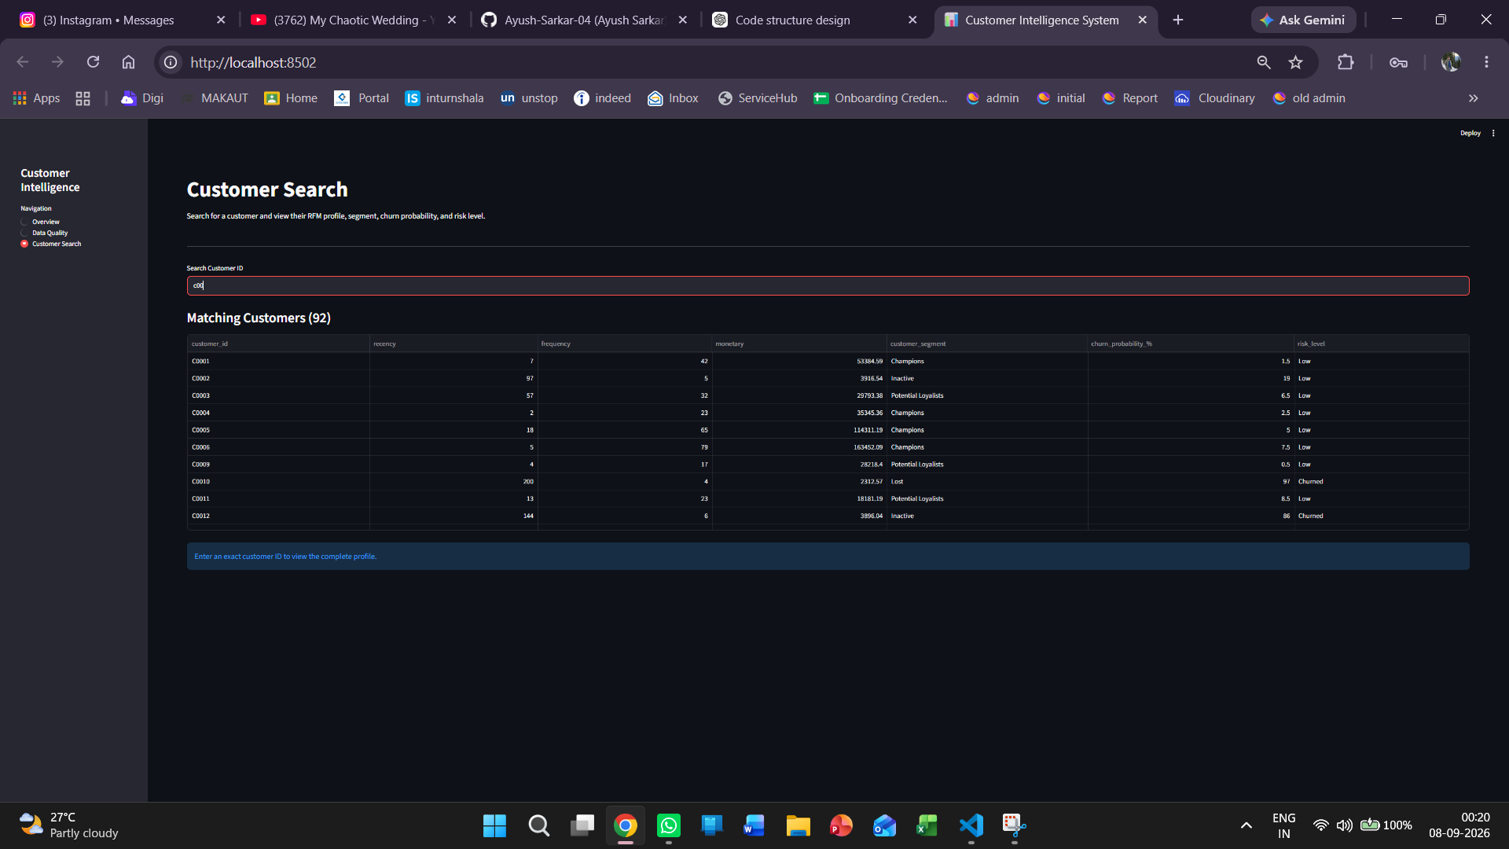
Figure 30.2. Partial Customer Search showing current customer matches after latest-observation filtering.
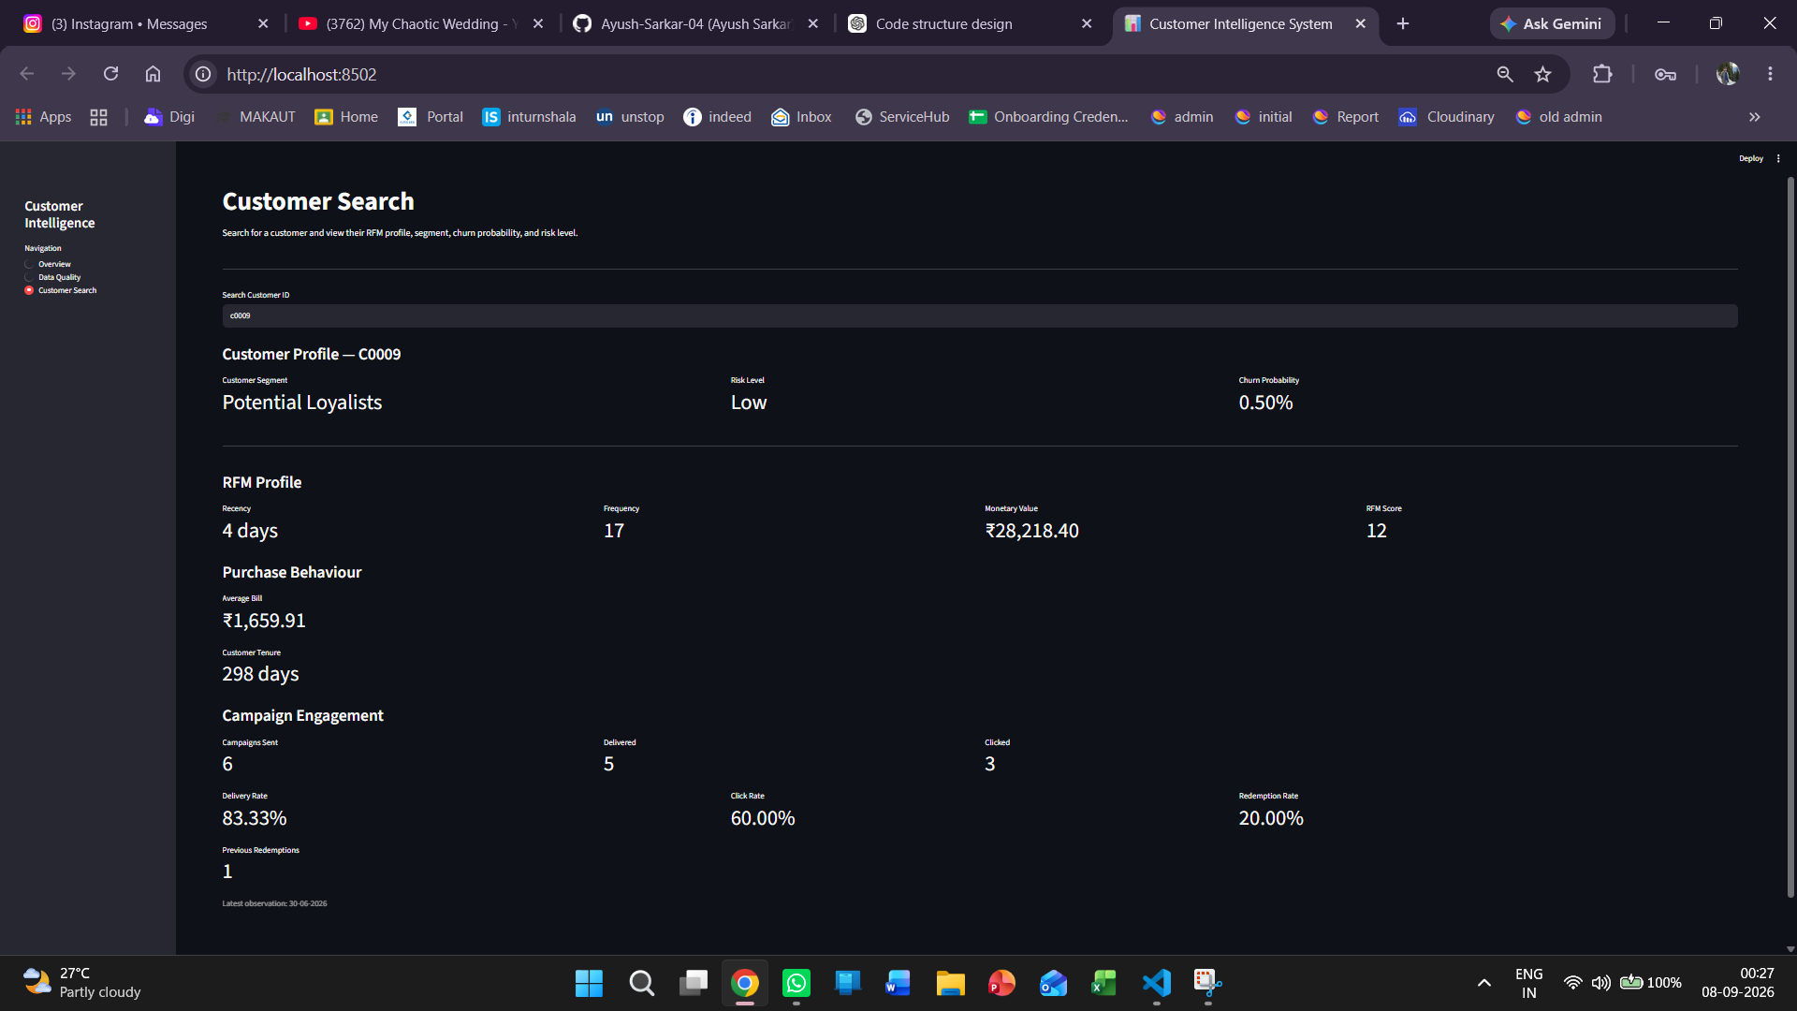
Figure 30.3. Exact Customer Search showing the complete C0009 profile with RFM, churn, risk and campaign metrics.

30.4 Feature-to-Interface Traceability
Analytical Layer | Application View | User-Facing Output
Validation + resource protection | Data Quality | Dataset status, 19 validation checks, row/column counts, issues
RFM feature engineering + segmentation | Customer Search | Recency, frequency, monetary value, RFM score, segment
Churn prediction + risk classification | Customer Search | Churn probability and risk level
Campaign analytics | Customer Search | Campaign sent/delivered/clicked/redeemed counts and rates
Reusable Plotly visualization layer | Analytics/Application layer | Segment, risk and segment × risk visual outputs

30.5 Application Test Evidence
The user-facing features have been validated independently and through focused feature test suites. The current application integrates Executive Overview, Data & Upload, Data Quality, Customer Search, Customer Intelligence, Retention & Model Insights, Campaign Performance and Campaign Affinity. Campaign Affinity has 11 passing focused tests, Feature Importance has 9, and the full automated test suite currently completes with 125 passing tests.
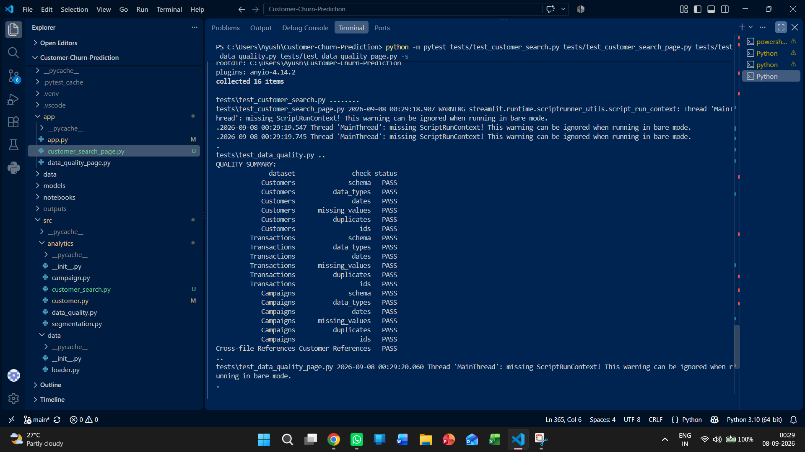
Figure 30.4. VS Code terminal evidence for the combined new-feature test run covering Customer Search and Data Quality components.

31. Integrated Implementation Status
The project status below consolidates the analytical pipeline and the new application layer into a single implementation view. The entries describe implemented and tested functionality only.
Module | Status | Current Evidence
Project structure | PASS | Project folders, environment and configuration established.
Fixed dataset schemas | PASS | Customers, Transactions and Campaigns use predefined columns.
Schema and data validation | PASS | Schema, types, dates, missing values, duplicates, IDs and references tested.
Upload/resource protection | PASS | 50 MB, 500,000-row and 4-file limits tested.
Combined upload validation | PASS | Valid multi-file uploads accepted; invalid references rejected.
Preprocessing | PASS | Column, date, numeric, missing-value and empty-row handling tested.
Feature engineering | PASS | Customer tenure, RFM, campaign engagement and previous-redemption features implemented and tested.
Churn labeling | PASS | 90-day future-purchase churn target implemented and tested.
ML dataset preparation | PASS | 5,015-observation supervised dataset prepared.
Model training/evaluation | PASS | Logistic Regression, Decision Tree and Random Forest trained/evaluated; Random Forest selected by ROC-AUC.
Model persistence | PASS | Three trained models saved and loading verified.
Churn prediction | PASS | 5,015 predictions and churn probabilities generated.
Risk classification | PASS | Low, Medium, High and Very High probability-based risk levels implemented and tested.
Campaign analytics | PASS | Campaign funnel and campaign-type performance implemented and tested.
Customer segmentation | PASS | Seven RFM-based segments implemented and tested on 5,015 observations.
Customer analytics integration | PASS | Segmentation, prediction and risk outputs combined and tested.
Visualization layer | PASS | Three reusable Plotly chart functions implemented and tested.
Streamlit application | PASS | Eight integrated views: Executive Overview, Data & Upload, Data Quality, Customer Search, Customer Intelligence, Retention & Model Insights, Campaign Performance and Campaign Affinity.
Data Quality Dashboard | PASS | 19 quality checks surfaced in a user-facing dashboard; demo data passes all checks.
Customer Explorer | PASS | Exact/partial customer search and latest-observation profile view tested.
Retention priority | PASS | Churn probability and customer value percentile combined into a 0–100 retention priority score; priority bands and expected revenue at risk implemented.
Model feature importance | PASS | Random Forest feature_importances_ exposed as ranked feature contributions; 9 automated tests passed.
Campaign affinity | PASS | Customer × campaign-type delivered/clicked analysis, click-rate logic and Best Campaign Type selection implemented; 11 focused tests passed.

32. End-to-End Implemented Pipeline
The integrated system currently follows this sequence:
Fixed demo data / validated user CSV upload
↓
File size / row count / file count protection
↓
Fixed-schema and data-quality validation
↓
Cross-file customer-reference validation
↓
Preprocessing
↓
Feature engineering
↓
90-day churn labeling / ML dataset preparation
↓
Model training and evaluation
↓
Model persistence
↓
Customer churn prediction and probability generation
↓
Risk classification
↓
RFM customer segmentation
↓
Combined customer analytics
↓
Campaign analytics
↓
Reusable visualization generation
↓
Streamlit application layer
↓
Executive Overview / Customer Intelligence / Retention & Model Insights / Campaign Performance / Data Quality / Customer Search / Campaign Affinity

33. Development Test Evidence Summary
Area | Observed Test Result
Segmentation | 4 passed
Customer analytics integration | 3 passed
Visualization | 6 passed
Model persistence | 1 passed
Prediction module | 3 passed
Risk classification | 2 passed
Campaign analytics | 1 passed
Model training | 1 passed
Model evaluation | 1 passed
Customer Search backend | 8 passed
Customer Search Streamlit page | 3 passed
Data Quality validation | 4 passed
Data Quality Streamlit page | 1 passed
Customer analytics regression after observation_date preservation | 5 passed
Feature importance | 9 passed
Campaign affinity | 11 passed
Retention priority | Implemented; validation coverage maintained
The 13 September 2026 documentation update represents the current portfolio-system checkpoint. The project has progressed from a validation-focused pipeline to an integrated customer intelligence and campaign analytics system. In addition to validation, preprocessing, feature engineering, churn modeling, segmentation, visualization, Data Quality and Customer Search, the current implementation includes controlled custom CSV upload, retention prioritization, model feature importance, campaign performance and customer campaign affinity analytics. The complete multi-page Streamlit interface is integrated and the full automated test suite passes.

34. Retention Priority Analytics
Retention Priority extends churn prediction into an actionable prioritization layer. It answers the business question: Which customers should receive retention attention first when both likelihood of churn and customer value are considered?
The score combines two signals: 60% predicted churn probability and 40% customer value percentile. Customer value percentile is calculated from monetary value using a percentile rank across the analyzed observations. The resulting score is scaled to a 0–100 range.
Retention Priority bands are:
- Low: score below 25.
- Medium: score from 25 to below 50.
- High: score from 50 to below 75.
- Critical: score at or above 75.
Expected Revenue at Risk is calculated as churn_probability × monetary. This metric is intended as a prioritization proxy for the customer's currently observed monetary value exposed to predicted churn; it is not a forecast of future revenue loss.
On the 5,015-observation dataset, the observed retention-priority distribution was 2,125 Low (42.4%), 2,172 Medium (43.3%), 515 High (10.3%) and 203 Critical (4.0%).
The retention layer is designed to complement, not replace, churn risk. Risk answers 'how likely is churn?', while retention priority answers 'how urgently should this customer be considered for retention based on churn likelihood and relative value?'

35. Random Forest Feature Importance
Feature Importance adds model interpretability to the selected Random Forest model. It answers the business question: Which input features contribute most strongly to the model's churn predictions?
The implementation reads the Random Forest feature_importances_ values, aligns them to the fixed ML feature schema, ranks them in descending order, and exposes rank, feature name and importance value. The output is descriptive model importance, not a causal explanation of churn.
Observed Random Forest feature importance:
- Recency — 22.42%
- Average bill — 13.99%
- Customer tenure — 10.44%
- Monetary — 9.42%
- Average purchase gap — 8.98%
- Campaigns since last purchase — 7.00%
- Frequency — 6.79%
- Click rate — 4.22%
- Campaigns received — 3.43%
- Campaigns sent — 3.25%
- Campaigns delivered — 3.01%
- Delivery rate — 2.19%
- Campaign clicks — 2.03%
- Redemption rate — 1.92%
- Previous redemptions — 0.90%
The ranking indicates that purchase-behavior variables, especially recency and average bill, are the strongest contributors among the selected model features. Campaign engagement variables contribute additional signal but are not the dominant group in the current model.
The feature-importance module has 9 passing automated tests.

36. Campaign Affinity Analytics
Campaign Affinity is a customer-level campaign-response analysis that answers: Which campaign types have generated the strongest observed click response for a given customer?
For each customer and campaign type, the module calculates sent, delivered, clicked, not-clicked and click rate. Sent represents exposure attempted, delivered represents received exposure, and clicked represents observed interaction. Click rate is calculated as clicked ÷ delivered. Undelivered campaigns are therefore not counted as opportunities to click.
The current campaign-affinity output contains 4,421 customer × campaign-type rows, covering 999 customers and 6 campaign types. Across the analyzed campaign data, delivered campaigns reconcile to 7,311 and clicks to 2,236.
The customer-level view preserves exposure counts so a 1-delivered/1-click result is not interpreted as equally reliable as repeated behavior. The interface supports exact customer-ID search as well as partial, case-insensitive matching.
Best Campaign Type identifies the strongest observed response using a deterministic hierarchy: highest click rate, then highest delivered exposure, then highest clicks. Campaign types with zero delivered exposure are excluded. If a customer has delivered campaigns but no clicks, no demonstrated best campaign type is returned.
The term 'Best Campaign Type' refers to observed campaign response, not proven customer preference or causal campaign effectiveness.
The Campaign Affinity backend, focused test suite and main-application integration are complete. The interface supports exact customer-ID search and partial, case-insensitive matching, customer-level campaign response comparison, and campaign-type affinity analysis.
The Campaign Affinity test suite currently has 11 passing automated tests.

37. Updated Streamlit Application Structure
The dashboard architecture has evolved into an eight-view decision-support structure designed to keep each page focused on a distinct business question.
- Executive Overview — What is the current business footprint and overall customer health?
- Customer Intelligence — How are customers distributed across RFM segments and churn-risk levels?
- Retention & Model Insights — Which customers deserve the highest retention attention, and what features drive the selected model?
- Campaign Performance — How are campaigns performing through the sent → delivered → clicked → redeemed funnel, and which campaign types perform best?
- Data Quality — Is the input data valid, complete and structurally safe to analyze?
- Customer Search — What does the current profile of a specific customer look like?
- Campaign Affinity — Which campaign types have generated the strongest observed click response for a selected customer?
The interface follows a consistent grayscale visual language. Risk and priority are represented through grayscale intensity and typography rather than semantic colors. Charts are selected by analytical purpose: horizontal bars for category comparison, 100% stacked horizontal bars for composition, funnels for sequential conversion, and ranked horizontal bars for feature importance.
The application intentionally avoids duplicating the same KPI or visualization across pages unless it is necessary for context. Each page is designed to answer a distinct business question and connect analytical outputs to a practical decision.

38. Updated Feature-to-Interface Traceability
Analytical Layer | Application View | User-Facing Output
Data validation + resource protection | Data Quality | Dataset validity, file/resource limits, quality checks and issues
RFM segmentation | Customer Intelligence / Customer Search | Segment distribution, Segment × Risk composition and customer segment
Churn prediction + risk | Executive Overview / Customer Intelligence / Customer Search | Churn health KPIs, risk distribution, probability and risk level
Retention priority | Retention & Model Insights / Customer Search | Priority score, priority band and expected revenue at risk
Random Forest feature importance | Retention & Model Insights | Ranked model feature importance
Campaign funnel + type performance | Campaign Performance | Sent, delivered, clicked, redeemed and campaign-type rates
Campaign affinity | PASS | Customer × campaign-type delivered/clicked analysis, click-rate logic and Best Campaign Type selection implemented; 11 focused tests passed.
Customer analytics integration | Customer Search | Current customer profile combining RFM, segmentation, churn, risk and campaign engagement

39. Updated Current Implementation Status
The following status reflects the implementation checkpoint represented by this documentation update. A PASS indicates the capability is implemented and supported by development evidence; it does not imply production deployment or autonomous decision-making.
Module | Status | Current State
Data validation / upload protection | PASS | Fixed schemas, content checks, cross-file references, 50 MB/file, 500,000 rows/file and 4-file limits.
Preprocessing | PASS | Column cleaning, date/numeric conversion, missing-value checks and empty-row removal.
Feature engineering | PASS | Tenure, RFM, campaign engagement and previous-redemption features with observation-date leakage control.
Churn labeling | PASS | 90-day future-purchase definition implemented and tested.
ML training / evaluation | PASS | Logistic Regression, Decision Tree and Random Forest evaluated; Random Forest selected by ROC-AUC.
Prediction / risk | PASS | Persisted models, churn prediction, probability output and four probability-based risk levels.
Customer segmentation | PASS | Seven RFM-based segments implemented and tested.
Customer analytics integration | PASS | Segmentation, prediction, risk and engagement outputs aligned across 5,015 observations.
Retention priority | PASS | 0–100 prioritization score, priority bands and expected revenue at risk implemented.
Campaign analytics | PASS | Overall funnel and campaign-type performance implemented.
Campaign affinity | PASS | Customer × campaign-type delivered/clicked analysis, click-rate logic and Best Campaign Type selection implemented; 11 focused tests passed.
Feature importance | PASS | Random Forest feature-importance ranking implemented; 9 tests passed.
Visualization | PASS | Reusable Plotly charts and decision-specific visualization patterns implemented.
Streamlit application | PASS | Eight integrated views: Executive Overview, Data & Upload, Data Quality, Customer Search, Customer Intelligence, Retention & Model Insights, Campaign Performance and Campaign Affinity.

40. Updated End-to-End Decision-Support Pipeline
Fixed demo data / validated user CSV upload
↓
File size / row count / file count protection
↓
Fixed-schema and data-quality validation
↓
Cross-file customer-reference validation
↓
Preprocessing
↓
Feature engineering
↓
90-day churn labeling / ML dataset preparation
↓
Model training and evaluation
↓
Model persistence
↓
Customer churn prediction and probability generation
↓
Risk classification
↓
RFM customer segmentation
↓
Combined customer analytics
↓
Retention priority and expected revenue at risk
↓
Campaign performance analytics
↓
Customer campaign affinity and Best Campaign Type
↓
Random Forest feature importance
↓
Reusable visualization generation
↓
Streamlit decision-support application

41. Updated Development Test Evidence Summary
The test evidence spans validation, preprocessing, feature engineering, churn labeling, machine learning, prediction, risk classification, segmentation, customer analytics, visualization, Data Quality, Customer Search, retention priority, feature importance, campaign analytics and Campaign Affinity. The full automated test suite currently reports 125 passing tests.
Area | Observed Test Result
Segmentation | 4 passed
Customer analytics integration | 3 passed
Visualization | 6 passed
Model persistence | 1 passed
Prediction module | 3 passed
Risk classification | 2 passed
Campaign analytics | 1 passed
Model training | 1 passed
Model evaluation | 1 passed
Customer Search backend | 8 passed
Customer Search Streamlit page | 3 passed
Data Quality validation | 4 passed
Data Quality Streamlit page | 1 passed
Customer analytics regression after observation_date preservation | 5 passed
Feature importance | 9 passed
Campaign affinity | 11 passed
Retention priority | Implemented; focused validation maintained

42. Documentation and Scope Notes
This document should be treated as a living system document during development. Sections describing implemented modules, test evidence and application structure should be updated when implementation changes. Screenshots are evidence of the development state at the time they were captured and should not be interpreted as the only source of current functionality.
The current project remains a portfolio system rather than a production deployment. Production hardening would require, among other items, deployment configuration, authentication/authorization, operational monitoring, model/version governance, data drift monitoring and a true request-frequency rate limiter if required. These are outside the current implementation scope.
Current checkpoint date: 13 September 2026.

43. Final Application, Upload and Pipeline Evidence
This section records the completed user-facing application state, the completed custom-data upload workflow and the end-to-end decision-support pipeline at the 13 September 2026 portfolio checkpoint. The screenshots are representative captures from the final development state and complement the technical implementation and automated test evidence documented above.

43.1 Custom Data Upload Workflow
The Data & Upload interface supports controlled loading of Customers, Transactions and Campaigns CSV files. Users can download the predefined templates, upload the three raw datasets, validate them against the fixed schemas and resource limits, and activate the custom dataset only after successful validation. The implemented resource limits are 50 MB per file, 500,000 rows per file and four files per upload.
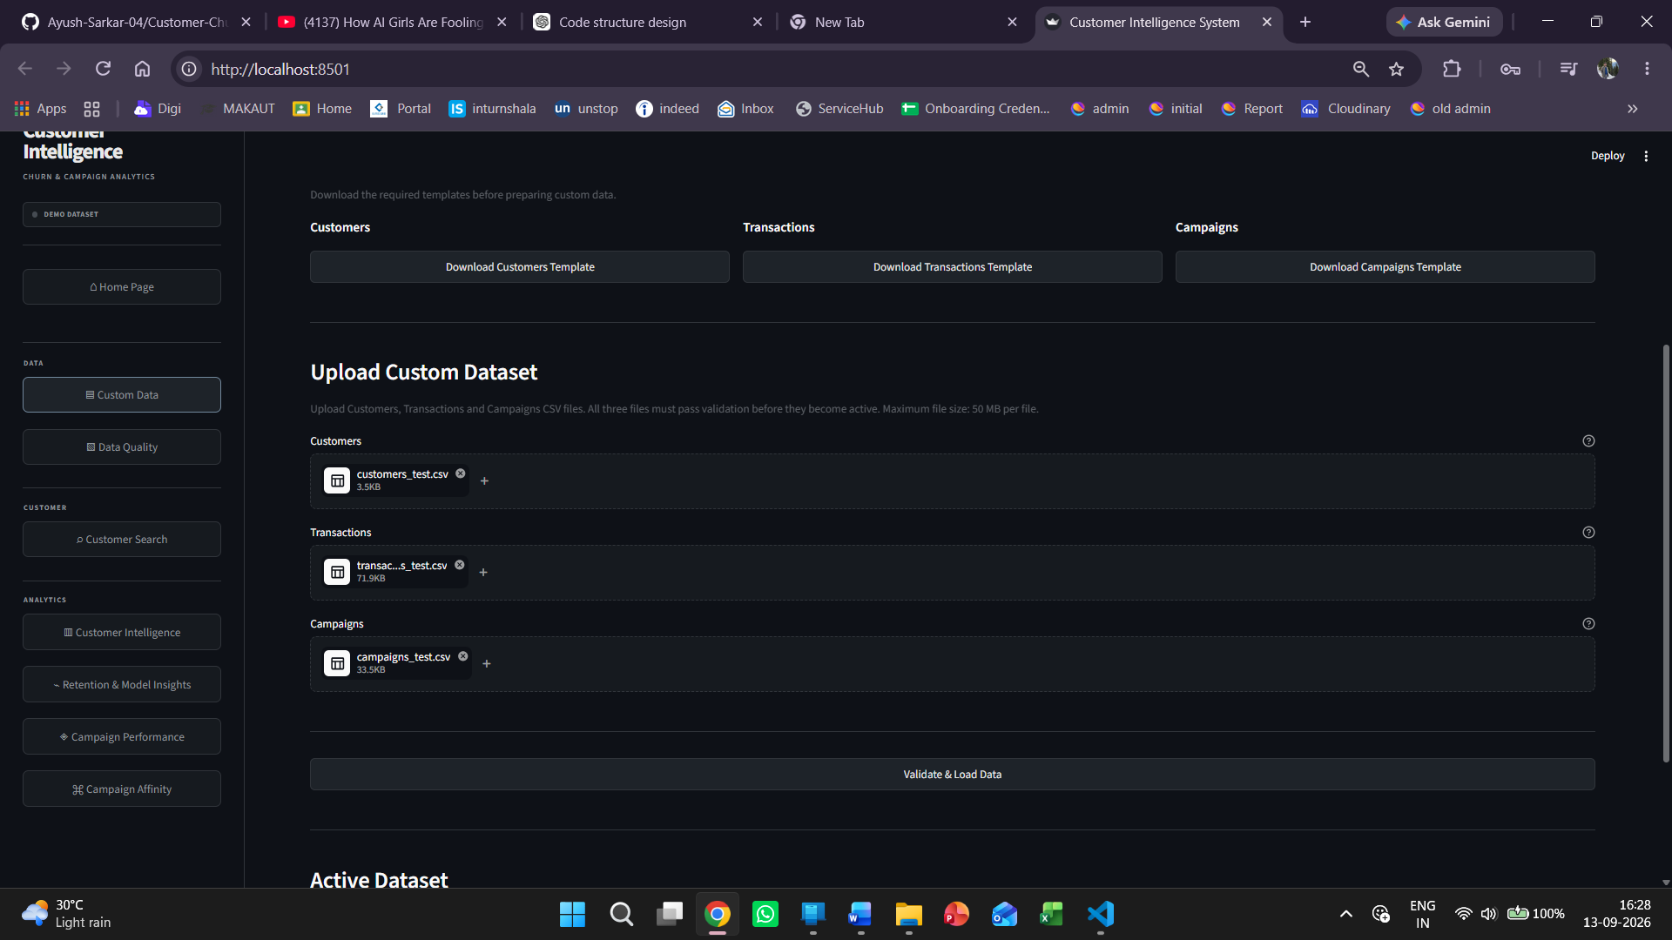
Figure 43.1. Data & Upload view showing the three-file custom dataset upload workflow and validation action.
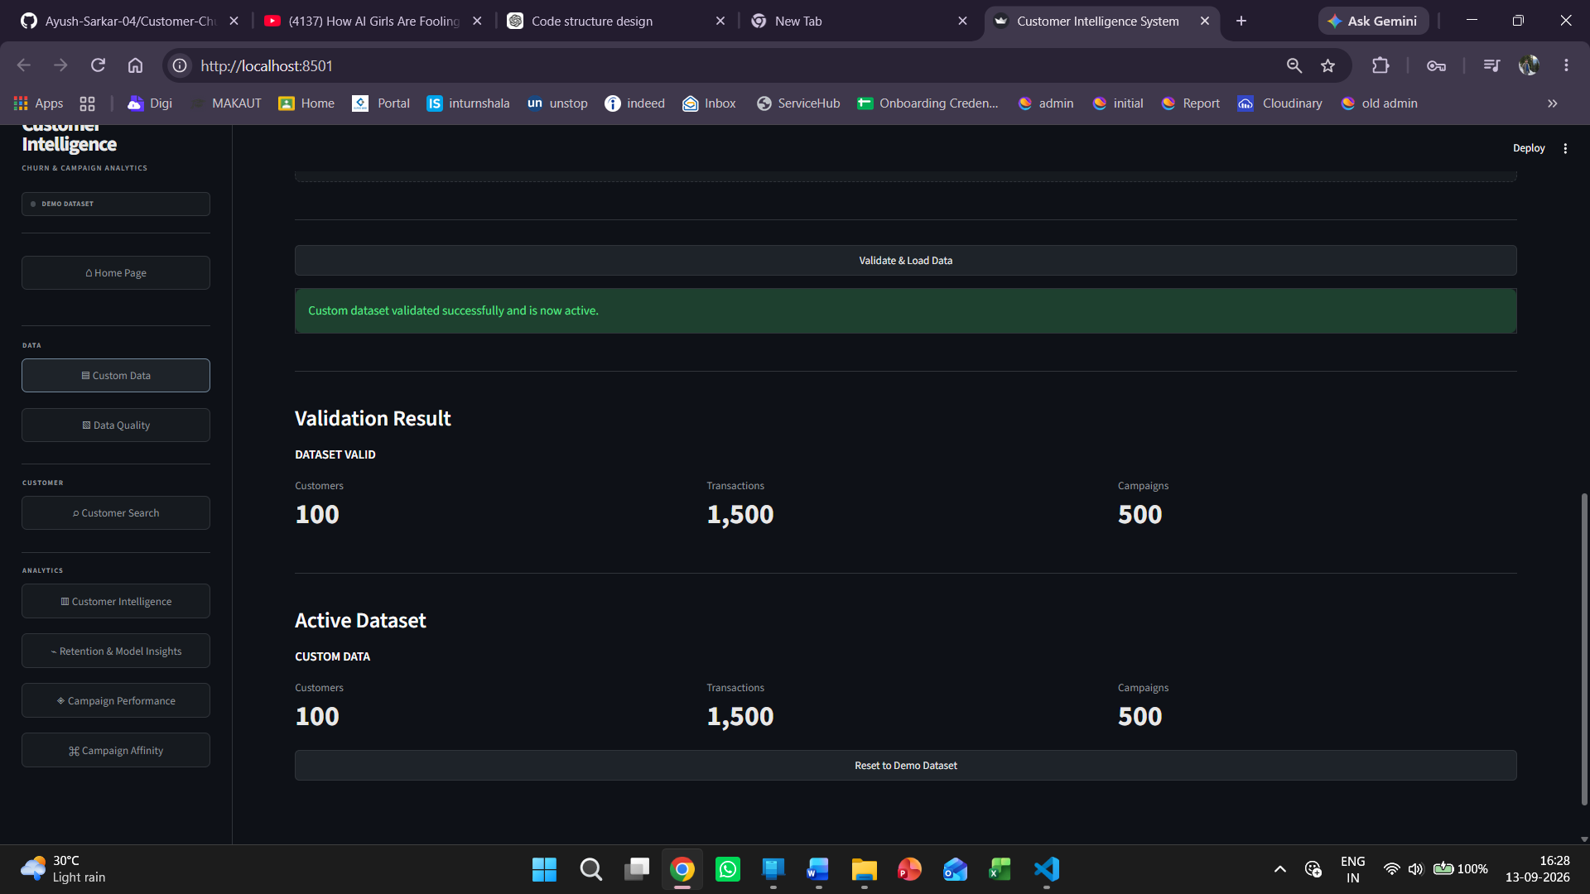
Figure 43.2. Successful custom-dataset validation result showing the active dataset after loading.

43.2 Final Streamlit Application Views
The following captures provide visual evidence of the integrated Streamlit application, including customer intelligence, campaign performance and the newly completed campaign-affinity interface.
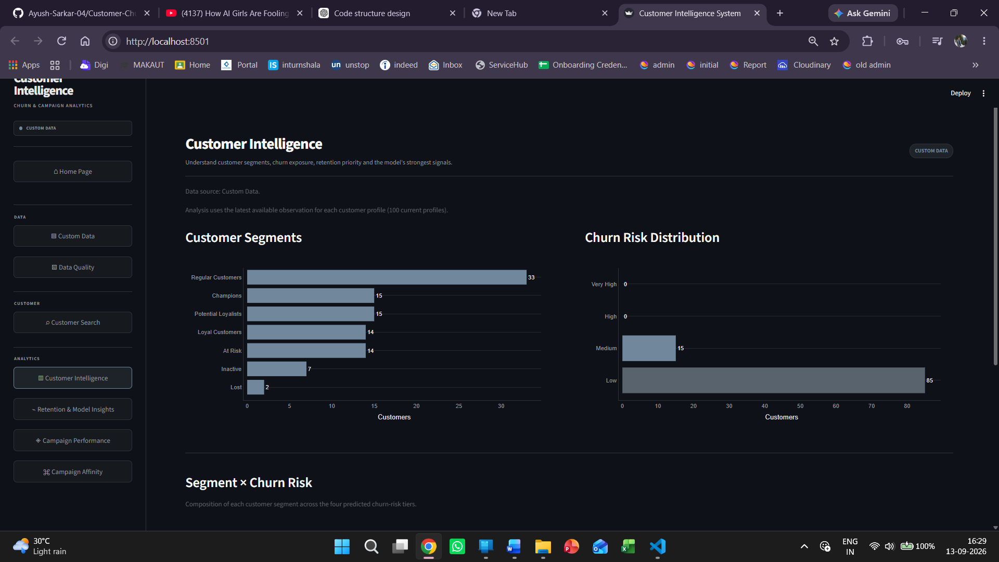
Figure 43.3. Customer Intelligence view showing customer segments and churn-risk distribution.
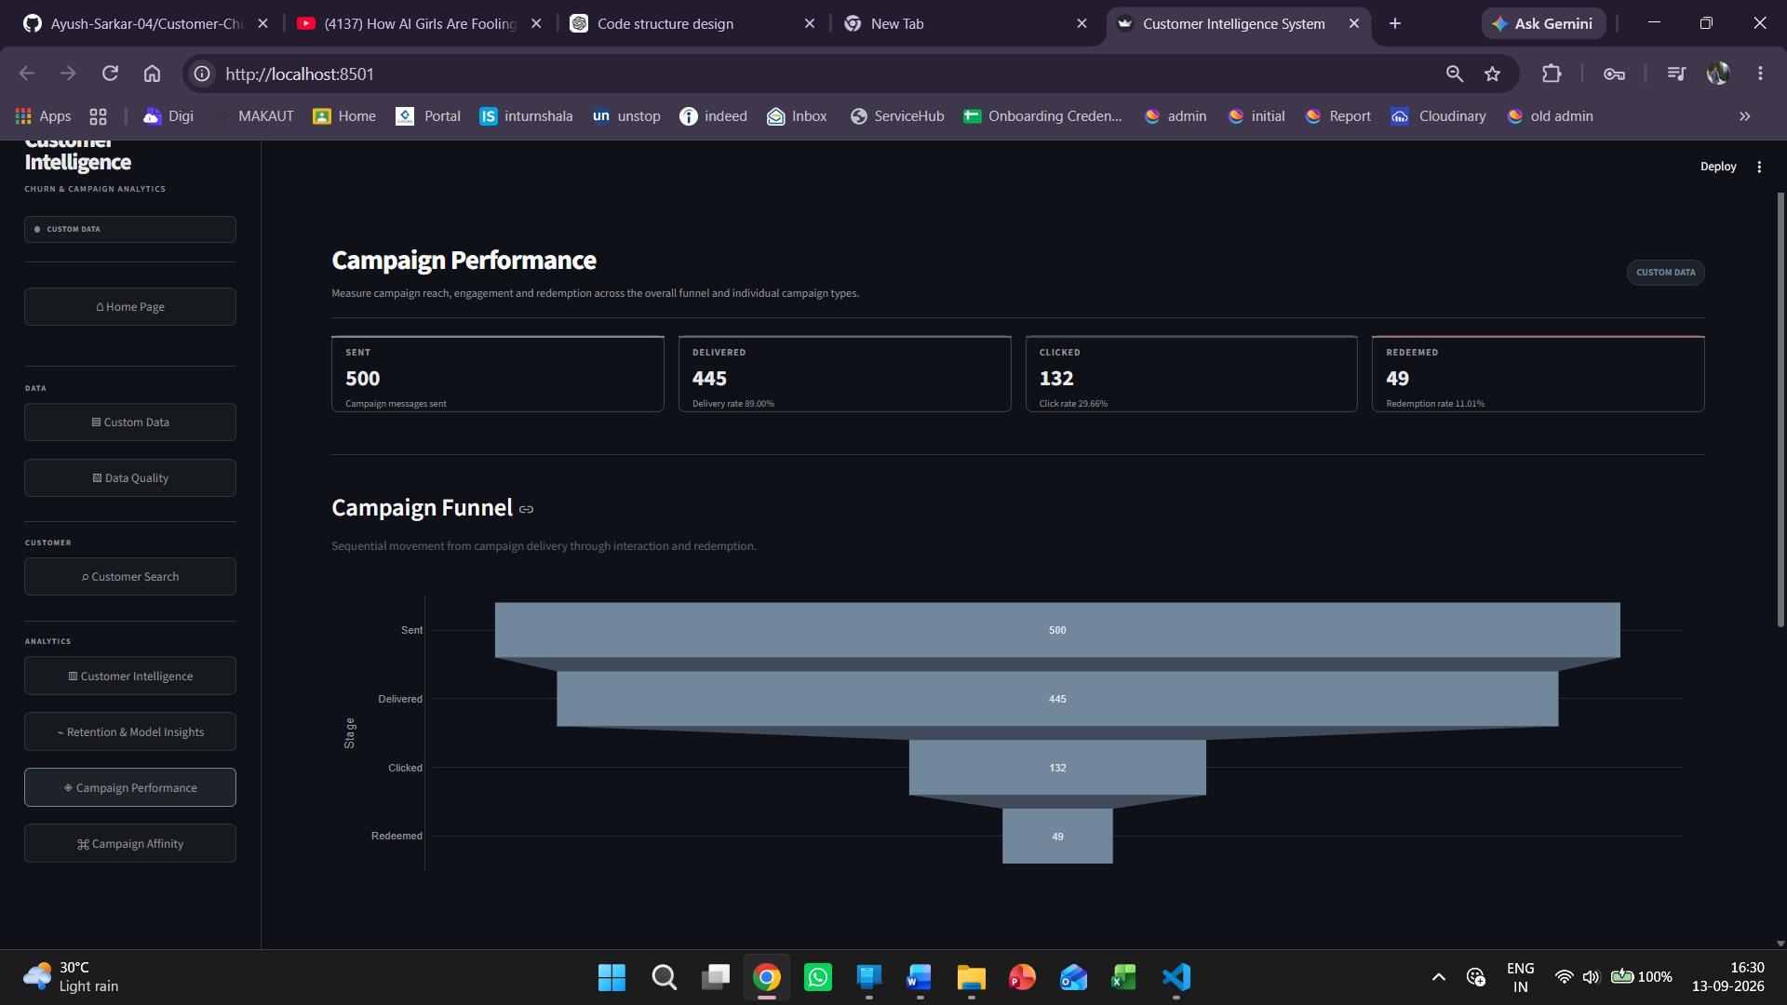
Figure 43.4. Campaign Performance view showing the campaign funnel and headline campaign metrics.
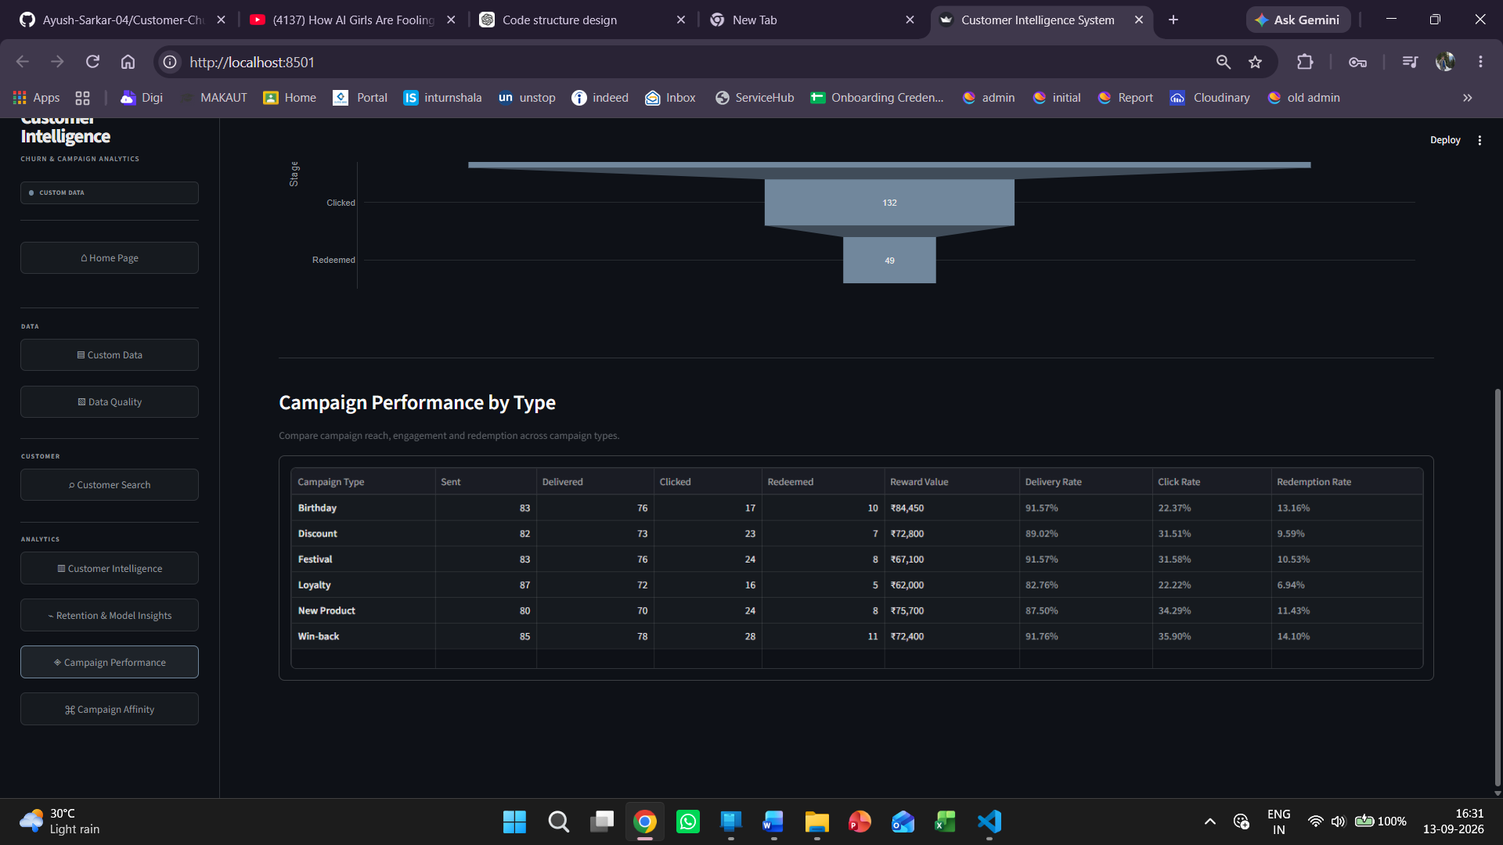
Figure 43.5. Campaign Performance by Type showing comparative campaign metrics.
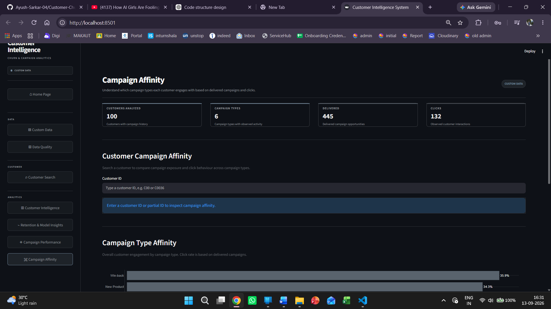
Figure 43.6. Campaign Affinity overview showing customer-level campaign-response analysis.
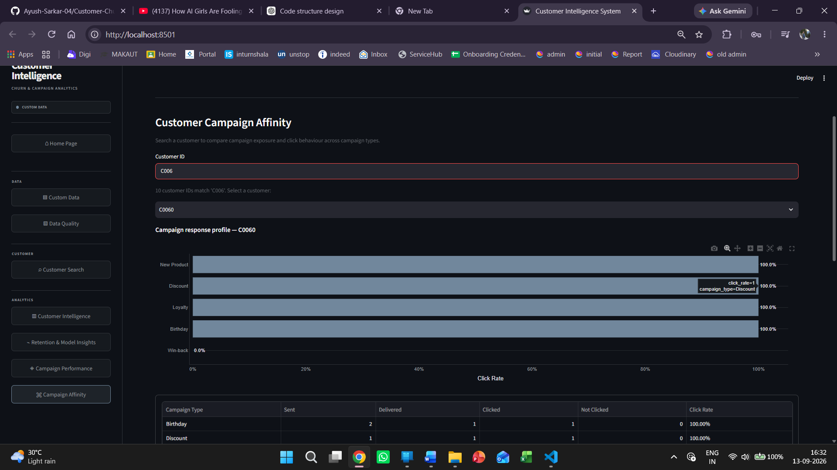
Figure 43.7. Campaign Affinity customer view showing campaign-type response rates.
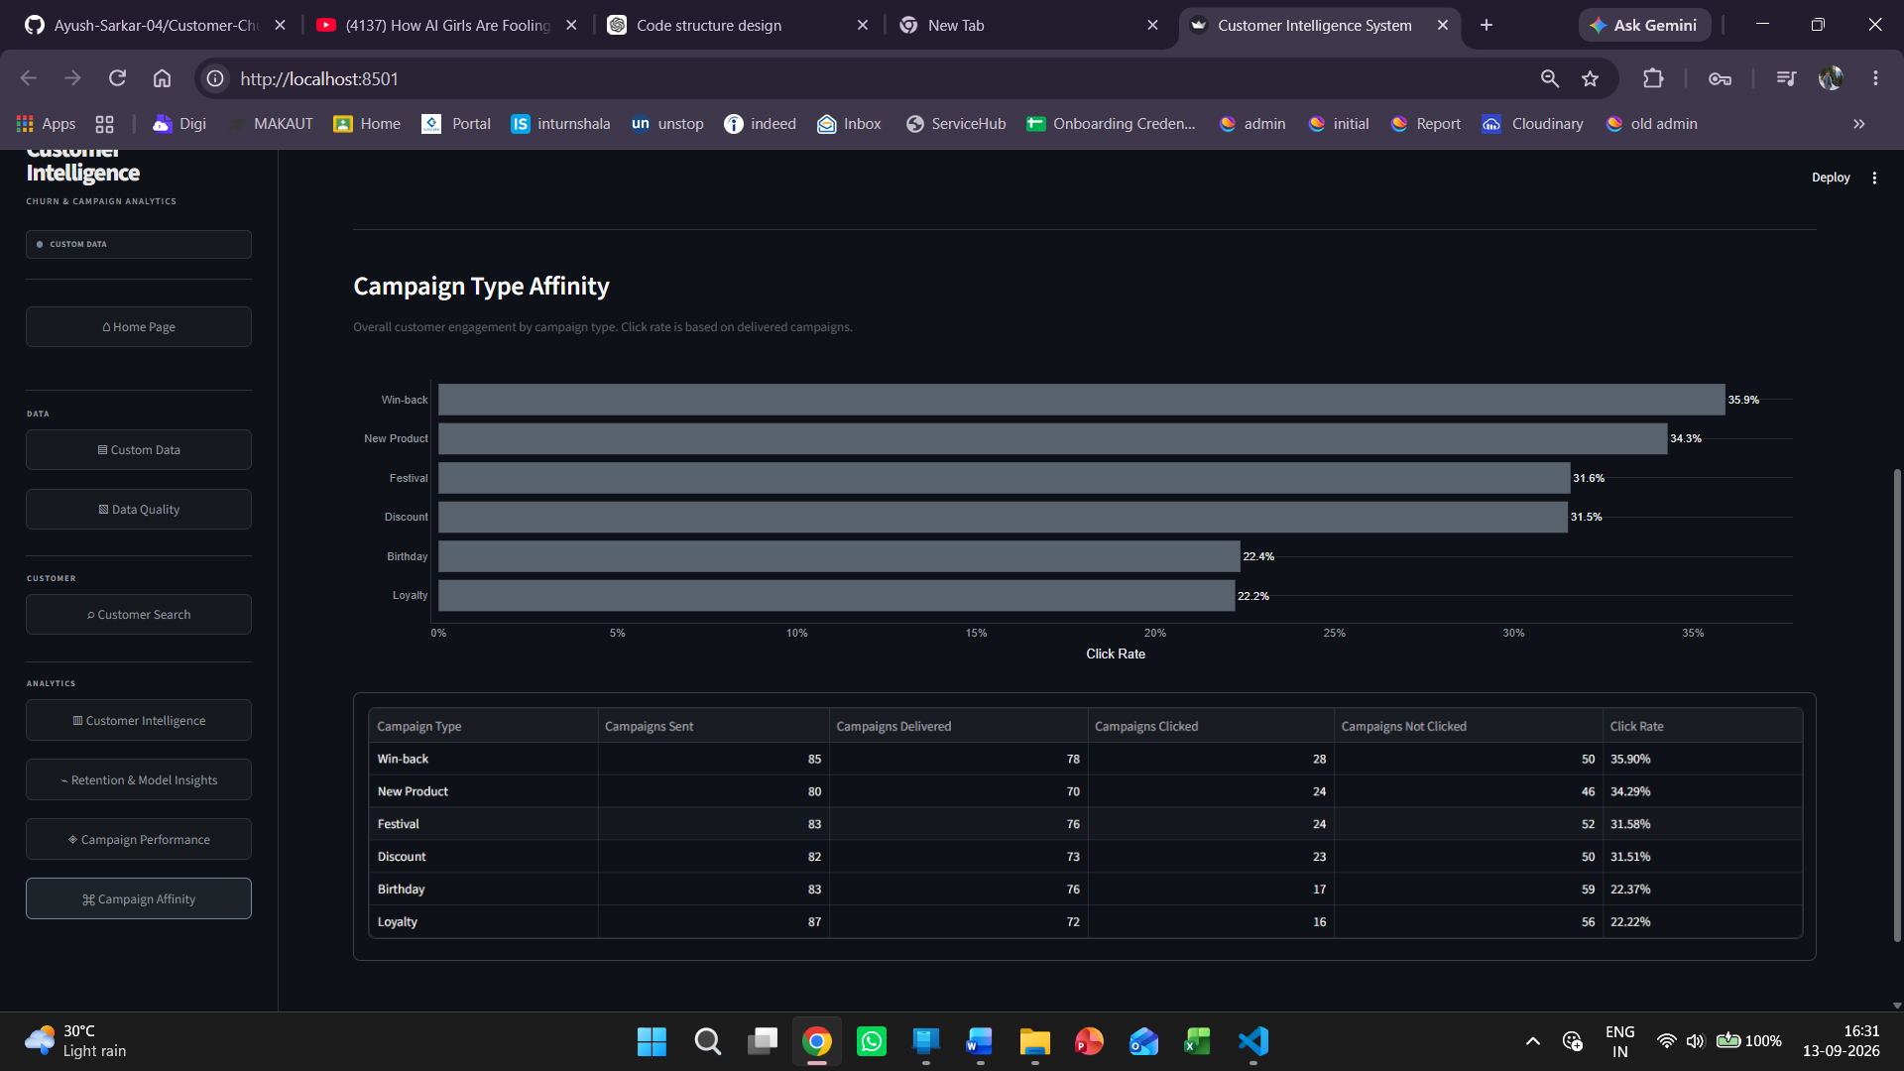
Figure 43.8. Campaign Type Affinity showing comparative observed click response by campaign type.

43.3 End-to-End Pipeline Reference
The completed system connects controlled data intake to analytical outputs and the Streamlit decision-support interface. The implemented flow is: validated demo or custom CSV data → resource protection → fixed-schema and quality validation → preprocessing → feature engineering → 90-day churn labeling → model training/evaluation and persistence → churn prediction and probability generation → risk classification → RFM segmentation → combined customer analytics → retention priority and expected revenue at risk → campaign performance → customer campaign affinity → Random Forest feature importance → reusable visualizations → Streamlit application.
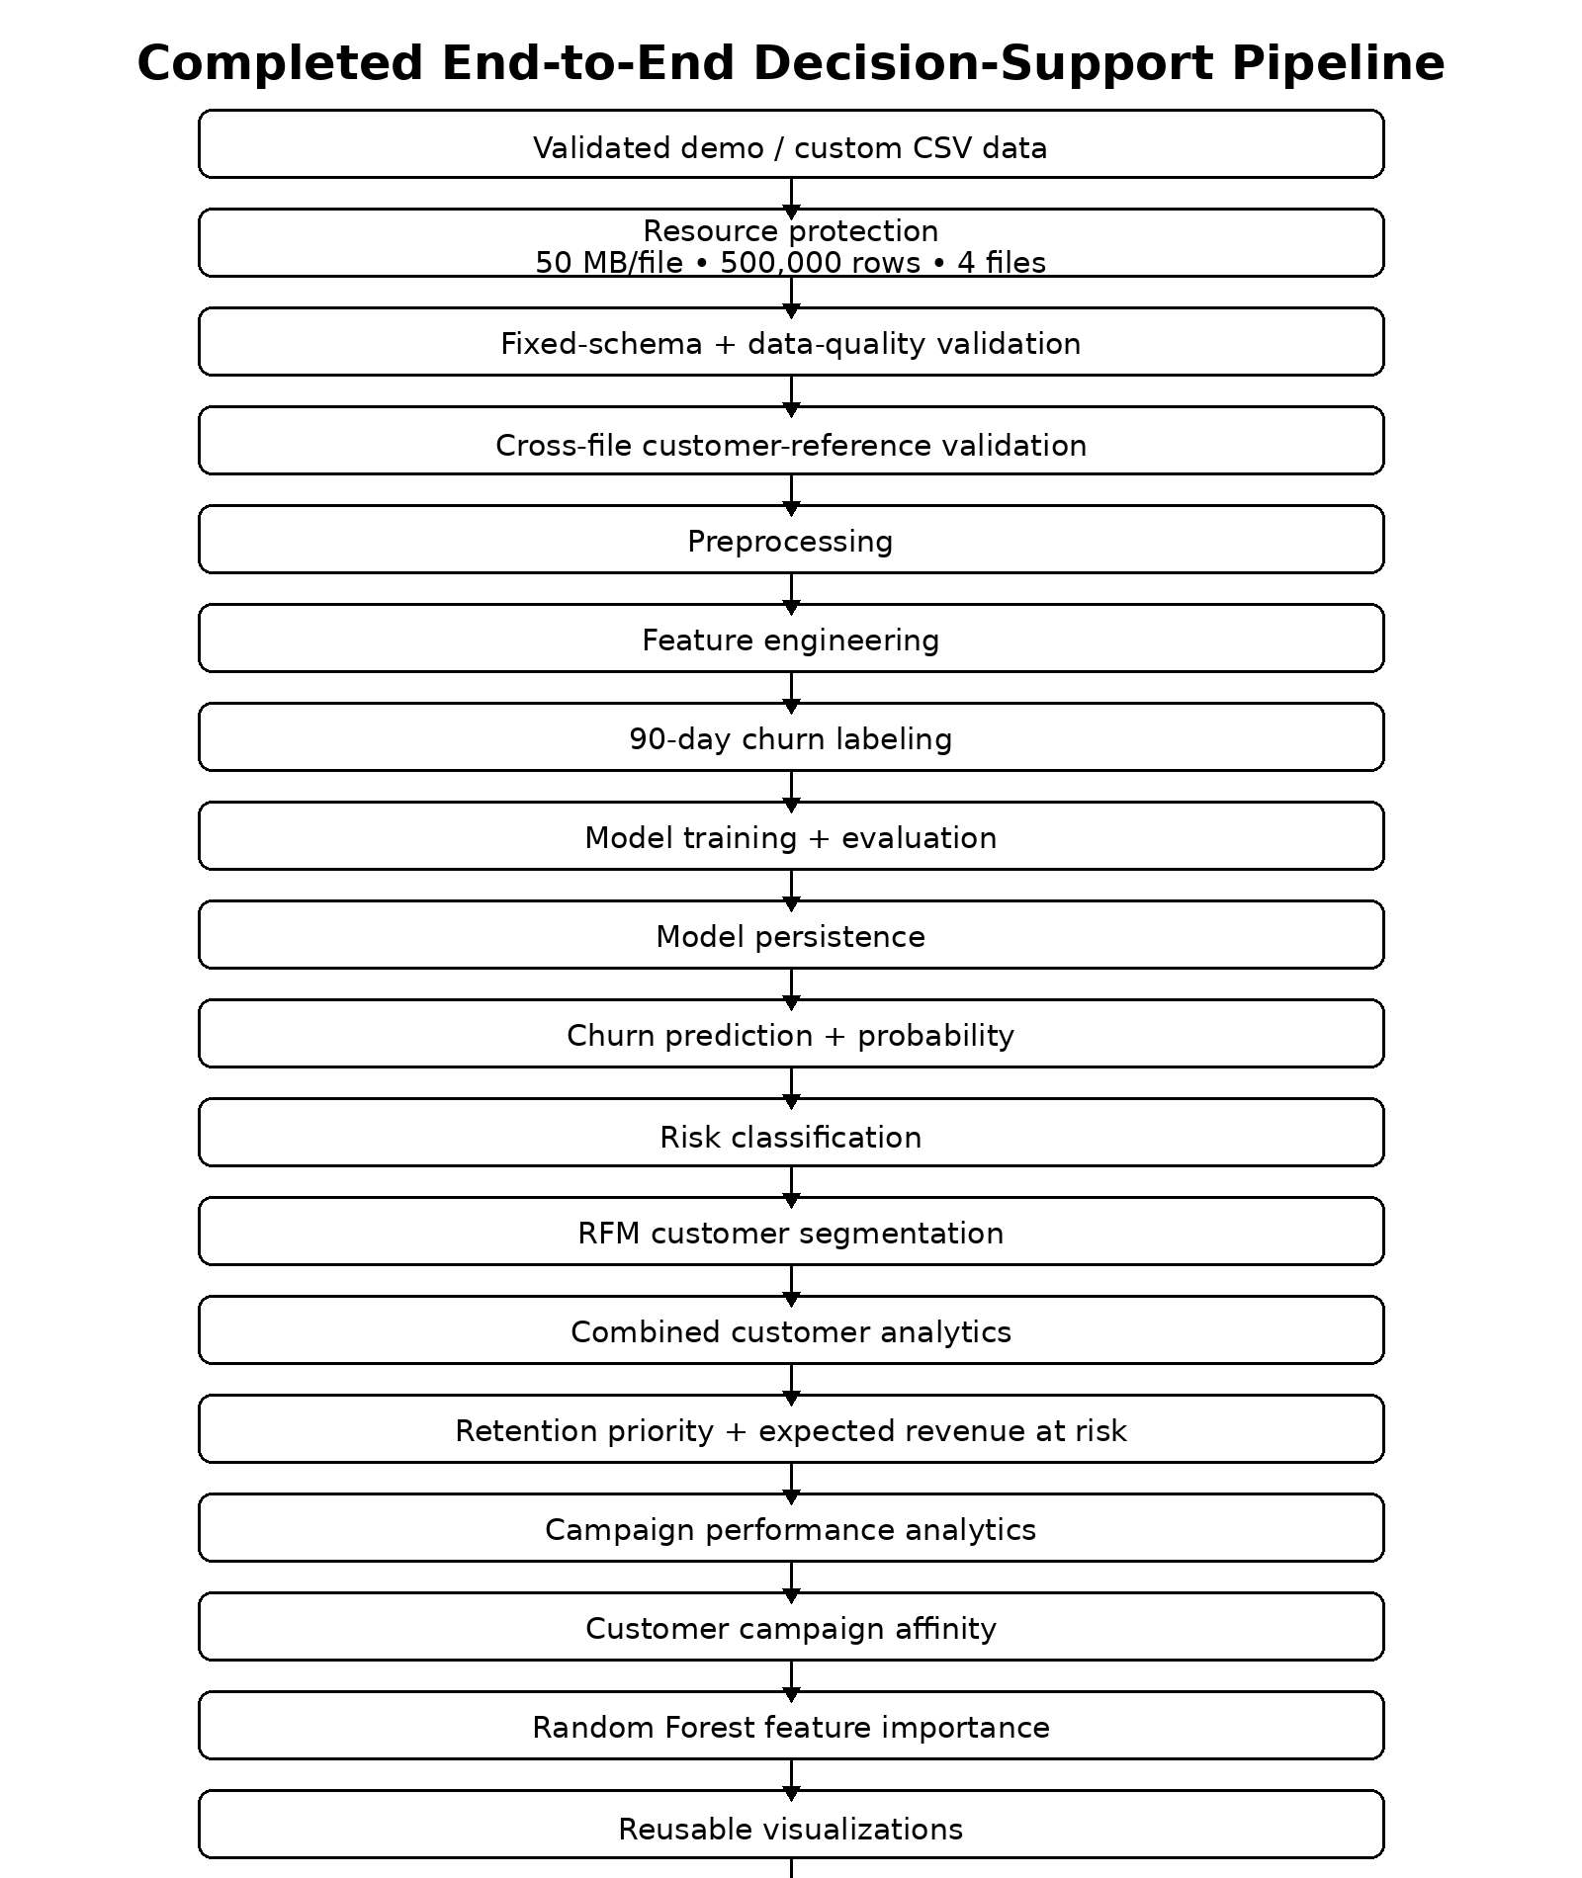
Figure 43.9. Completed end-to-end decision-support pipeline, presented as a consolidated visual reference.
The figures in this section are representative visual captures rather than a claim of production deployment. They document the completed portfolio-system checkpoint and are intended to be read together with the implementation status and test evidence in Sections 39–42.
Customer Churn Prediction and Campaign Analytics System • Final System Documentation

44. UI Redesign and Visual System
The Streamlit interface was visually redesigned to provide a more consistent, portfolio-ready decision-support experience while preserving the analytical functionality of the existing application.
- A unified dark-blue application background was introduced across the dashboard.
- Warm cream cards and tables were used to create stronger visual separation from the dark application surface.
- A muted brown primary accent was used for active navigation and emphasis.
- The sidebar was reorganized into compact functional groups so that related analytical views are easier to locate.
- Typography, spacing, borders and card treatment were standardized across the application.
- Charts were given consistent sizing, labels and analytical hierarchy rather than being treated as isolated plots.
- Tables use a consistent header/body treatment and readable numeric formatting.
- The redesign remains decision-oriented: each page is organized around a business question rather than simply displaying a collection of metrics.

44. UI Redesign and Visual System
The final interface uses a unified dark-blue application shell, compact sidebar navigation, warm cream information cards, consistent KPI treatments and a restrained visual hierarchy. The following ten screenshots are the selected final UI evidence for the redesigned application. They cover the main application views, with two captures used for the Data & Upload page because its content extends below the initial viewport.
Figure 44.10. Economic Intelligence — customer value, retention cost, Expected Value at Risk and Net Value at Risk.

Figure 44.9. Campaign Affinity — customer campaign affinity search and campaign-type engagement.
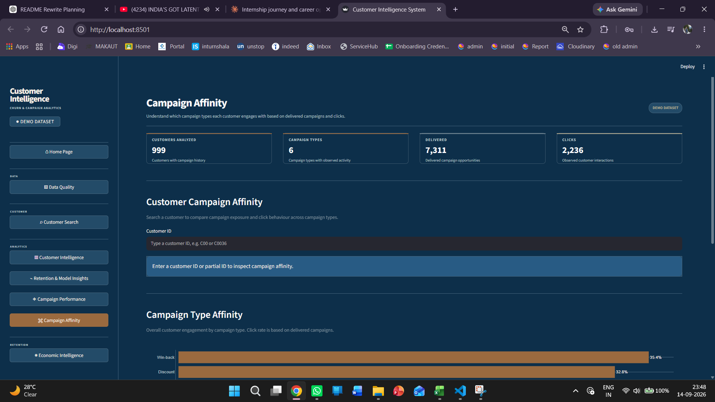
Figure 44.8. Campaign Performance — campaign funnel and campaign performance metrics.
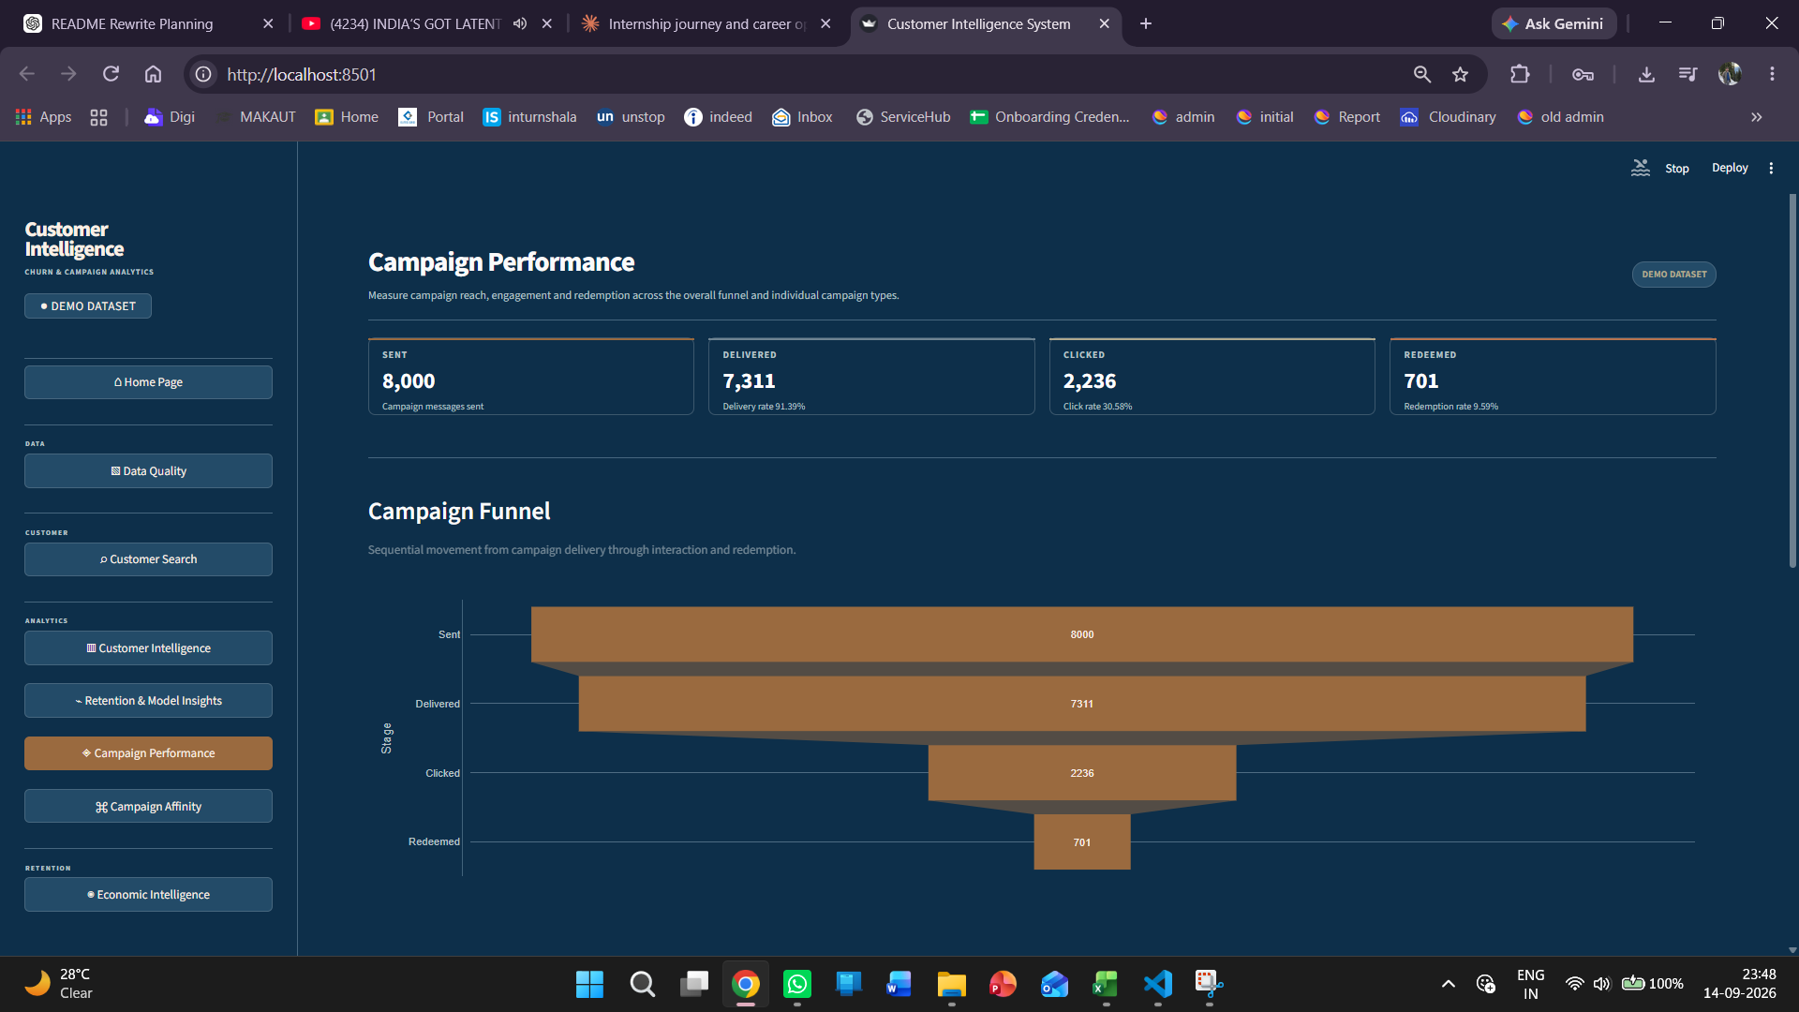
Figure 44.7. Retention & Model Insights — churn-driver feature importance and retention analysis.
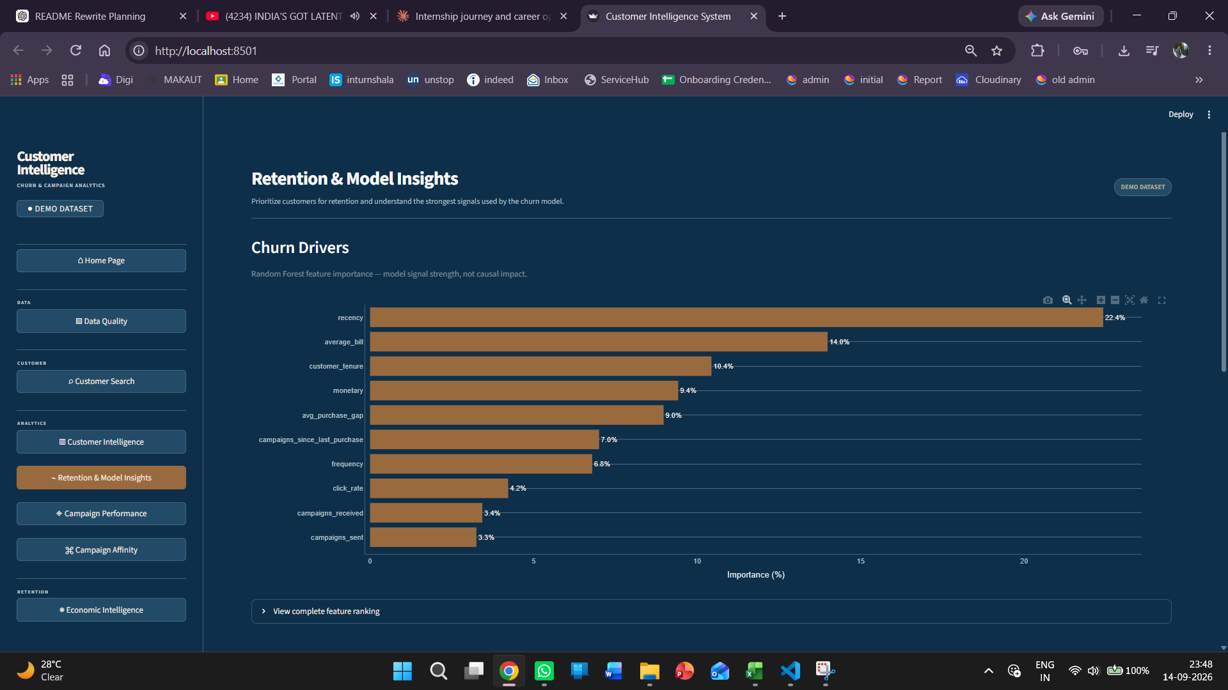
Figure 44.6. Customer Intelligence — customer segments, churn-risk distribution and Segment × Churn Risk analysis.
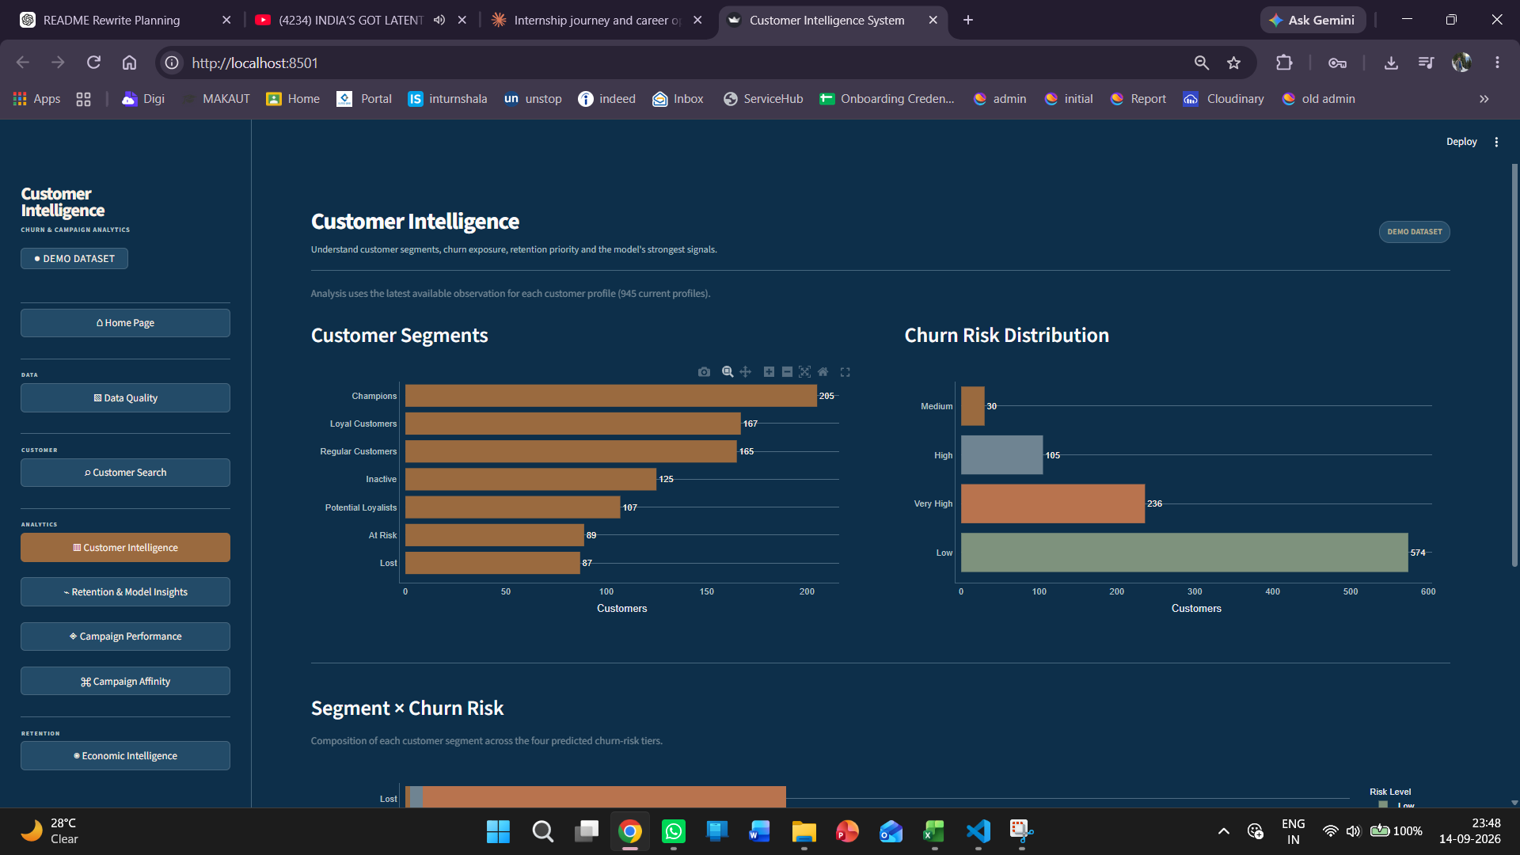
Figure 44.5. Customer Search — customer profile, risk indicators, RFM profile and purchase behaviour.
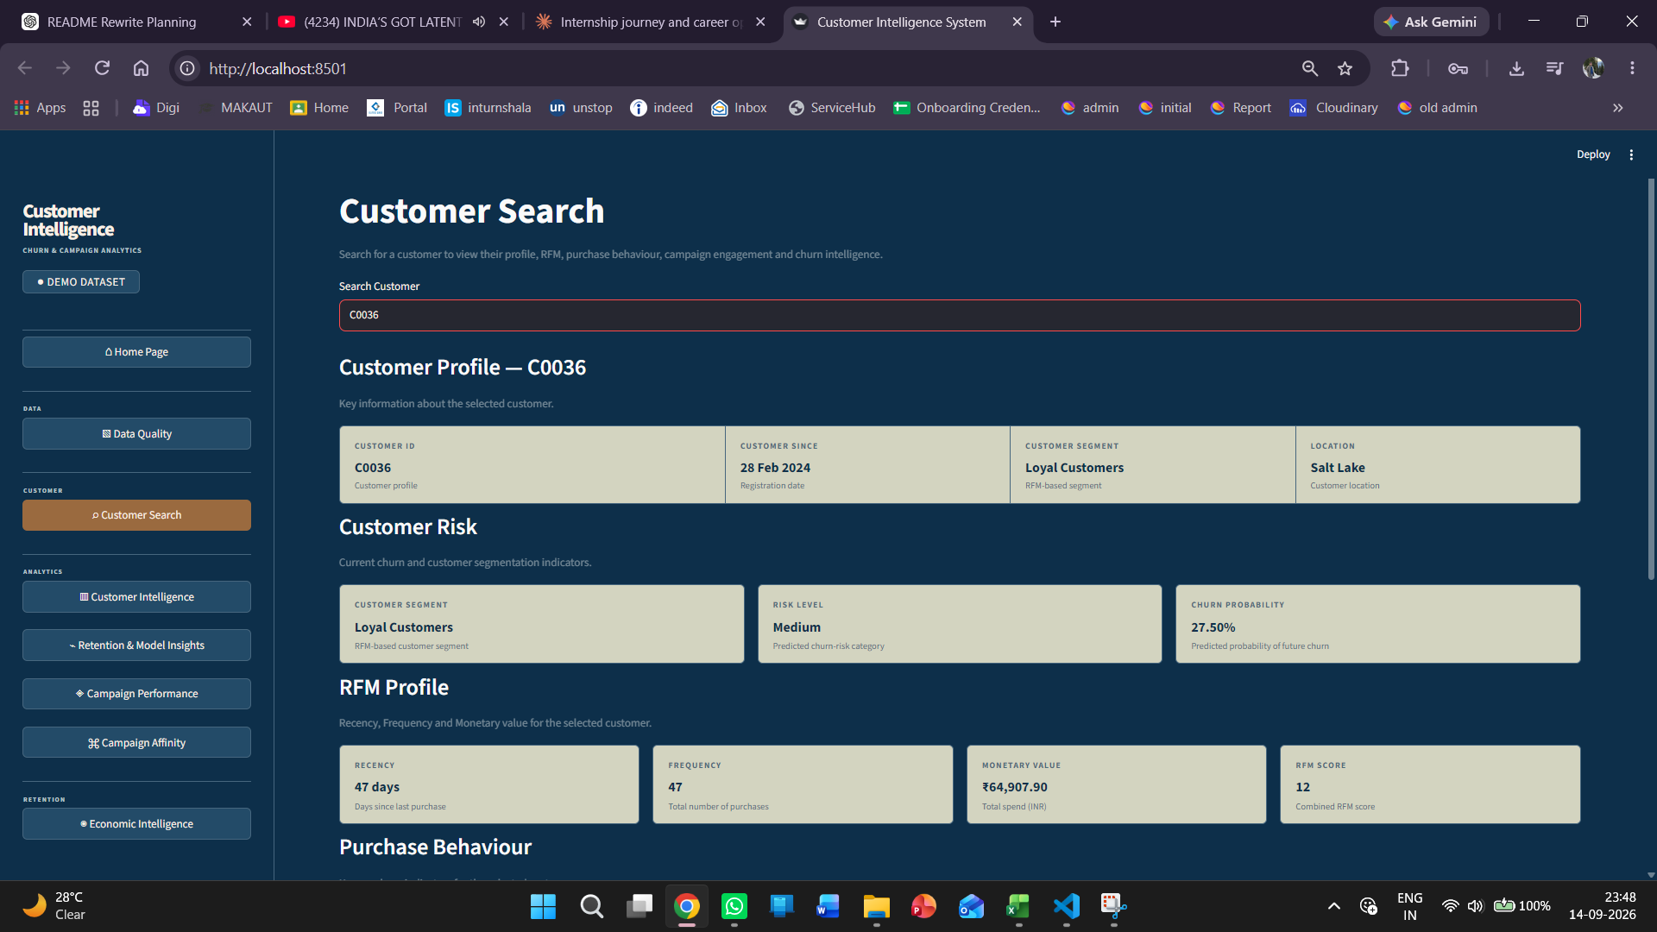
Figure 44.4. Data & Upload — download templates and custom CSV upload controls.
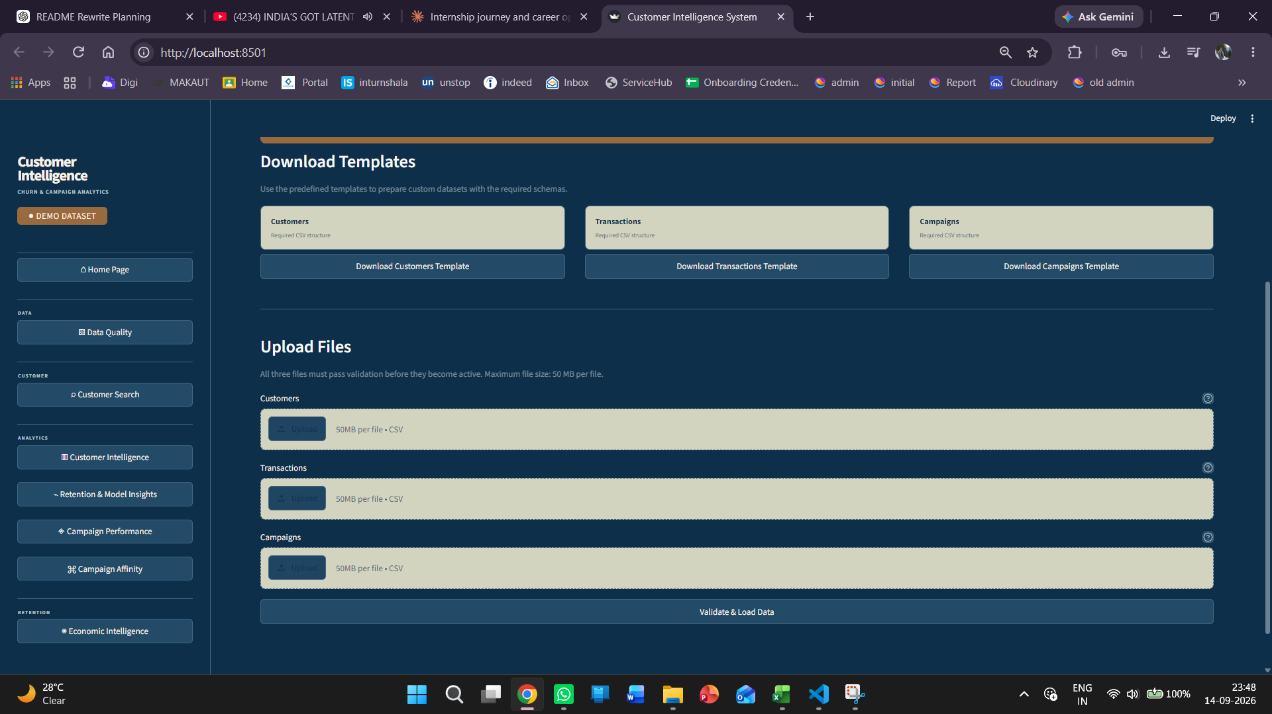
Figure 44.3. Data & Upload — dataset source selection and active dataset state.
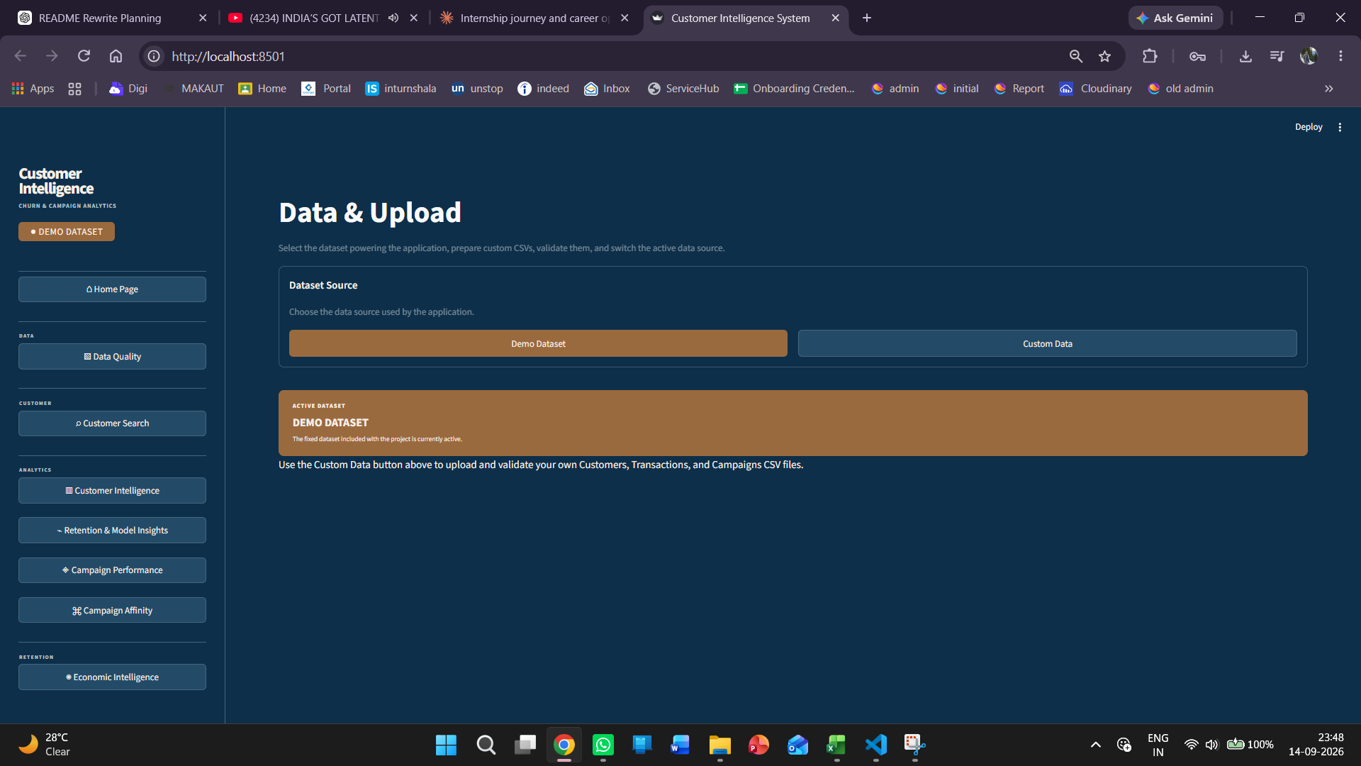
Figure 44.2. Data Quality — dataset validation status, dataset overview and validation checks.
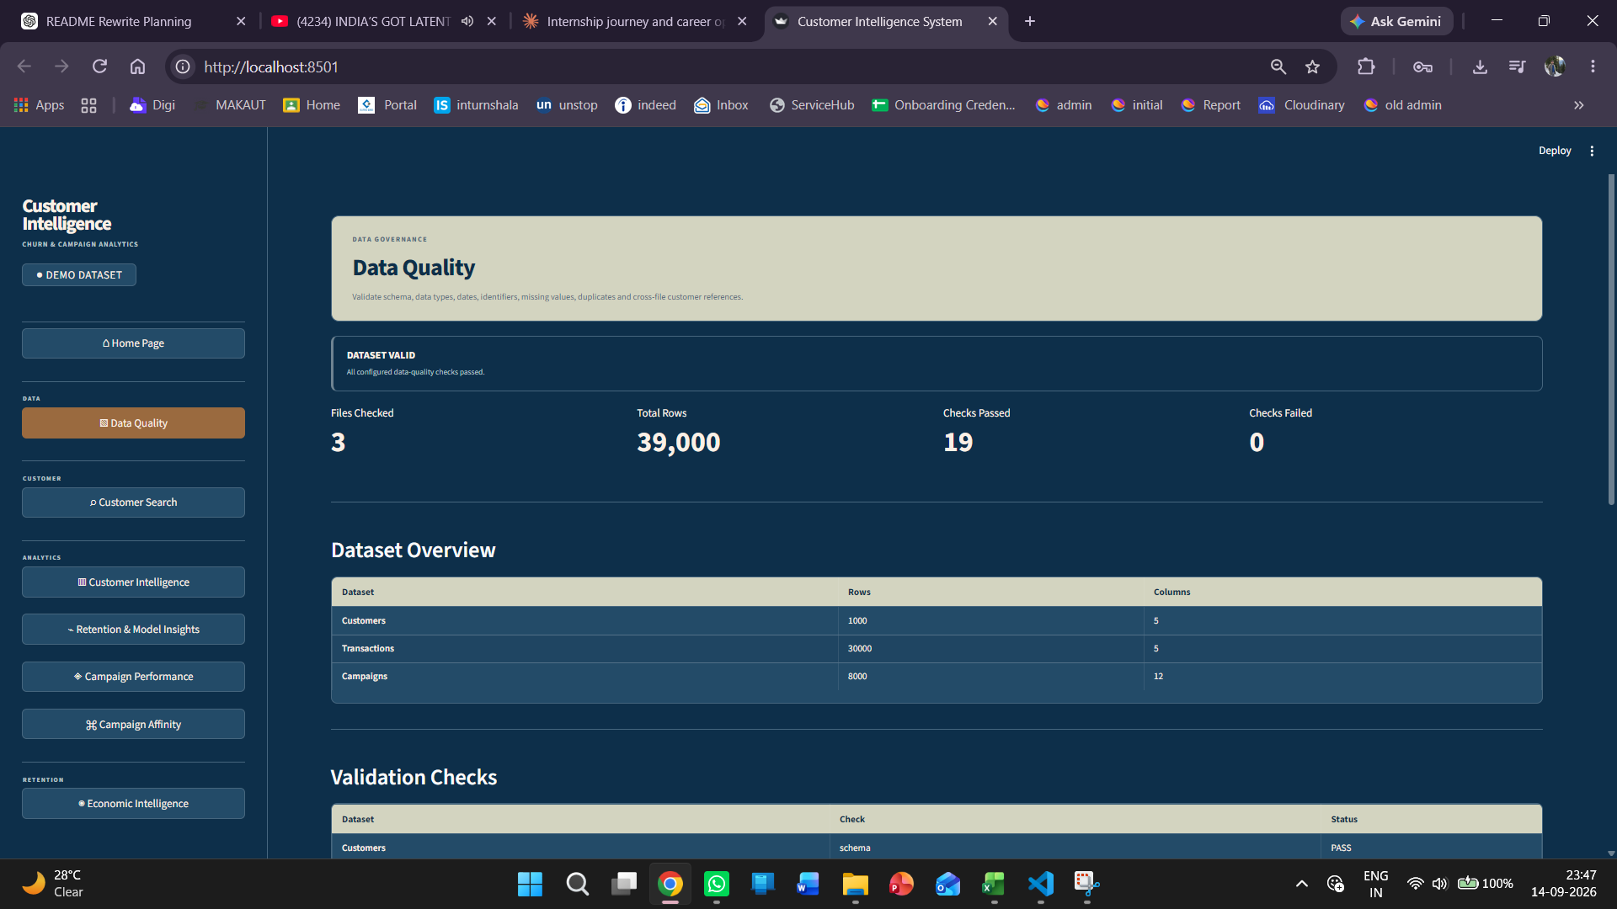
Figure 44.1. Home Page — business overview, customer health and the redesigned sidebar navigation.
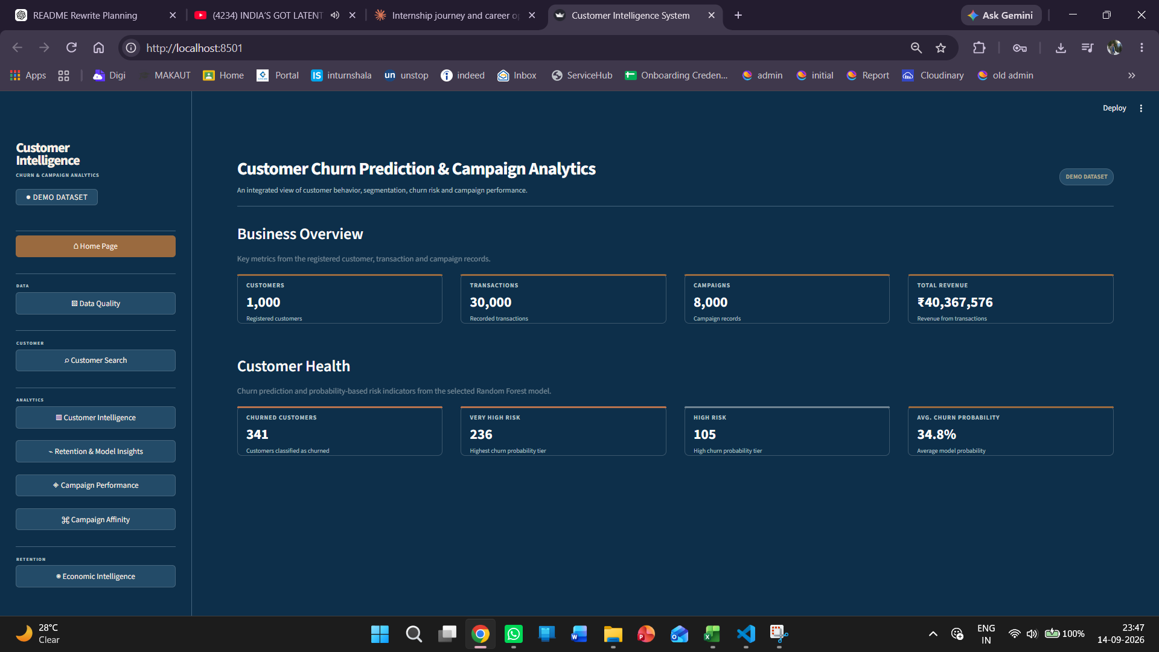
This screenshot set is intentionally limited to the final representative views and replaces the earlier larger UI gallery.

45. Economic Intelligence
Economic Intelligence extends the churn system from probability-based customer risk into an economic view of retention exposure. The page answers: Where is the business exposed to the greatest economic risk? It combines customer value, observed historical retention cost and predicted churn probability.

45.1 Implemented Economic Features
Feature | Definition / Role | Current Evidence
Customer Value / historical LTV | Historical customer value calculated from transaction history. The current implementation treats customer_value as historical revenue rather than a predictive future-LTV forecast. | Custom-data view: ₹11,470,028 total customer value across 100 analyzed customer profiles; displayed average ₹114,700.
Retention Cost Model | Calculates campaign-related retention cost and supports aggregation by campaign type and customer. | Custom-data view: ₹37,408 total observed retention cost; displayed average ₹374 per customer.
Expected Value at Risk (EVaR) | EVaR = churn probability × customer value. It represents probability-weighted economic exposure, not guaranteed revenue loss. | Custom-data view: ₹1,657,495 total EVaR; displayed average ₹16,575.
Net Value at Risk | Net Value at Risk = EVaR − retention cost. It ranks exposure after the observed retention-cost proxy is deducted. | Custom-data view: ₹1,620,087 total net value at risk.

45.2 Economic Intelligence Page — Complete Visual Evidence
The following four screenshots document the complete Economic Intelligence page in Custom Data mode. Together they show the page header and KPI layer, customer-value/churn relationship, historical retention cost by campaign type, and the ranked customer economic-exposure table.

Figure 45.1. Economic Intelligence — page header and KPI layer. The Custom Data view shows Customer Value ₹11,470,028, Retention Cost ₹37,408, Expected Value at Risk ₹1,657,495, Net Value at Risk ₹1,620,087 and 100 customers analyzed.
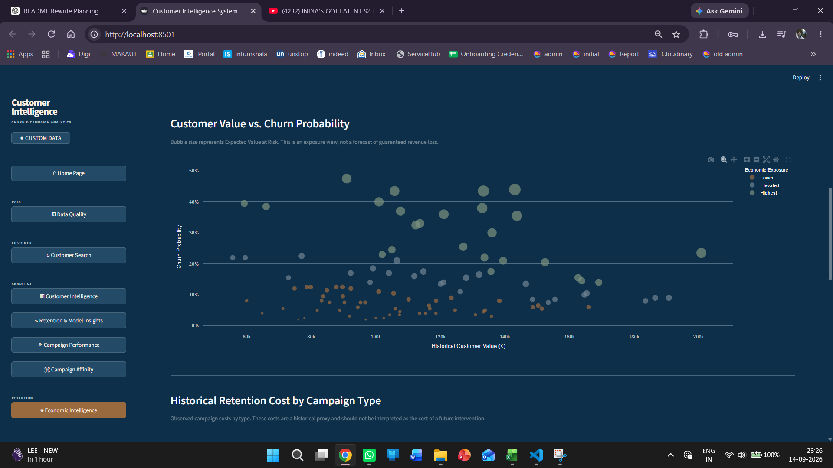
Figure 45.2. Economic Intelligence — Customer Value vs. Churn Probability. Bubble size represents Expected Value at Risk and the chart explicitly frames the output as economic exposure rather than guaranteed loss.
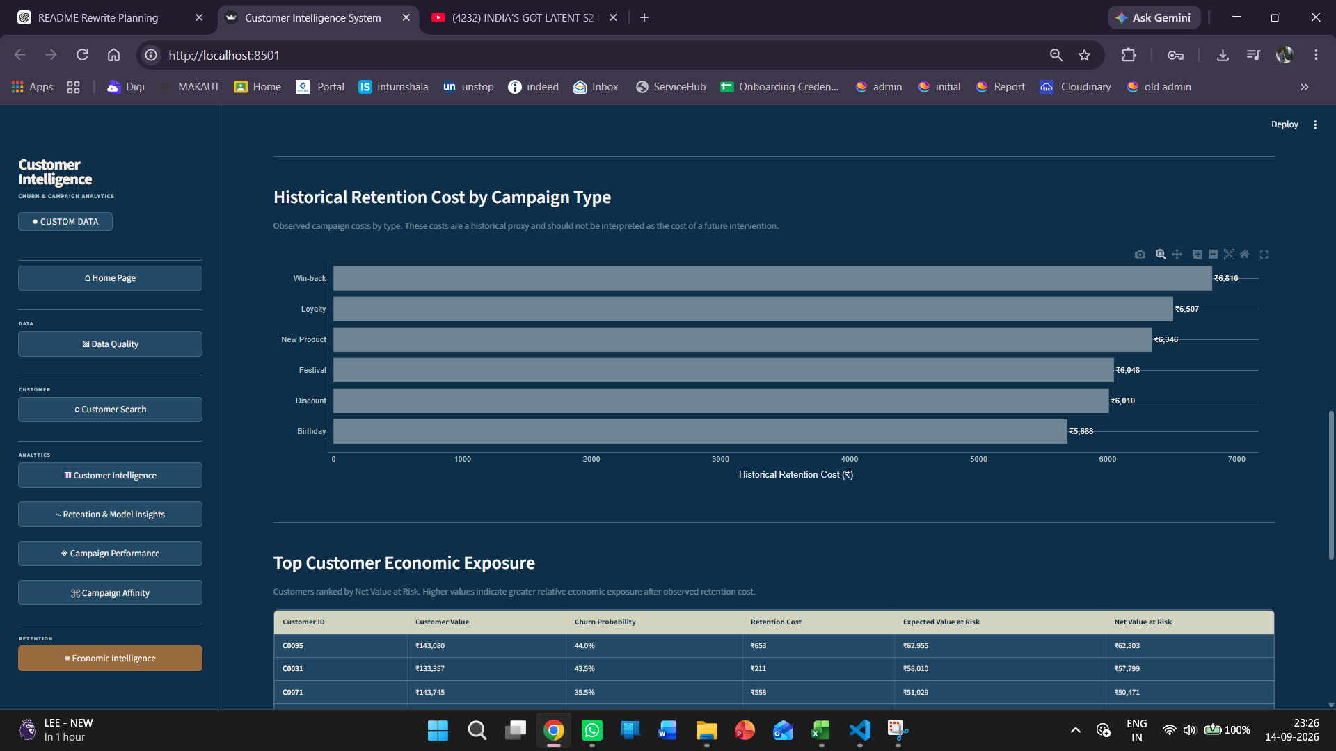
Figure 45.3. Economic Intelligence — Historical Retention Cost by Campaign Type. The chart compares observed campaign costs across Win-back, Loyalty, New Product, Festival, Discount and Birthday.
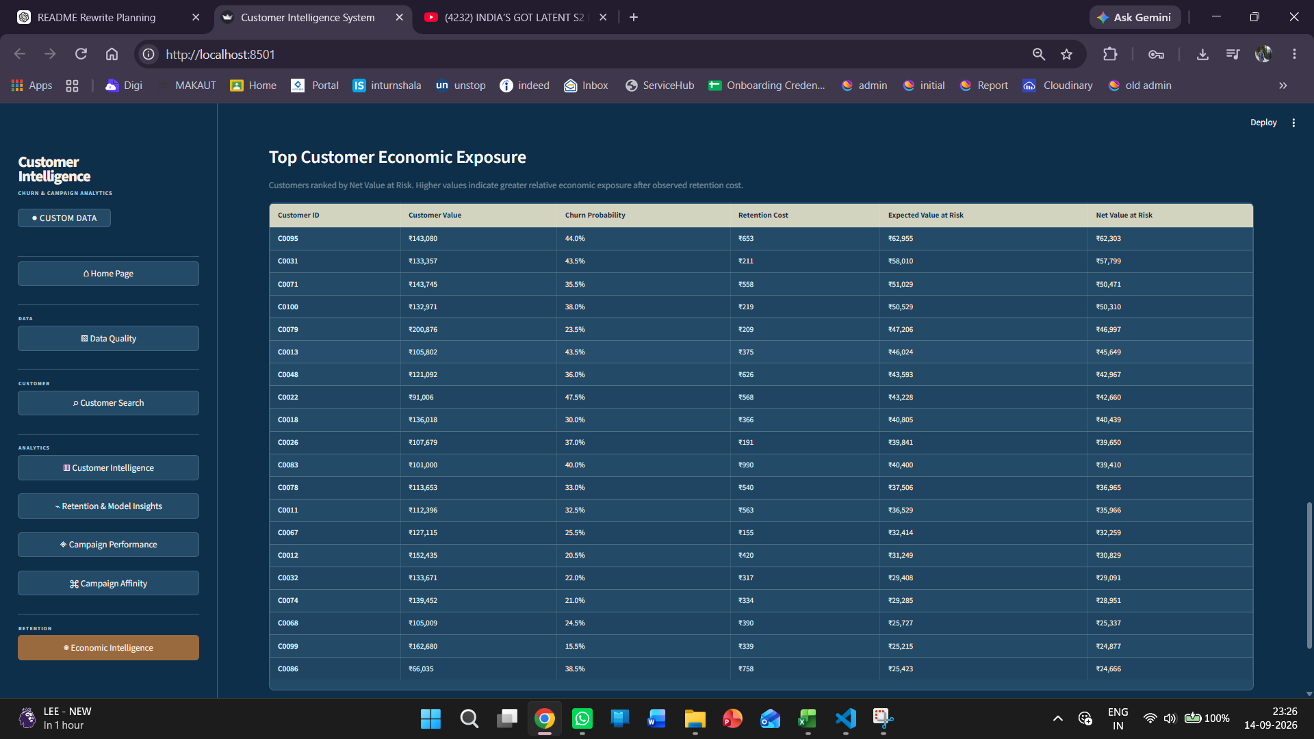
Figure 45.4. Economic Intelligence — Top Customer Economic Exposure. Customers are ranked by Net Value at Risk, with customer value, churn probability, retention cost and EVaR shown together.

45.3 Representative Economic Output
The ranked output provides a concrete example of how the economic layer changes the interpretation of churn risk. For customer C0095, the displayed historical customer value is ₹143,080 and churn probability is 44.0%. This produces an EVaR of approximately ₹62,955. After the displayed retention cost of ₹653 is deducted, the resulting Net Value at Risk is ₹62,303.
The page also shows that a customer does not need to have the highest churn probability to have the highest economic exposure: customer value and churn probability interact. This is the primary decision-support purpose of the Economic Intelligence layer.

45.4 Interpretation and Limitations
- Customer Value is historical value in the current implementation, not a predictive lifetime-value forecast.
- Retention Cost is based on observed historical campaign cost and is a proxy rather than a guaranteed future intervention cost.
- EVaR is a probability-weighted exposure metric; it does not mean that the displayed amount will definitely be lost.
- Net Value at Risk is not ROI and does not represent revenue saved by a retention action.
- The Economic Intelligence page does not use campaign_outcomes.csv. Historical campaign outcomes are reserved primarily for the future Campaign Portfolio Simulator and related campaign-effectiveness analysis.
- The synthetic treatment/control dataset is experimental/synthetic data and must not be interpreted as real causal evidence.

46. Comprehensive Test and Output Evidence
This section consolidates the development-test evidence for the implemented system. Where an exact automated test count was explicitly recorded, it is shown. Where the master documentation records validation evidence but not a standalone test count, the result is stated without inventing a count.

46.1 Full Regression Checkpoint
Checkpoint | Result
Full automated test suite | 201 passed
Level 2 economic feature tests | 65 focused tests passed (14 + 15 + 17 + 19)
Retention Cost Model | 14 tests passed
Customer Value / historical LTV | 15 tests passed
Economic Value at Risk | 17 tests passed
Economic Priority | 19 tests passed

46.2 Feature-by-Feature Test and Output Summary
Feature / Module | Testing | Representative Output / Evidence
Fixed-schema / data validation | Validation evidence recorded; 19 dashboard checks pass on demo data | Valid schemas accepted; missing/extra columns, invalid types/dates, missing values, duplicates, IDs and cross-file references are rejected with specific errors.
Upload / resource protection | Upload-level tests documented | 50 MB/file, 500,000 rows/file and 4-file limits enforced; oversized, over-row-limit and over-file-count inputs rejected.
Preprocessing | Test evidence recorded across individual and full preprocessing tests | Column names standardized; dates converted to datetime64[ns]; numeric fields converted; invalid values become NaN/NaT for quality handling; empty rows removed.
Feature engineering | Test evidence recorded | Unit test generated a 1,000 × 20 customer feature table with zero missing values and zero duplicate customer IDs.
Churn labeling | Tested successfully | 90-day future-purchase churn target generated for the supervised learning dataset.
Model training | 1 test passed | 4,012 training records and 1,003 testing records; Logistic Regression, Decision Tree and Random Forest trained.
Model evaluation | 1 test passed | Random Forest selected by ROC-AUC at 0.8639; Logistic Regression 0.8172; Decision Tree 0.7293.
Model persistence | 1 test passed | Three Joblib models saved/loaded successfully: Logistic Regression, Decision Tree and Random Forest.
Prediction module | 3 tests passed | 5,015 customer-level churn predictions and probabilities generated.
Risk classification | 2 tests passed | Low <25%, Medium 25–<50%, High 50–<75%, Very High ≥75% churn-probability bands applied.
Customer segmentation | 4 tests passed | Seven RFM segments generated across 5,015 observations; Regular Customers is the largest segment at 35.73%.
Customer analytics integration | 3 tests passed | RFM, segmentation, prediction, risk, observation-date and campaign-engagement outputs aligned across 5,015 observations.
Visualization layer | 6 tests passed | Segment distribution, churn-risk distribution and Segment × Risk Plotly charts generated successfully.
Campaign analytics | 1 test passed | 8,000 sent; 7,311 delivered; 2,236 clicked; 701 redeemed; 91.39% delivery, 30.58% click and 9.59% redemption rates.
Customer Search backend | 8 tests passed | Exact/partial case-insensitive customer search supported; latest-observation filtering produces 945 current customer profiles.
Customer Search Streamlit page | 3 tests passed | Customer profiles expose RFM, segment, churn probability, risk and campaign-engagement outputs.
Data Quality validation | 4 tests passed | Validation layer detects schema, data-type, date, missing-value, duplicate, ID and reference issues.
Data Quality Streamlit page | 1 test passed | Demo dashboard: 3 files checked, 39,000 total rows, 19 checks passed and 0 failed.
Customer analytics regression | 5 tests passed | Observation-date preservation remains compatible with current-customer filtering and integrated analytics.
Retention Priority | Implemented; focused validation maintained | 0–100 score combines 60% churn probability and 40% customer-value percentile; Low, Medium, High and Critical bands.
Random Forest feature importance | 9 tests passed | Recency is highest at 22.42%, followed by Average bill at 13.99% and Customer tenure at 10.44%.
Campaign Affinity | 11 tests passed | 4,421 customer × campaign-type rows across 999 customers and 6 campaign types; Best Campaign Type uses deterministic observed-response ranking.
Retention Cost Model | 14 tests passed | Campaign cost, optional incentive/other cost components, total/average cost, campaign-type aggregation and customer-level cost supported.
Customer Value / historical LTV | 15 tests passed | Customer-level historical revenue, purchase count, average order value, active days, annualized revenue and customer value produced.
Economic Value at Risk | 17 tests passed | EVaR and Net Value at Risk calculated with input validation, ranking and summary support.
Economic Priority | 19 tests passed | Economic priority score derived from percentile rank of Net Value at Risk; Low/Medium/High/Critical tiers supported with deterministic ranking.

47. Updated Current System State — 14 September 2026
The 14 September 2026 checkpoint extends the previously documented eight-view customer intelligence and campaign analytics application with the first Level 2 economic decision-support page.
Area | Current State | Evidence
Core churn pipeline | PASS | Validation, preprocessing, feature engineering, 90-day churn labeling, ML training/evaluation, persistence, prediction and risk classification implemented.
Customer intelligence | PASS | RFM segmentation, customer analytics integration, Customer Search and customer-level risk outputs implemented.
Campaign intelligence | PASS | Campaign Performance and Campaign Affinity implemented; observed campaign funnel and customer-response analysis available.
Model interpretability | PASS | Random Forest feature importance implemented and tested.
Retention prioritization | PASS | Retention Priority implemented with value/risk-based 0–100 prioritization.
UI redesign | PASS | Unified dark-blue visual system, cream cards/tables, compact sidebar and consistent chart/page treatment implemented.
Economic Intelligence backend | PASS | Retention Cost Model, Customer Value, EVaR and economic calculations implemented; 65 focused Level 2 tests passed.
Economic Intelligence frontend | PASS | Dedicated Streamlit Economic Intelligence view integrated and verified with Custom Data mode; complete page captured in Figures 45.1–45.4.
Integrated Streamlit views | PASS | Current interface contains the original eight decision-support views plus Economic Intelligence.
Retention Budget Simulator | NOT STARTED | Reserved for the next Level 2 planning feature.
Campaign Portfolio Simulator | NOT STARTED | Reserved for the next Level 2 planning feature; campaign_outcomes.csv is intended primarily for this stage.

47.1 Updated Decision-Support Flow
The current analytical flow is: validated demo/custom data → resource protection → fixed-schema and quality validation → preprocessing → feature engineering → 90-day churn labeling → model training/evaluation and persistence → churn prediction/probability → risk classification → RFM segmentation → combined customer analytics → retention priority and expected revenue at risk → campaign performance → campaign affinity → Random Forest feature importance → Economic Intelligence (customer value + retention cost + EVaR + Net Value at Risk) → Streamlit application.

47.2 Current Scope Boundary
- Economic Intelligence is a diagnostic/exposure view, not an autonomous retention execution system.
- The current page does not perform treatment-effect estimation or causal campaign attribution.
- Retention Budget Simulator and Campaign Portfolio Simulator remain future implementation scope.
- campaign_outcomes.csv contains historical post-campaign outcomes and is intended for future portfolio simulation/effectiveness work; it is not required for the current Economic Intelligence calculations.
- synthetic_campaign_experiment.csv is synthetic randomized treatment/control data intended for experimentation/simulation and is not historical causal evidence.
Current checkpoint date: 14 September 2026.

